THE ROLE OF 3D TECHNOLOGY IN

FILMS AND TELEVISION

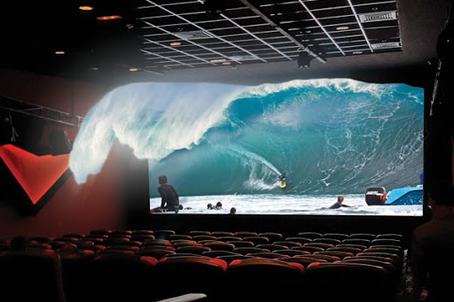

By: Rahul Gulati

CU ID: 10640249

Instructor name: Ms. Manbir Chyle Lalwani

1. **Introduction**

Undoubtedly, 3D technology has completely revolutionised both the television and film industries. Nowadays, several major films incorporate the use of 3D technology in their filmmaking processes (*Europac, 2017)*. The reason for this is simple – exorbitant amounts of money would need to be spent if these 3D objects were handcrafted, and, as a result, 3D scanners are used to recreate these objects, saving both money and time, which are the most valuable assets for movies and television programs (*Europac, 2017)*.

* 1. **How 3D technology has changed the way films are watched and appreciated**

One of the main differences between a 2D and 3D film is that, in a 2D movie, one image from one angle is seen at a time, while in a 3D movie, more than one image from more than one angle is seen at a time (*KrishaStudio, 2020)*. The 1950s was known as the ‘golden era’ of 3D movies, and revolutionary technologies were introduced, such as the anaglyph, which involved the projection of two images through green and red filters (*Martin, Luke 2014)*. When a person would look through these filters, the resulting image would ‘split’, giving rise to a 3D effect. People were exposed to an entirely new experience, and this new 3D technology completely changed how people watched and appreciated movies (*Martin, Luke 2014)*. These types of movies generated significant amounts of buzz at the time. 3D movies help audiences evolve from passive to active, in the sense that they played a role in actively, unconsciously interpreting the message in a myriad of ways through socio-cultural contexts (*Martin, Luke 2014)*.



**A machine was given an anaglyph effect in the 1953 short film ‘3D Motor Rhythm.’**

The initial popularity surge in 3D movies came about after the success of ‘Bwana Devil’ in 1952, a spine-chilling movie about a lion predator, and the 3D effects in this movie made people feel like a lion was jumping right into their lap (*Martin, Luke 2014)*. However, it must be mentioned that 3D short films in London which premiered at the Festival of Britain in 1951 were also quite successful, although they could not be considered as full-feature 3D films (*Jones, Nick 2020).* Filmmakers, cinemas and films themselves took advantage of this new technology with posters for movies like ‘The` Creature from the Black Lagoon’ in 1954 with quotes like ‘It comes off the screen right at you!’, which helped generate more excitement among the audience, and create more memorable, immersive experiences (*Martin, Luke 2014)*. ‘An immersive experience elicits the realistic feeling of being there or being present in a virtual space’ (*Immersive Analytics, n.a.)*.This period also saw exponential growth in the birth rate, which led to a teenage audience for these kinds of movies. The key players in the film industry took this opportunity to create more horror-themed movies in 3D (*Martin, Luke 2014)*.



**The Bwana Devil was one of the first, and most compelling 3D movies, which set the stage for further advancements of this technology and set the stage for more immersive experiences**

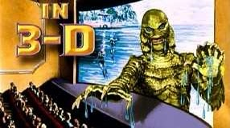

**The ‘Creature from the Black Lagoon’ generated significant buzz among the audiences of the time.**

It is essential to mention that 3D movies were costly, in terms of their production, especially at that time (*Martin, Luke 2014)*. 3D movies were more expensive than 2D movies, and as a result, not everyone was able to enjoy this viewing experience, and they were not able to appreciate this type of technology. Large amounts of labour were also required to produce 3D movies, and this also contributed to their decline (*Martin, Luke 2014)*.

Nevertheless, in the 1980s, the movie sensation Jaws came into cinemas, and it used a unique lens adapter film which divided the frame in half, and each half corresponded to each eye (*Martin, Luke 2014)*. The resulting film looked flat and had image bleeding around the edges, but despite all its flaws, it was a huge success and generated an incomprehensible revenue of over $87 million due to people’s obsession over 3D technology (M*artin, Luke 2014)*. This particular example shows that 3D movies had changed people’s perception of viewing experiences so much that they watched a flawed movie solely for the experience of 3D (*Martin, Luke 2014)*. According to the Oxford Dictionary, **‘**Zeitgeist is the defining spirit or mood of a particular period of history as shown by the ideas and beliefs of the time’ (*Oxford Dictionary, n.a.)*. It could be argued that 3D movies were a good example of the digital zeitgeist at the time since they were watched because they were trending despite being terrible. By now, it was clear that different techniques used to create 3D movies changed people’s viewing experience and appreciation of these movies as compared to the techniques used in 2D movies, and other 3D movies (*Martin, Luke 2014)*.

In 2009, Avatar hit the cinemas in 3D. Now, in the 21st century, everything has changed. 3D movies have grown in popularity, and they have become somewhat cheaper compared to the past (*Martin, Luke 2014)*. Avatar saw a shift both in attitude and appreciation from the older generations, and they became more tolerant towards 3D movies. The ratio between the number of people who opted for the 3D version vs the 2D version was 90:10, which is phenomenal (*Martin, Luke 2014)*. The success of this movie was partly due to the reason of a dual-camera system which recorded two separate photographs for each eye and blended everything seamlessly to produce a movie like no other (*Martin, Luke 2014)*. Inspired by its success, the spectacular 3D movie Hugo about an orphaned boy provided a powerful narrative and showed the real power of storytelling through films. It also brought out aspects of media culture, which showed how people’s stories are reflections of a culture (*Martin, Luke 2014).* It was released in 2012, and according to the director, 3D movies are glimpses into the future by paying homage to the history of the cinema and giving the world greater meaning through three dimensions (*Martin, Luke 2014)*.

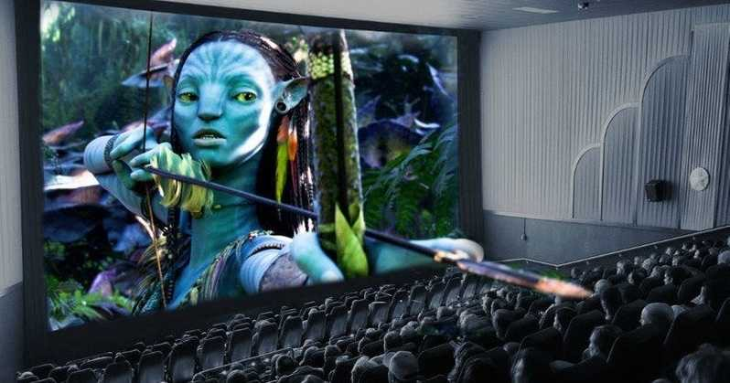

**Avatar 3D was one of the most commanding 3D movies of the 21st century.**

The evidence through the evolution of 3D movies seems to suggest that this technology enhances a person’s viewing experience, but this is not always the case. In a University of Utah study conducted in 2014 among 408 adults aged between 18-64, 3D technology did not enhance the viewing experience, and it did not evoke stronger emotions as compared to 2D technology (*Lean, Ling 2014)*. The study found that both 2D and 3D are equally effective at evoking emotional responses, and 3D films only serve as a novelty for audiences (*Lean, Ling 2014).*

Interestingly, the same study found stronger physiological responses arising from movies with a large number of 3D effects, like ‘The Polar Express’, since there is a feeling of immersion and the study also found that intense feelings of excitement and fear can be elicited using 3D technology which drastically changes the way movies are watched and appreciated (*Lean, Ling 2014)*. 3D technology could also bring in aspects of immediacy, since people are immersing themselves in the movie in ways they would never have before, in the sense that the audience feels that they are a part of the environment. The audience feels like they are playing an active role in communicating with the characters of the movie leading to a completely different viewing experience (*Lean, Ling 2014)*. According to the Cambridge Dictionary, Immediacy is defined as ‘the quality or feeling of being directly involved (in something) (*Cambridge Dictionary, n.a.)*. Despite the attitude shift arising from Avatar in 3D, this study also found that the older generation, which has been exposed to higher quality movies arising from better filming techniques, believe that 3D technology is at a much lower resolution than those old techniques. They feel that their viewing experience is worse with the advent of 3D technology, rather than being improved by it (*Lean, Ling 2014)*.

A film director named Hitchcock attempted to reimagine a 1954 play ‘Dial M for Murder’, but he claimed that his work here was sub-par (*Jones, Nick 2020)*. However, this movie received loads of attention for the way 3D effects were used in a restricted and constrained manner (*Jones, Nick 2020).* A majority of the movie was shot on a single set, and scenes are emphasised to show this 3D effect (*Jones, Nick 2020)*. There was usually some kind of physical barrier between the actors and the audience, which seems to create a sort of gap between them. These barriers created a sort of ‘claustrophobic’ space that increased intimacy and provided an entirely different viewing experience to the audience. Certain aspects of immediacy and hyperreality can also come into play here (*Jones, Nick 2020)*. According to the Wiley Library, Hyperreality is defined as ‘the paradoxical concept of a reality that is experienced as excessively real – it describes phenomena that are deemed to be more real than the real itself’(*Taylor, Paul 2012).* 3D movies are excellent examples of hyperreality since the audience cannot distinguish the content in 3D movies from reality when they are immersed in it.

New technology promises to get rid of the much-despised 3D glasses needed to be worn to watch 3D movies, and this new technology is set to revolutionise 3D cinema itself (*Chowdhury, Hasan 2016)*. Scientists from MIT have developed ‘automultiscopic displays’ which would allow people sitting anywhere in the theatre to view the movie in 3D without glasses, which completely changes the way movies are watched and appreciated and sets the stage for more immersive and realistic experiences (*Chowdhury, Hasan 2016)*. Following the success of Avatar, Avatar 2 and 3 are being filmed, and they are rumoured to be in glasses-free 3D. If these rumours are true, they will radically transform the viewing experience by removing the hassle of wearing an extra set of glasses and will lead to more profound immersive experiences as well (*Ruimy, Jordan 2018*). In Europe and North America, cinemas are streaming less 3D movies as compared to 2D movies because of the popularity that 2D movies still holds. Contrary to this, the popularity of 3D movies is increasing in Asia - In 2016, Asia had over half of the world’s 3D movie screens, and in 2019, 3D films accounted for 20% of global box office sales (*FinancialBuzz, 2019)*. An unpredicted increase in the demand for 3D technology in the East has arisen, due to 3D becoming ‘the new standard’ and due to increased demand for a premium cinematic experience.

* 1. **How 3D technology has elevated the role and relevance of television in contemporary society**

In 1953, a year after the release of Bwana Devil in 3D in cinemas, significant excitement was generated by the debut of 3D TV at a press conference in the US (*Novak, Matt 2012)*. This period saw a sort of ‘cold war’ between 3D movies and 3D television as they competed with each other to produce compelling and innovative content to draw large audiences (*Novak, Matt 2012)*. 3D television promised to elevate television to another level, and transform its role of showing static 2D content to providing immersive experiences, whether that be for entertainment or even for obtaining information (*Novak, Matt 2012)*. However, rumours of 3D televisions had surfaced several years earlier in 1936, when a large card (used for advertisements at the time) proclaimed that, one day, 3D televisions would become a reality. It would have TV shows in 3D as if by ‘magic’ (*Novak, Matt 2012)*. The announcement was huge since this technology had come out less than a decade after broadcast television was introduced, but it showed that 3D TV was setting the stage to make TV more relevant to consumers and play a more prominent role in their lives (*Novak, Matt 2012)*.

The first glimpse of 3D TV in action was a show broadcasted by a Los Angeles channel KECA with a science fiction programme named ‘Space Patrol’. Initially, a five-minute episode of the show was run at the Biltmore Hotel in L.A., mainly for the benefit of the media (*Deffree, Suzanne 2019)*. At the time, 3D glasses were needed to watch this show, and only the media had these special glasses, so as a result, people without these glasses saw only a blurry set of images (*Bassior, Jean-Noel, 2005*). The upside was that this colossal experiment provided a glimpse into ‘The Next Big Thing’ which was, of course, 3D television, and once again proved how television’s role and relevance was slowly being transformed thanks to this technology (*Bassior, Jean-Noel 2005)*. Interestingly enough, despite the possibilities of this technology, the demand was not very high because people did not want to have to wear these ‘big, special glasses’ to watch TV (*Bassior, Jean-Noel 2005)*. The show then started to air for 15 minutes and five days a week, but the demand for 3D TV technology did not increase, and so the show was discarded.

There was a sense of relief from the producers as well because the script needed to be memorised mere minutes before the show was aired, and the technical complications before each show were multifold (*Bassior, Jean-Noel 2005).* Despite Space Patrol, full-fledged 3D TV technology was not entirely available for the public. In 2012, advances in technology enabled people with 3D glasses to fully immerse and experience what they watch on 3D TVs, and people without these glasses would view a 2D image (*Novak, Matt 2012)*. Due to this, these televisions played a different role depending on the consumer's preferences. If consumers did not opt for 3D glasses, TV played a primary role of informing and entertainment, but if people opted for these 3D glasses, TV played a very different role of immersing people in stories, and immersed them in the heart of the action, so that it was not a mere source of entertainment or information, but a near-real experience (*Novak, Matt 2012)*. 3D glasses developed by a particular manufacturer for their TVs did not work for another manufacturer's TVs which caused frustration and urged people to search for alternate technology (*Novak, Matt 2012).*

According to research, if TV shows and movies incite more feelings of realism, they result in more emotional responses, and as a result, the satisfaction obtained from these shows is also elevated as well (*Rooney & Hennessey, 2013).* Several major manufacturers have created 3D televisions to enhance people’s viewing experience and bring it into the 3rd Dimension, thereby elevating the role of 2D televisions, which only involved images locked in place (*Kunic & Sego, 2011)*. 3D technology in television promises more immersive and more detailed experiences which will change how people perceive everything they watch and experience (*Kunic & Sego, 2011)*. Besides this, 3D televisions will also allow 3D movies to be screened on them, instead of only being able to be watched in theatres, which further elevates their role in contemporary society (*Kunic & Sego, 2011)*.

The largest animation companies in the world like Dreamworks are acknowledging the benefits of shifting to 3D technology by proclaiming that 3D is the best innovation since the introduction of colour technology itself, proving that the creative and transformative possibilities of 3D are endless, and the opportunities to engage with audiences and act as a medium of storytelling are exciting (*Kunic & Sego, 2011)*. These possibilities make 3D technology highly relevant in contemporary society. As the evolution of 3D technology in televisions takes place, glasses-free 3D TVs are slowly being introduced to the general public, which will once again transform people’s viewing experience entirely (*Kunic & Sego, 2011).*

The emergence of 3D technology comes with an intriguing question – will this technology lead to increased consumption of shorter, but more immersive stories told through television shows? What would be the implications of this on society in general? How will this change the stories we tell and the stories we believe? The pandemic has caused us to increase our content consumption through streaming services like Netflix which increases the demand for more immersive content, and this is the perfect opportunity for 3D TV shows, as they will be more relevant to the current situation, and to consumer needs during this unpredictable time (*Vadodaria, Neel 2020)*. Combining streaming service shows with 3D TVs can elevate television to another level and provide the immersive experiences consumers demand (*Vadodaria, Neel 2020).*

One of the best examples of 3D TV’s impact on people was seen in the British Isles, where Sky Sports had secretly chosen nine pubs to project a prominent football game in 3D (*Pope, Nick 2020)*. People were fully immersed in the game, and they ducked when the ball ‘came towards them’. Newspapers like ‘The Daily Mail’ said that ‘watching football has changed profoundly’ (*Pope, Nick 2020)*. The impacts and effects on people were so enormous that another 1,000 pubs ordered 3D TVs from Sky Sports. This is also an excellent example of the effects of hyperreality since the audience is immersed in the football game to such an extent that they cannot differentiate it from reality. The popularity had peaked so much that football fans began buying their own 3D TVs, and Sky Sports even began contemplating hosting these games in cinema theatres (*Pope, Nick 2020)*. However, some challenges arose like the fact that the positioning of camera angles in stadiums was not suitable for 3D. Health issues like migraines and headaches also arose due to 3D watching. People in pubs began to get bored with 3D technology and found it somewhat repetitive (*Pope, Nick 2020)*. Despite the decline seen afterwards, this is justly one of the best examples of how 3D technology has revolutionised and played a more significant role in how people watch football, as well as elevating the role of television in order to make the experience fully immersive (*Pope, Nick 2020)*. However, over the next four years, 1.5 million 3D TVs were sold in the UK, and 50% of households opted to watch the Olympics in 3D. 3D technology will provide immersive experiences for those who cannot afford stadium tickets, and for those who are immobile due to health reasons, which gives it more relevance (*Pope, Nick 2020).*

3D technology has also elevated the role of 3D TVs by helping them create a platform for 3D gaming, which also transforms its traditional role of merely providing static entertainment (*Stuart, Keith 2011)*. Our depth perception capacity will help enhance and elevate gaming on 3D TVs with the help of gaming systems like the PS3 and XBOX 360 (*Stuart, Keith 2011)*.

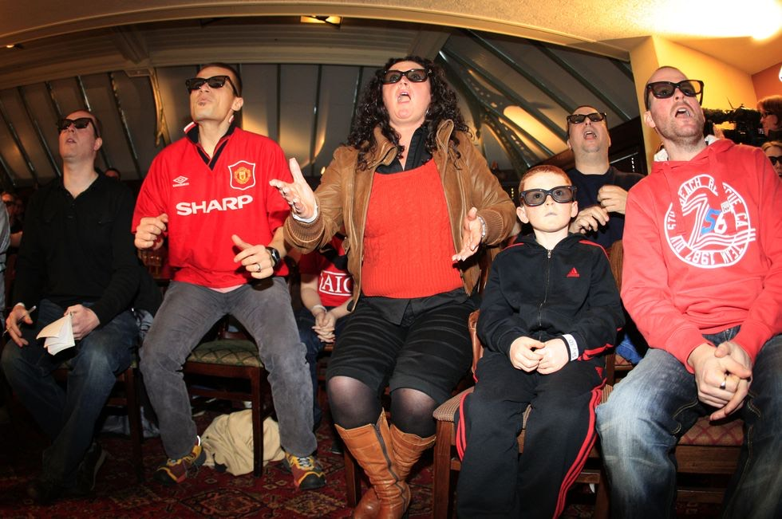

**The first live football match in broadcasted by Sky Sports in 3D was a massive success and drew a large crowd.**

However, according to IBC, 3D TVs have declined in popularity because of the emergence of newer technologies like 8K, VR and AR technologies. A good example was seen in the US in 2016 when sales of 3D TVs dropped to 8% from 23% in 2013 (C-*Scott, Marc 2015*). Although 3D technology seems to improve the viewing experience of shows, the demand for it is not very high since people feel that this technology is best suited for cinemas (C-*Scott, Marc 2015).*

Nowadays, there are only a few 3D channels for 3D TVs, and the question remains about whether it will grow in popularity in the future or become irrelevant due to newer technologies.

1. **Conclusion**

Movies in general, especially 3D movies, play a significant role in shaping people’s perceptions and views of different cultures, and people’s perceptions of the world, bringing in aspects of digital culture. Digital culture explores how technology changes the way we interact and perceive the world around us (*GDS Insights, n.a.).* 3D technology has changed the film and TV industries in a myriad of ways, and the possibilities in the future are endless. From production to the viewing experience itself, 3D is setting the stage for further advancements of technology which will transform the way we view the world *(GDS Insights, n.a.)*. Other industries are also embracing 3D technology to transform the way they operate and the way they engage and interact with consumers. Newer technologies like 4D, Virtual Reality, and Augmented Reality will blur the lines between the real and virtual worlds so that they are both indistinguishable. This also brings in aspects of the digital zeitgeist which shows that 3D movies are only a ‘trend’ during a particular period, and 4D movies are gaining momentum, and soon 3D movies will seem insignificant and outdated (*Oxford Dictionary n.a.)*.

**References**

1. Lean, L (2014). *Think 3D Movies Are Better Than 2D Ones? This Might Just Change Your Mind.* [online] Vulcan Post. Available at: <https://vulcanpost.com/19508/3d-movies-give-emotional-response-2d/> [Accessed 18 Dec. 2020].
2. Taylor, P. (2012). Hyperreality. *The Wiley-Blackwell Encyclopedia of Globalization* [online]. Available at : <https://onlinelibrary.wiley.com/doi/abs/10.1002/9780470670590.wbeog280> [Accessed 16 Dec 2020].
3. KrishaStudio (2020). *A comprehensive difference between 2D animation and 3D animation*. [online] Available at: <https://krishastudio.com/a-comprehensive-difference-between-2d-animation-and-3d-animations/#:~:text=In%202D%2C%20frames%20are%20created>. [Accessed 15 Dec 2020].
4. Martin, L. (2014). *The Relationship Between 3D Technology and a Film’s Success*. [online] The Artfice. Available at: <https://the-artifice.com/3d-technology-and-films-success/> [Accessed 14 Dec. 2020].
5. Immersive Analytics. (n.d.). *What is Immersive?* [online] Available at: <https://www.immersiveanalytics.com/vision/what-is-immersive/#:~:text=A%20simple%20definition%20would%20be> [Accessed 19 Dec. 2020].
6. Jones, N. (2020). *Spaces Mapped and Monstrous - Digital 3D Cinema and Visual Culture*. [Book]. New York: Columbia University Press, pp.52–63. [Accessed 17 Dec. 2020].
7. Oxford Dictionary (n.d.). *Definition of Zeitgeist* [online]. Available at: <https://www.oxfordlearnersdictionaries.com/definition/english/zeitgeist?q=zeitgeist> [Accessed 19 Dec. 2020].
8. Chowdhury, H. (2016). *3D cinema without the glasses: a potential new technology could change how we watch films* [online]. NewStatesman. Available at: <https://www.newstatesman.com/culture/film/2016/07/3d-cinema-without-glasses-potential-new-technology-could-change-how-we-watch> [Accessed 16 Dec. 2020].
9. Ruimy, Jordan (2018). *James Cameron Says ‘Avatar’ Sequels Have Wrapped Production; Rumored to Be in Glasses-Free 3D*. [online] World of Reel. Available at: <https://www.worldofreel.com/blog/james-cameron-says-avatar-sequels-have-wrapped-production-rumored-to-be-in-glasses-free-3d> [Accessed 19 Dec. 2020].
10. FinancialBuzz.com (n.d.). *Modernized Iterations of 3D Technology are Set to Rekindle the Industry*. [online] PRNewswire. Available at: <https://www.prnewswire.com/news-releases/modernized-iterations-of-3d-technology-are-set-to-rekindle-the-industry-300856416.html> [Accessed 19 Dec. 2020].
11. Novak, M. (2012). *3DTV: The future that never was* [online]. BBC. Available at: <https://www.bbc.com/future/article/20120209-paleofuturist-3dtv> [Accessed 19 Dec. 2020].
12. Pope, N. (2020). *The Rise And Fall Of 3D TV Football*. [online] Esquire. Available at: <https://www.esquire.com/uk/culture/a32476886/rise-and-fall-of-3dtv-football/> [Accessed 15 Dec. 2020].
13. Cambridge Dictionary (n.d.). *Definition of Immediacy* [online]. Available at: <https://dictionary.cambridge.org/dictionary/english/immediacy> [Accessed 19 Dec. 2020].
14. Deffree, S. (2019). *1st US 3D TV program is broadcast, April 29, 1953 - EDN*. [online] EDN. Available at: <https://www.edn.com/1st-us-3d-tv-program-is-broadcast-april-29-1953/> [Accessed 21 Dec. 2020].
15. Bassior, J.-N. (2005). *Space Patrol: Missions of Daring in the Name of Early Television*. [Book]. North Carolina: McFarland & Company Inc, Publishers, pp.80–100.
16. Rooney, B. and Hennessey, E. (2013). Actually in the Cinema: A Field Study Comparing Real 3D and 2D Movie Patrons’ Attention, Emotion, and Film Satisfaction. *Media Psychology*, [online] 16(4), pp.441–460. Available at: <https://www.researchgate.net/publication/259197246_Actually_in_the_Cinema_A_Field_Study_Comparing_Real_3D_and_2D_Movie_Patrons’_Attention_Emotion_and_Film_Satisfaction> [Accessed 18 Dec. 2020].
17. Kunic, S. and Sego, Z. (2011). 3D Television. *Croatian Radiotelevision*, [online] pp.2–6. Available at: <https://www.researchgate.net/publication/252052329_3D_Television> [Accessed 16 Dec. 2020].
18. Vadodaria, N. (2020). *Opinion: 3D TV’s Deserves a Comeback. The Time’s Opportune.* [online] Medium. Available at: <https://medium.com/swlh/opinion-3d-tvs-deserves-a-comeback-the-time-s-opportune-98b587b266d5> [Accessed 20 Dec. 2020].
19. Staurt, K. (2011). The Guardian. *3D: a gamers’ guide*. [online] Available at: <https://www.theguardian.com/technology/gamesblog/2011/apr/15/3d-a-gamers-guide> [Accessed 21 Dec. 2020].
20. C-Scott, M. (2015). *Third time unlucky for 3D television – so what went wrong this time?* [online] The Conversation. Available at: <https://theconversation.com/third-time-unlucky-for-3d-television-so-what-went-wrong-this-time-36907> [Accessed 16 Dec. 2020].
21. GDS Insights (n.d.). *What is Digital Culture? – Everything You Need to Know*. [online] Available at: <https://gdsgroup.com/insights/technology/what-is-digital-culture/>. [Accessed 18 Dec. 2020].