What is the

negative impact of

social media on mental health?

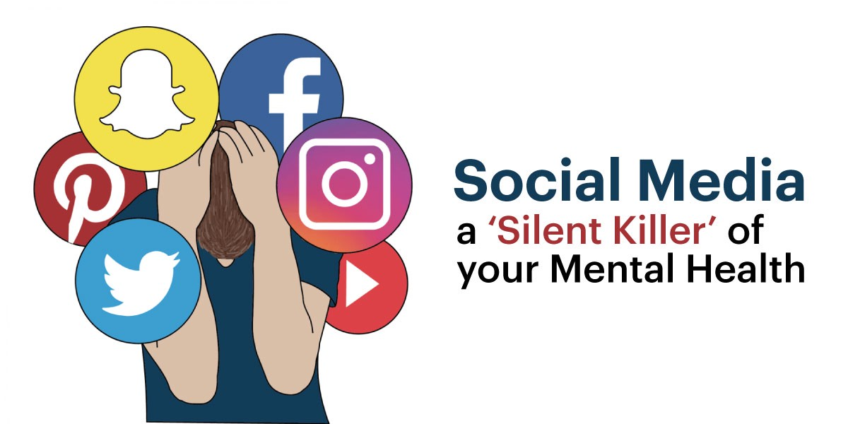

Rahul Gulati

CU ID: 10640249

Bachelor of Arts with Honours in Media and Communications

Instructor: Ms Sharmila Goyal

**Letter of Transmittal**

Sharmila Goyal

PSB Academy

Marina Square

Singapore

Dear Ms Sharmila,

This essay meets the requirements of my assignment.

All the content in this essay is my own work.

Thank you,

Rahul Gulati

**Table of Contents**

|  |  |
| --- | --- |
| **Heading** | **Page Number** |
| **Abstract** | 4 |
| **Justification** | 5 |
| **1.Introduction** | 6 |
| **2.The negative effects of social media on mental health**  **2.1. Case Study**  **2.2. The effects of social media on mental health**   1. **Anxiety and Depression** 2. **Sleep and Attention Span** 3. **Self-Esteem and Human Connection** 4. **Memory and the Brain** | 7  7  7  7  9  11  13 |
| **3. Conclusion** | 15 |
| **References** | 16 |
|  |  |

**Abstract**

The purpose of this essay is to analyse the adverse effects of social media on mental health. A variety of research articles and journals have been used to write this academic paper. The effects of social media on mental health have been a subject of dispute since the Internet came into force. Several studies reveal that social media can ignite feelings of anxiety, loneliness, and a ‘fear of missing out’. It can also lead to several harmful effects like a lack of sleep and severe disorders like depression. It is important to note that there is a difference between the adverse effects of social media and the perception of them. Some positive effects of social media are also present, like connecting with like-minded individuals, but the adverse effects of social media on mental health outweigh the positive ones.

**Justification**

I have chosen the ‘impact of social media on mental health’ as my topic because it is interesting, and provides an insight into a well-known controversial issue. Social media can have a profound impact on how we feel, and ultimately our mental health, and I found this intriguing.

1. **Introduction**

According to a research paper from the University of Central Florida, approximately 73% of adults use at least one social media platform (*Strickland, Amelia 2014*). According to the University of Nevada, adolescents aged 18-25 have the highest level of mental illness (25.8%) compared to other age groups, and one of the primary reasons for this is social media (*The University of Nevada n.a.).* The National Institute of Mental Health reports that 49.5% of adolescents will suffer from a mental disorder for their whole lives, which is incredibly disturbing (*The University of Nevada n.a.)*. Several studies have linked social media use to mental health disorders such as depression and generalised anxiety disorders (GAD). Social media can affect memory and attention span as well (*The* *University of Nevada, n.a.)*. A study conducted by O’Reilly and her colleagues among 54 adolescents aged 11-18 showed that adolescents themselves perceive social media as a threat to mental health, citing that it affects their mood and causes anxiety disorders among themselves, and is a platform for cyber-bullying which can severely impact the mental health of the victim (*O’Reilly et al. 2018)*. Adolescents also claim that social media is addictive, and the regulation of social media usage is crucial (*O’Reilly et al., 2018)*. In another study conducted over eight years involving 500 adolescents aged 13-20, it was found that the risk of mental disorders did not increase when larger amounts of time were spent on social media (*Coyne et al., 2019*).

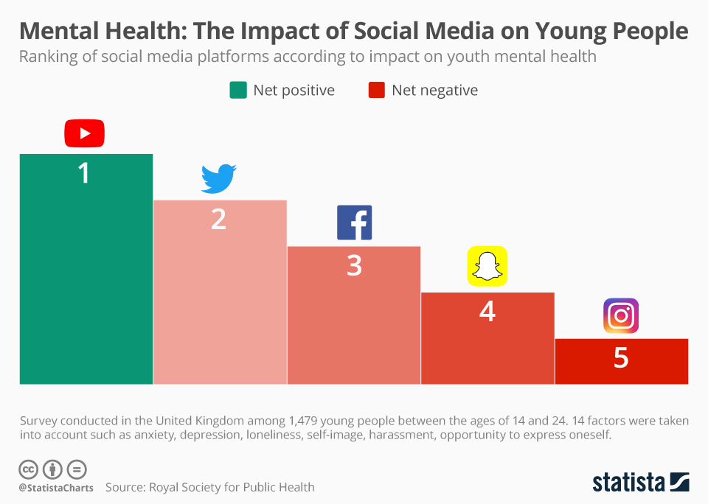

**The effect of various social media platforms on adolescents’ mental health**

**Source: Statista**

[**https://www.statista.com/chart/19262/impact-of-social-media-on-mental-health/**](https://www.statista.com/chart/19262/impact-of-social-media-on-mental-health/)

1. **The negative impact of social media on mental health**
   1. **Case study**

In 1995, a revolutionary project named HomeNet came into existence. This project initially involved the distribution of computers to 48 households. An important highlight of this study was that 20% of these households had never used a computer before (*Kraut et al., 1996)*. Hence, with access to them now, these people found it difficult to understand this technology. HomeNet, however, had a fundamental aim- to monitor the effect of internet usage on mental health (*Kraut et al.,1996.)*. Teenagers used their access to the internet to communicate with strangers and friends, giving rise to one of the earliest forms of social media *(Kraut et al., 1996)*. The results of this study found only a slightly negative impact on mental health, unlike future studies several years later, which saw more significant correlations between these two factors (*Kraut et al., 1996)*. This study highlighted that the internet and social media should be used in limited quantities and should not be overused (*The HomeNet Group, 1998)*.

* 1. **The effects of social media on mental health**

1. **Anxiety and Depression**

Several recent studies have shown that people who use social media for large amounts of time are anxious whenever they do not engage with it, but develop a different kind of anxiety when they finally start their engagement with it (*Reed, Phil 2020)*.

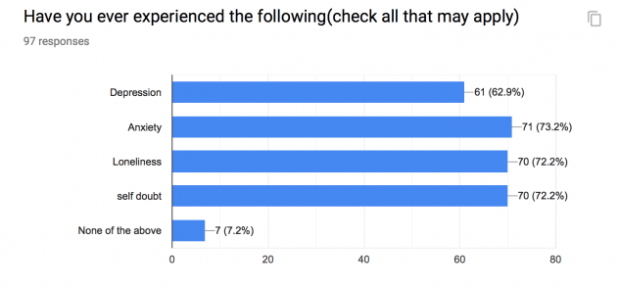

**A study involving 97 people shows how people experience anxiety and depression (among other negative effects) due to social media usage.**

**Source: Social Media Trends**

[**https://wp.wwu.edu/socialmedia/findings/**](https://wp.wwu.edu/socialmedia/findings/)

Social media helps facilitate positive interactions among adolescents in particular. Social media sites like YouTube, Facebook and Twitter help people find support when they need it the most and reduce their anxiety (*Dobrean & Pasarelu 2016)*. However, a four-year study conducted among adolescents found a link between excessive usage of social media, anxiety and depression (*Boers, Afzali & Conrod, 2019*).

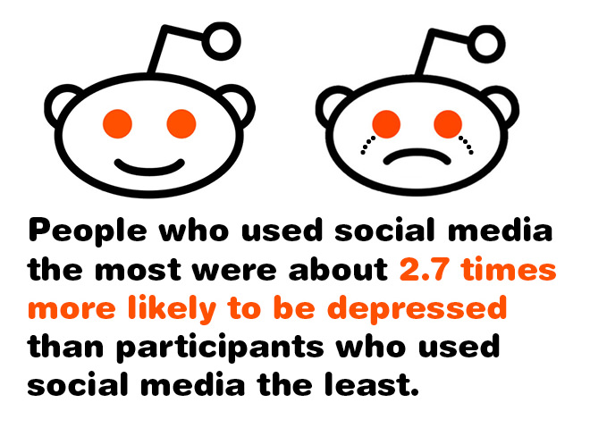

**Research shows that increased social media usage can lead to depression.**

**Source: Behavioural Health of the Palm Beaches**

[**https://www.bhpalmbeach.com/are-depression-and-social-media-usage-linked/**](https://www.bhpalmbeach.com/are-depression-and-social-media-usage-linked/)

Another study conducted among over ten thousand adolescents in six European countries by Tsitsika et al. in 2014 also showed how using social media for extensive periods contributed to higher levels of anxiety and depression (*Keles, McCrae and Grealish,2019)*. The results of a Serbian study conducted by Igor Pantic and his colleagues among 160 high school students showed a link between social media and depression (*Pantic et al. 2011*). However, this study also found that there was no link between television and depression (*Pantic et al. 2011)*. A study conducted by Yan et al. in 2007 in China among adolescents also found a correlation between excessive social media usage and anxiety based on low self-esteem (*Keles, McCrae and Grealish, 2019*).

1. **Sleep and Attention Span**

Excessive social media usage can result in disturbed sleep patterns, which in turn has a severe impact on mental health. A University of Glasgow study, involving 12,000 teenagers, found that adolescents who spent over 5 hours a day on social media had around 70% likelihood of sleeping late at night, compared to those who spent less time on it (*BBC, 2019*). The ‘fear of missing out’ makes teenagers worried about disconnecting from social media before they sleep.

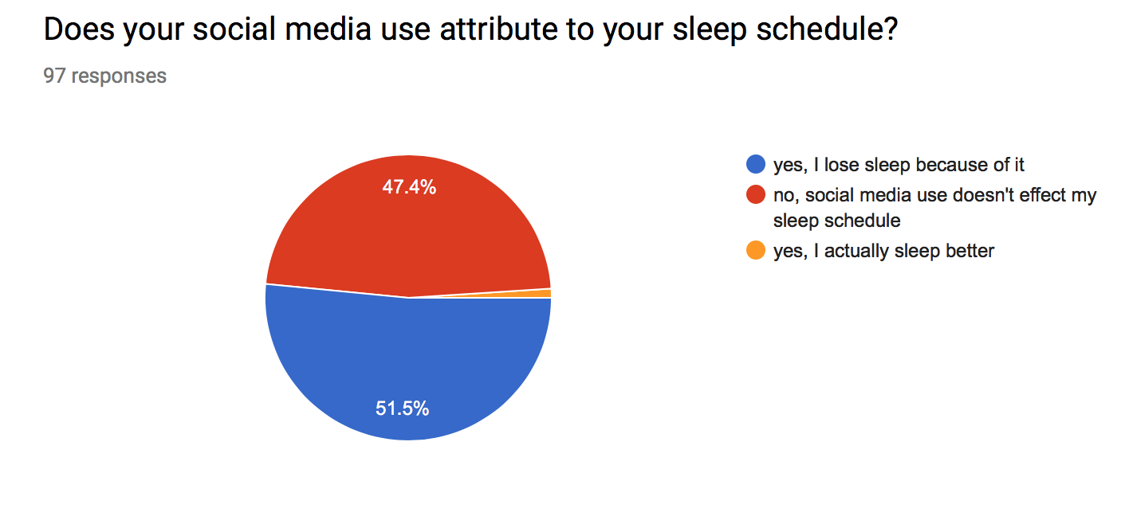

**A majority of people claim that social media contributes to a loss of sleep**

**Source: Social Media Trends**

[**https://wp.wwu.edu/socialmedia/findings/**](https://wp.wwu.edu/socialmedia/findings/)

Many people develop biases based on what they see online. Several studies have revealed that people only choose media sites that align with their beliefs (*Kim, Jean 2018)*. According to a South Korean study conducted by Lee et al. from the journal ‘*Telematics and Informatics*’, people who involved themselves with politics to a greater extent had more biased opinions on social media platforms compared to those who did not (*Kim, Jean 2018*). However, there is no concrete evidence that social media permanently reduces people’s attention span (*Forbes, 2019*).

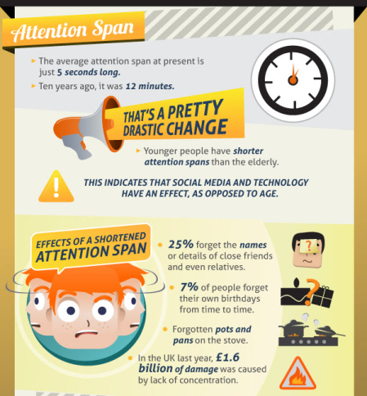

**Research shows that people’s attention span has decreased due to social media and technology.**

**Source: halfblog.net**

[**https://halfblog.net/2011/12/15/infographic-creators-have-a-5-second-attention-span/**](https://halfblog.net/2011/12/15/infographic-creators-have-a-5-second-attention-span/)

Due to a large number of stories and data people are overpowered by, they can effectively become desensitised to violence (*Kim, Jean 2018)*. People’s attention spans are also greatly affected by a large amount of information they receive, and people get distracted easily (*Kim, Jean 2018*). People transfer their attention from one traumatic story to another in rapid succession, and this is extremely alarming. A Scientific American investigation into social media’s effects on people’s attention spans revealed that flawed research methods and inaccurate data tried to show that social media has a permanent negative effect on our attention spans when in reality, the negative effect is only temporary (*Denworth, Lydia 2019*).

1. **Self Esteem and Human Connection**

When people compare themselves to others by looking at pictures or posts which look ‘perfect’ on social media, their self-esteem is affected to a great extent. As a result, people develop feelings that they are not good enough and that they have something to prove to somebody else when, in reality, they are perfect just as they are (*Keles, McCrae and Grealish, 2019)*. A University of Copenhagen study in 2015, involving 1,095 participants, conducted by Mary Ann Liebert, found that the participants who did not use Facebook for a week were more satisfied in their lives, as compared to those who did (*Tromholt, Morten 2016)*.

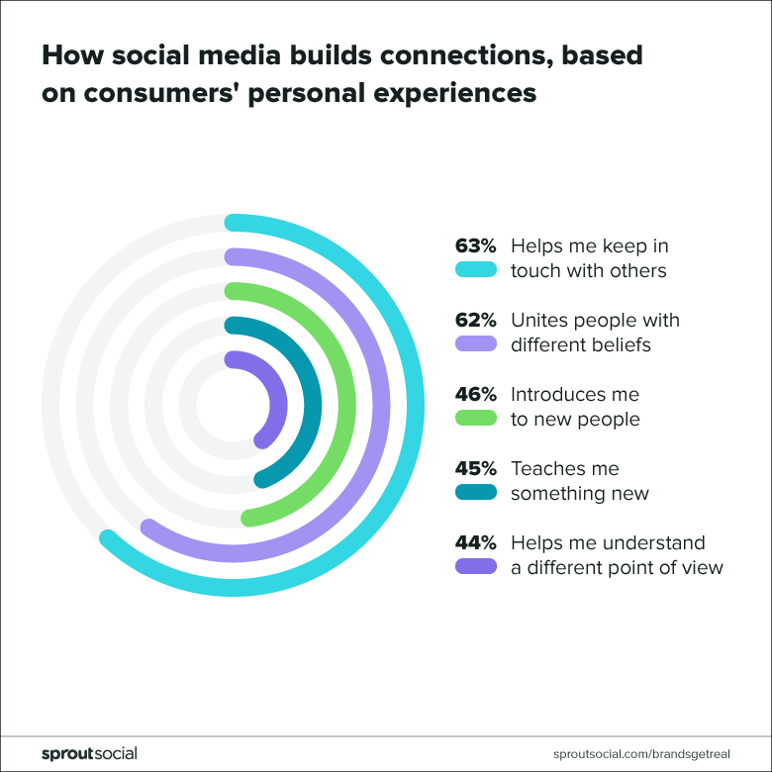

**How social media builds positive connections**

**Source: Sprout social**

[**https://sproutsocial.com/insights/data/social-media-connection/**](https://sproutsocial.com/insights/data/social-media-connection/)

Reducing the usage of social media can be beneficial. A research study in Canada among 188 female students helps illustrate this point, and the results from this study (published in the Body Image Journal in 2019) found that women’s’ self-worth was affected after they engaged with someone they felt was more attractive (*Beres, Damon 2020)*. The study also found that by spending less time on social media, this feeling of ‘not being beautiful enough’ is reduced (*Beres, Damon 2020)*.

The young generation, particularly adolescents, attach themselves to social media, which ultimately hampers communication and real-life relationships (*Harman, Rosie 2019)*. Social media provides insights into other people’s lives which others would not know about otherwise (*Harman, Rosie 2019*). These insights can stir up negative emotions like anger and jealousy, which can have a severe impact on human connection.

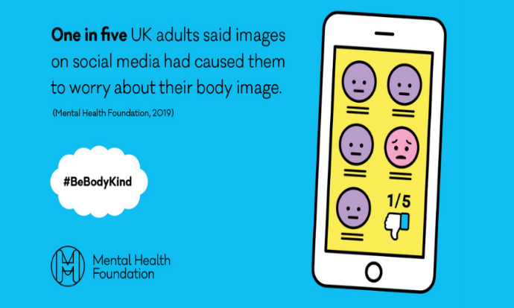

**In the UK, one in five adults claimed that social media reduced self-esteem**

**Source: Mental Health Foundation** [**https://www.mentalhealth.org.uk/publications/body-image-report/exec-summary**](https://www.mentalhealth.org.uk/publications/body-image-report/exec-summary)

However, social media enables people to keep in touch with family and friends, even if they are in a different country, and this would otherwise not be possible to such an extent. People can connect with other like-minded individuals on social media, which contributes to an increase in human connections (*Tufekci, Zeynep 2012*). This concept is especially relevant in the time of the COVID virus, where social distancing must be maintained, and physical interactions are limited *(Tufekci, Zeynep 2012).*

Excessive viewing of photographs of food on social media can trigger parts of the brain responsible for hunger, leading to eating disorders like bulimia and anorexia, and can also contribute to obesity (*Beres, Damon 2020)*. Eating disorders have a severe impact on people’s self-esteem, thus affecting their mental health to a significant extent (*Bares, Damon 2020*). Therefore, limiting the viewing of stimuli-inducing photographs on social media is essential.

1. **Memory and the Brain**

The results from a research study conducted by The Gerontological Society of America, which primarily focused on short-term memory lapses, showed that people’s memory was worse on the days they used excessive amounts of social media (*Zahodne & Sharifian, 2019*). Different demographics did not play a role in altering the results, and no observations were made regarding long-term memory lapses. However, a study conducted by Wang, Lee and Hou found that posting on social media helped people remember events better since writing and talking about situations strengthens people’s memory about that particular event (*Wang, Lee & Hou, 2017*). On the other hand, writing everything on social media also has a negative effect-people rely on the internet too much, and specific details about an event can be easily forgotten (*MacMillan, Amanda 2016)*.

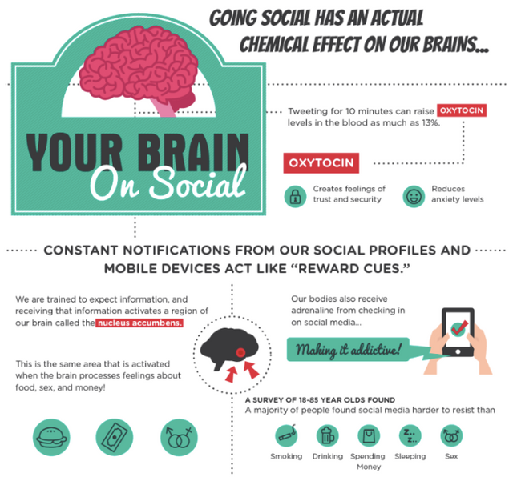

**The results of a survey conducted among 18-65-year-olds show that social media’s negative ‘addictive’ effect makes it harder to resist than even drinking and smoking.**

**Source: Steemit.**

<https://steemit.com/sirwinchester/@sirwinchester/how-social-media-changes-our-brains>

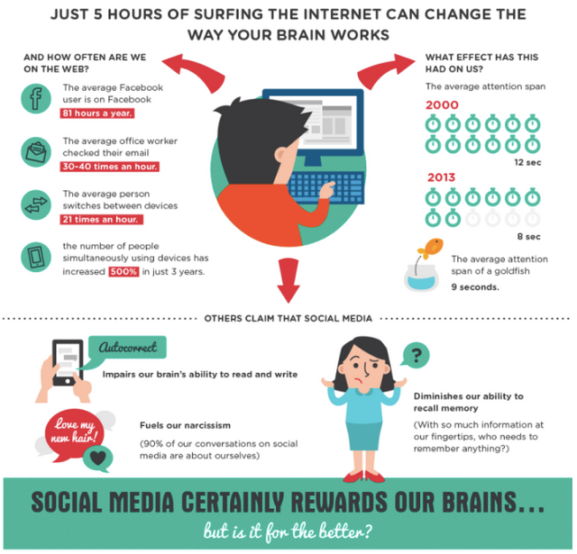

The negative effects of social media on people’s brains is more than it seems

Source: Steemit.

<https://steemit.com/sirwinchester/@sirwinchester/how-social-media-changes-our-brains>

1. **Conclusion and Recommendations**

In conclusion, social media has both positive and negative impacts on mental health. Some of the adverse effects include disorders like anxiety disorders, eating disorders and depression. Some positive effects of social media involve helping people remember events better and develop stronger connections with loved ones where physical interaction is impossible. However, the negative impacts of social media on mental health outweigh the positive ones. More research needs to be conducted on this topic to find stronger links between heavy social media use and several disorders. Social media usage should be self-regulated, which decreases negative feelings like the feeling of missing out and decreases the chance of developing anxiety disorders and depression. Enhanced treatment plans must be developed for people with mental disorders, and therapy would be incredibly beneficial for people to cope with situations and events they encounter in their lives, as well as what they observe on social media.

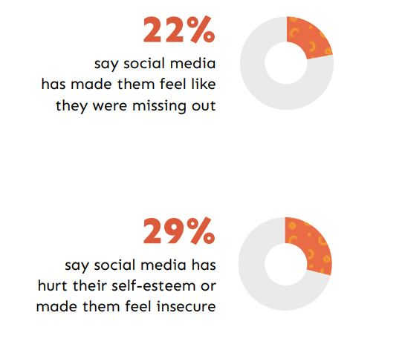

**Statistics showing the adverse effects of social media on mental health**

**Source: Econsultancy**

[**https://econsultancy.com/social-natives-deleting-accounts-what-does-this-mean-for-marketers/**](https://econsultancy.com/social-natives-deleting-accounts-what-does-this-mean-for-marketers/)

**References**

1. Strickland, A. (2014). *Exploring the Effects of Social Media Use on the Mental Health of Young Adults*. [online] Available at: <https://stars.library.ucf.edu/cgi/viewcontent.cgi?article=2683&context=honorstheses1990-2015>. [Accessed 7 Oct. 2020].
2. Kraut, R., Scherlis, W., Mukhopadhyay, T., Manning, J. and Kiesler, S. (1996). The HomeNet Field Trial of Residential Internet Services. *Communications of the ACM*, [online] 39(12), pp.55–63. Available at:<https://www.cs.cmu.edu/~kiesler/publications/1996pdfs/1996_HomeNet-cacm.pdf> [Accessed 8 Oct. 2020].
3. Pantic, I., Damjanovic, A., Todorovic, J., Topalovic, D., Bojovic-Jovic, D., Ristic, S. and Pantic, S. (2011). ASSOCIATION BETWEEN ONLINE SOCIAL NETWORKING AND DEPRESSION IN HIGH SCHOOL STUDENTS:  BEHAVIORAL PHYSIOLOGY VIEWPOINT. *Psychiatria Danubina*, [online] 24(1), pp.90–93. Available at: <https://www.researchgate.net/publication/221975813_Association_between_online_social_networking_and_depression_in_high_school_students_Behavioral_physiology_viewpoint> [Accessed 9 Oct. 2020].
4. Beres, D. (2020). *10 Hidden Negative Effects of Social Media on Your Brain*. [online] The Healthy. Available at: <https://www.thehealthy.com/mental-health/negative-effects-of-social-media/>. [Accessed 5 Oct. 2020].
5. Keles, B., McCrae, N. and Grealish, A. (2019). A systematic review: The influence of social media on depression, anxiety and psychological distress in adolescents. *International Journal of Adolescence and Youth*, [online] 25(1), pp.1–15. Available at: <https://www.tandfonline.com/doi/full/10.1080/02673843.2019.1590851>. [Accessed 4 Oct. 2020].
6. Tromholt, M. (2016). The Facebook Experiment: Quitting Facebook Leads to Higher Levels of Well-Being. *Cyberpsychology, Behavior, and Social Networking*, 19(11), pp.661–666. Available at: <https://pdfs.semanticscholar.org/2a13/6b93eb4d98dda97aa93c3ee58fd3230d5b9c.pdf>. [Accessed 7 Oct. 2020].
7. Reed, Phil (2020). *Anxiety and Social Media Use*. [online] Available at: <https://www.psychologytoday.com/sg/blog/digital-world-real-world/202002/anxiety-and-social-media-use> [Accessed 8 Oct. 2020].
8. Forbes (2019). *Does Using Social Media Really Affect Your Attention Span?* [online] Forbes. Available at: <https://www.forbes.com/sites/quora/2019/11/20/does-using-social-media-really-affect-your-attention-span/#20fa421c1a57> [Accessed 8 Oct. 2020].
9. Tufekci, Z. (2012). *Social Media’s Small, Positive Role in Human Relationships.* [online] The Atlantic. Available at: [www.theatlantic.com/technology/archive/2012/04/social-medias-small-positive-role-in-human-relationships/256346/](http://www.theatlantic.com/technology/archive/2012/04/social-medias-small-positive-role-in-human-relationships/256346/). [Accessed 8 Oct. 2020].
10. MacMillan, A. (2016). *How Posting on Facebook Affects Your Memory*. [online] Real Simple. Available at: <https://www.realsimple.com/health/mind-mood/memory/social-media-memory> [Accessed 6 Oct. 2020].
11. Wang, Q., Lee, D. and Hou, Y. (2017). Externalising the autobiographical self: sharing personal memories online facilitated memory retention. *Memory (Hove, England)*, [online] 25(6), pp.772–776. Available at: <https://www.tandfonline.com/doi/abs/10.1080/09658211.2016.1221115> [Accessed 21 Sept. 2020].
12. Denworth, L. (2019). Social Media Has Not Destroyed a Generation. *Scientific American*. [online] Available at: <https://www.scientificamerican.com/article/social-media-has-not-destroyed-a-generation/> . [Accessed 25 Sept 2020].
13. Boers, E., Afzali, M. and Conrod, P. (2019). Temporal Associations of Screen Time and Anxiety Symptoms Among Adolescents. *Canadian Journal of Psychiatry*, [online] 65(3), pp.206–208. Available at: <https://europepmc.org/article/med/31684757> [Accessed 8 Oct. 2020].
14. The HomeNet Group (1998). Social Impact of the Internet- What Does it Mean? *Communications of the ACM*, [online] 41(12), pp.21–22. Available at: <https://www.cs.cmu.edu/~kiesler/publications/1998pdfs/1998_social-impact-internet-mean.pdf> [Accessed 8 Oct. 2020].
15. Sharifian, N. and Zahodne, L.B. (2019). Social Media Bytes: Daily Associations Between Social Media Use and Everyday Memory Failures Across the Adult Life Span. *The Journals of Gerontology: Series B*, [online] 75(3), pp.540–548. Available at: <https://pdfs.semanticscholar.org/7b76/be636e388107f0325e6adf2bc7b782fb13ec.pdf> [Accessed 30 Sep. 2020].
16. O’Reilly, M., Dogra, N., Whiteman, N., Hughes, J., Eruyar, S. and Reilly, P. (2018). Is social media bad for mental health and wellbeing? Exploring the perspectives of adolescents. *Clinical Child Psychology and Psychiatry*, 23(4), pp.601–613. Available at: <https://journals.sagepub.com/doi/abs/10.1177/1359104518775154> [Accessed 1 Oct. 2020].
17. Coyne, S.M., Rogers, A.A., Zurcher, J.D., Stockdale, L. and Booth, M. (2019). Does time spent using social media impact mental health? An eight-year longitudinal study. *Computers in Human Behavior*, [online] p.106160. Available at: <https://www.sciencedirect.com/science/article/pii/S0747563219303723?via%3Dihub>. [Accessed 2 Oct. 2020].
18. Harman, R. (2019). *How Social Media Affects Relationships Positively and Negatively*. [online] Available at: <https://thriveglobal.com/stories/how-social-media-affects-relationships-positively-and-negatively/#:~:text=The%20negatives%20social%20media%20has%20on%20family%20relationships%20include%3A&text=Mental%20Health%3A%20It%20is%20very> [Accessed 8 Oct. 2020].
19. The University of Nevada (n.d.). *Impact of Social Media on Youth Mental Health*. [online] Available at: <https://onlinedegrees.unr.edu/online-master-of-public-health/impact-of-social-media-on-youth-mental-health/>. [Accessed 4 Oct 2020].
20. Kim, J. (2018). *Is Social Media Destroying Our Attention Spans?* [online] Psychology Today. Available at: <https://www.psychologytoday.com/sg/blog/culture-shrink/201812/is-social-media-destroying-our-attention-spans> [Accessed 9 Oct. 2020].
21. BBC (2019). *Heavy social media use linked to poor sleep.* BBC News. [online] Available at: <https://www.bbc.com/news/health-50140111>. [Accessed 8 Oct. 2020].
22. Dobrean, A. and Pasarelu, C.-R. (2016). Impact of Social Media on Social Anxiety: A Systematic Review. *New Developments in Anxiety Disorders*. [online] Available at: <https://www.intechopen.com/books/new-developments-in-anxiety-disorders/impact-of-social-media-on-social-anxiety-a-systematic-review>. [Accessed 9 Oct. 2020].

**Picture References**

1. Armstrong, M. (2019). *Infographic: Mental Health: The Impact of Social Media on Young People*. [online] Statista Infographics. Available at: <https://www.statista.com/chart/19262/impact-of-social-media-on-mental-health/>. [Accessed 9 Oct 2020].
2. wp.wwu.edu. (n.d.). *The Data | Social Media Trends*. [online] Available at: <https://wp.wwu.edu/socialmedia/findings/> [Accessed 9 Oct. 2020].
3. BHOPB (2019). *Are Depression and Social Media Usage Linked? - Behavioral Health Of The Palm Beaches*. [online] Behavioral Health Of The Palm Beaches. Available at: <https://www.bhpalmbeach.com/are-depression-and-social-media-usage-linked/>. [Accessed 7 Oct. 2020].
4. Geoff (2011). *Infographic creators have a 5 second attention span*. [online] halfblog.net. Available at: <https://halfblog.net/2011/12/15/infographic-creators-have-a-5-second-attention-span/> [Accessed 9 Oct. 2020].
5. Sprout Social (2019). *#BrandsGetReal: What consumers want from brands in a divided society*. [online] Sprout Social. Available at: <https://sproutsocial.com/insights/data/social-media-connection/>. [Accessed 2 Oct. 2020].
6. Mental Health Foundation. (2019). *Body image report - Executive Summary*. [online] Available at: <https://www.mentalhealth.org.uk/publications/body-image-report/exec-summary>. [Accessed 3 Oct. 2020].
7. Gillil, N. (2018). *If social natives are deleting their accounts, what does this mean for marketers?* [online] Econsultancy. Available at: <https://econsultancy.com/social-natives-deleting-accounts-what-does-this-mean-for-marketers/> [Accessed 9 Oct. 2020].
8. Ago, S. (2016). *How Social Media changes our Brains!* [online] Steemit. Available at: <https://steemit.com/sirwinchester/@sirwinchester/how-social-media-changes-our-brains> [Accessed 9 Oct. 2020].