IS ANY INFORMATION

IN THE MEDIA REAL AT ALL?

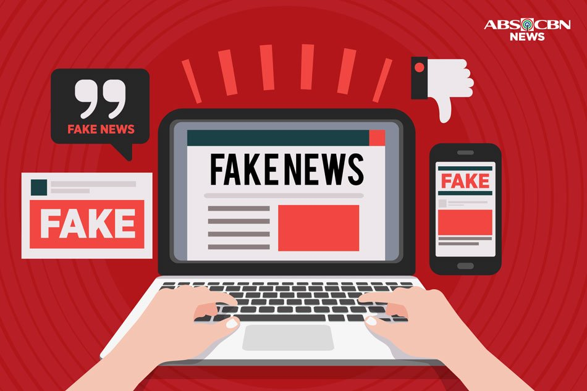

Name- RAHUL GULATI

G1948660K

Instructor - Aaron Rao Anand Rao

ABSTRACT

Fake news is one of the biggest problems which society faces today. The impact of it is both local and global. When epidemics break out, deceiving information is dangerous. Robots may be spreading fake news without our awareness. Influenced by history and the capability to change the future, fake news is a dangerous weapon. If misused by those in power, disastrous consequences can arise. Active and passive audiences react to pieces of information in different ways. This essay also examines the impact of fake news on students as well as how it can create false memories.

**1.Introduction**

Modernity has given people many choices related to consuming news using different forms of media. Some of these are radio, television and the internet. The large number of choices people have comes with three risks : 1) Risk of Saturation (too many options, so it is difficult to determine which source to derive news from); 2) Risk of Authenticity (difficulty understanding what news is real and what is not) ; 3) Risk of Manipulation and Persuasion (news can be manipulated to suit the news company or by the government for their selfish wants. It can also be used to persuade people to take an action). Delivery of news can take place in various forms which may be positive or negative. ‘Fake news’ can be used to indicate false or made-up news. Framing is when parts of factual news are selected and are given more significance than other parts (which are excluded) in order to understand the problem and come up with solutions (Ardèvol-Abreu, 2015). Presenting news using framing in positive or negative ways would result in certain things which may not be necessary to be emphasized (Ardèvol-Abreu, 2015). This is usually done to increase sales of the newspaper or increase ratings of news channels.

**2.The Issue of Fake News**

**2.1. Statistics Related to Fake news**

In America, 54% of people feel that fake news is a large problem and in Germany, 74% of people feel the same way (Panke, Stefanie 2019).

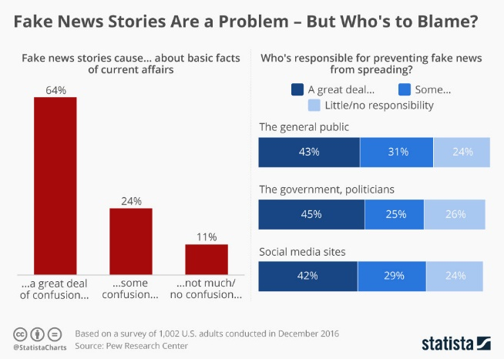

Figure 1- Fake News - Who is to blame? From businessinsider.sg

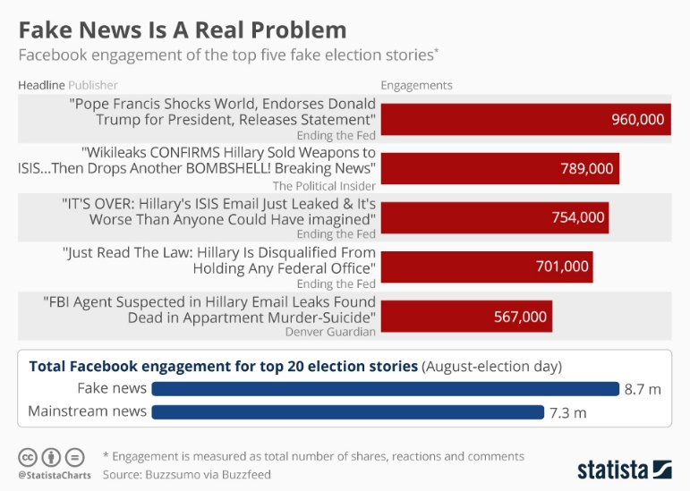

Figure 2 – Facebook engagement of top five fake news stories. From businessinsider.sg

**2.2. Example of a Large Spread of Fake News**

When the ZIKA virus arrived in America, deceptive posts about the virus were far greater favoured as compared to real ones (Sharma, Yadav, Yadav, & Ferdinand, 2017). A probable reason for the vast spread of fake news about this virus was that many people had no idea about it and blindly believed whatever they read. Tremendous efforts were made to disperse the spread of fake news so people could be treated and take preventive measures. Another claim surfaced that vaccines cause autism (Foster and Ortiz 2017). This claim was due to research conducted by Andrew Wakefield and his colleagues (Foster and Ortiz 2017). His test subjects were twelve children, and after giving them the MMR injection, he claimed that all these children had experienced mental problems (Foster and Ortiz 2017). Large amounts of fake news spread, convincing people that this was true. This resulted in the generation of fear and the decrease in the number of vaccinations (Foster and Ortiz 2017). If thousands of children are vaccinated, and if only a fraction of those develops autism, the MMR vaccine is not the problem (Foster and Ortiz 2017).

**2.3. Role of Fake News Robots**

Fake news spread by robots happens in two principal ways: Reinforcing fake news and Using false information to give feedback on posts related to real news (Panke, Stefanie 2019). These robots use Artificial Intelligence to promote false information. They are easy to construct and use. There is a possibility that fake news robots could have interfered in the 2016 US Elections, Brexit and tensions in Ukraine (Panke, Stefanie 2019).

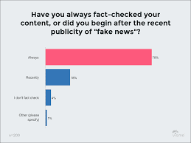

Figure 3 - Percentage of people who check the validity of news. From visme.co

**2.4. Steps taken to combat Fake News in a Local Context**

In September 2018, The Committee on Deliberate Online Falsehoods gave some advice which involved the ratification of the legislature, which would in turn help combat the spread of fake news (Media Literacy Council, 2018). The Singaporean government is encouraging people to check the validity and source as well as to see if the information in the article makes sense. They encourage people to research if the same information has been published somewhere else and if it was published earlier (Media Literacy Council, 2018). It is crucial to evaluate if the article had intended humour, and the government aims at informing people not to be influenced by their prejudices or biases.

[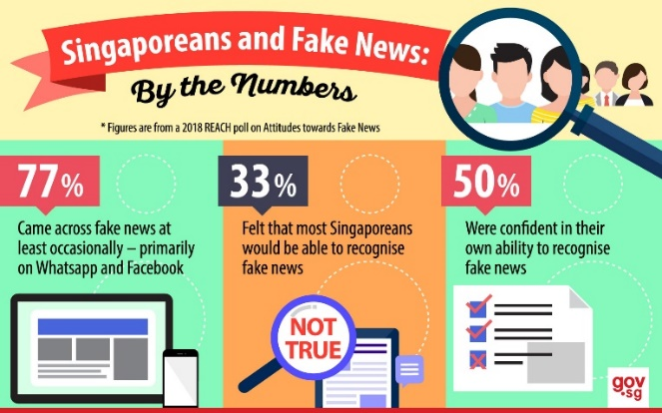](https://www.gov.sg/~/media/gov/factually/thumbnail/law%20and%20government/fakenews_infographic_nos.jpg)

Figure 4- Fake news in a local context. From gov.sg

**2.5. Fake News and Disinformation in History**

The earliest records of widespread false information were in 31 BC, where Octavian spread fake news to win the last war of the Roman Republic against his rival Marc Anthony (Carson, James 2019). After the war ended, Octavian cleverly changed his name to Augustus and once again spread misinformation, this time about himself being a sincere person (Carson, James 2019). In the 20th century, new ways of reaching mass audiences arose, which allowed fake news to spread faster. In 1938, the radio was the primary source of news for people as television did not exist (Schwartz, A.B., 2015). When the sci-fi broadcast ‘War of The Worlds’ released in America and the airing of the first episode began with an announcement of aliens landing on Earth, hundreds of Americans panicked and believed this ‘news’. Later, this ‘news’ was confirmed fake. This incident shows how significant the impact of fake news is on people (Schwartz, A.B., 2015). It also set the stage for the spreading of fake news in the future.

**2.6. Fake news in the future**

With the rapid advancement of technology, measures to combat fake news are becoming more difficult. Introduction of programmes are very beneficial wherein people would understand what fake news is and take measures to prevent not only the spread of it but also gain awareness about it.

**2.7. Fake News as a Tool for Governments**

For years, the government and other very substantial people have used fake news as a tool for their benefit. Before social media and even the internet itself, it was costly to enable a wide spread of information, unlike nowadays, where some information is not news but taken into that category (Carson, James 2019). Now, the spread of fake news on social media is smooth and all limitations have been removed. It has allowed everyone to create and destroy information leading to debates on credible information.

**2.8. Theories related to fake news**

**i. Hypodermic Needle Theory**

Baran and Davis define the Hypodermic Needle Theory as the transfer of information from the source to the receiver as direct and immediate, and this makes the audience powerless to resist the message (Kenechukwu, Stephen 2015, p116). It works as a direct transfer of information to the public, spread in such a way that it creates a response (Nwabueze, Okonkwo 2018, p2). The messages are potent and capable of making an immediate change. An example of this theory was the Monkey Pox outbreak in Nigeria in 2017. Fake news spread about soldiers infecting children with Monkey Pox with several newspapers reporting the death of children (Nwabueze, Okonkwo 2018, p6). Claims arose that all deaths took place in schools, which resulted in parents rushing and pulling their children out from schools and chaos erupted. The fake news rumours had begun on social media (Nwabueze, Okonkwo 2018). People did not consider the validity of such news and powerlessly accepted the information they received.

**ii. Two Step Theory**

Lazarsfeld, Berelson and Gaudet formulated the Two-Step Theory. The theory states that passage of information through a specific group of people called opinion leaders who interpret, change and convey this information to general audiences takes place (Postelnicu, Monica 2016). An example of this theory was seen in a project by Al Gore (Tizio, Amy n.a.). He employed opinion leaders online to make more people aware of climate change. Direct communication with the audience takes place. As an opinion leader, Al Gore helped influence public opinion and make a change for the good.

**iii. Media Literacy**

Media Literacy is when information received by audiences is thoroughly analysed and determined if it is valid or not (Mason, Krutka, Stoddard 2018). Media Literate audiences can distinguish which information is accurate. For audiences to be media literate, they must understand the situation in their country completely (Mason, Krutka, Stoddard 2018). Schools can add media literacy courses to make the next generation aware of real news. These audiences are active. Referring back to the Monkey Pox example, if the audience was active and media literate in that case, they would not have blindly believed what they read, and instead checked the validity on public health sites.

**2.9. The components of fake news**

Fake news can consist of stories which have no basis for their existence. The aim of these stories is only increasing the number of people who access the site and for monetary benefits (Carson, James 2019). The country itself can also spread fake news in the form of gathering support for a campaign or a person before an election (Carson, James 2019). It can also be used to create negative attitudes towards a particular group of people. Some news channels which support only one side of an argument can be a source of fake news. The final component of fake news is social media where large amounts of information are spread, and the genuineness is challenging to assess.

**2.10. Steps taken to combat Fake News in a Global Context**

Frustrated people targeted social media companies saying they did nothing to reduce fake news. Twitter, Facebook and Google finally took steps to combat this issue (Carson, James 2019). Facebook said it would hire fact-checkers to check the validity of stories and eliminate the advertisement of fake news sites on their platform. They promised to review current advertisements in a better way (Carson, James 2019). People still feel nothing is enough, and big companies are afraid to appear to have biased views on various topics. Russian President Vladimir Putin has created a new law which punishes people who spread fake news or criticism of the government (Straits Times, 2019).

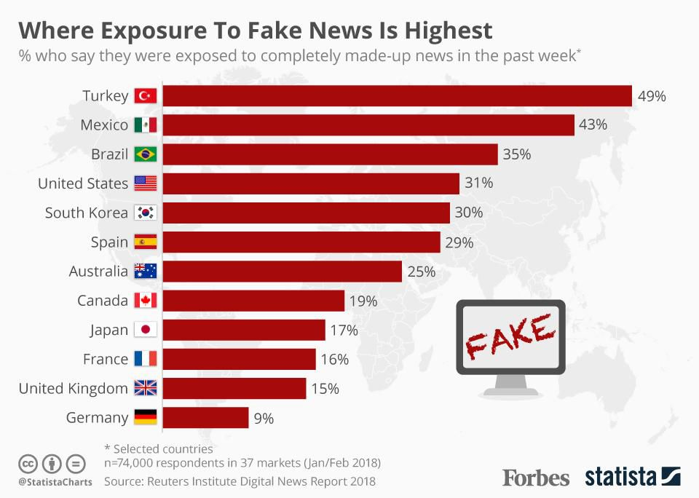

Figure 5- Where exposure to fake news is the highest. From forbes.com

**2.11. The Dangers of Fake News**

Fake news can result in violence. An example of the severity of this was seen in Washington, D.C., in 2016. Edgar Welch went into the Comet Ping Pong restaurant with a gun because of online rumours that the restaurant was keeping young children and using them as ‘sex slaves’ as part of ‘Hilary Clinton’s child abuse plan’ (Goldman and Kang 2016). Fake news is hazardous as it can make people go to extreme measures if they believe the news.

**2.12. Impact of Fake News on Students**

Peers can spread fake news, and due to trust in them, others can further spread it without considering its validity. The spread of fake news would, therefore, be very rapid, and the creation of false beliefs and ideas will take place in a vulnerable student’s mind (Straits Times, 1948). In countries like Brazil, classes for students to identify fake news have been made mandatory (Straits Times, 2018). It is evident that by taking this step, Brazil has recognised that fake news is a massive problem which could affect students and is taking steps to ensure they are not influenced by false information (Straits Times, 2018). Students and parents in Brazil realise the potential adverse effects of fake news as a result of the campaign (Straits Times, 2018). These students can effectively analyse information and determine what is right. Students around the world have adopted checking many sources for a piece of information because of greater awareness of fake news (Funke, Daniel 2018). The results of a 2016 Stanford University study showed that students find it challenging to find if an article is believable or not. The research conducted was based on 7,800 responses (Funke, Daniel 2018).

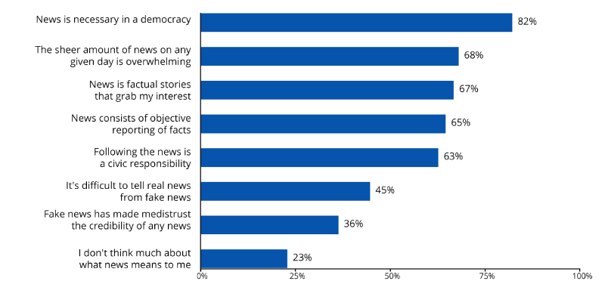

Figure 6- How students define the role of news in their lives. From storybench.org

**2.13. Fake News Can Lead to The Creation of False Memories**

In an election context, voters may have an erroneous recollection about certain events after seeing fake news, chiefly if that news is similar to what they feel about candidates or parties (Association for Psychological Science,2019). Making predictions for the 2020 U.S. election involves how fake news could lead to people having negative views about candidates (Association for Psychological Science,2019). Conduction of a study by the University of California involved 3,140 voters who were enrolled online and asked how they planned to vote in the upcoming election (Association for Psychological Science,2019). This was a relatively new study as it examined fake news and erroneous recollection in a real-world situation (Association for Psychological Science,2019). Each participant was presented with six news reports, two of which were fake and which showed candidates performing unlawful acts (Association for Psychological Science,2019). After the participants went through all the articles, they were asked if anything they had read seemed familiar. If it did, they were required to give clearly defined memories based on it (Association for Psychological Science,2019). The researchers told the participants that some of the articles they read were fake and asked the participants to identify those and make a decision based on that (Association for Psychological Science,2019). The results showed that almost half of the participants had a false memory for a fake news story and recalled sharp details about it. Many participants did not stop to rethink if what they were ‘remembering’ is wrong even after being told some of the articles were fake (Association for Psychological Science,2019). The results showed that fake news was ‘remembered’ more by a person if it was similar to their beliefs and attitudes. This study shows that the creation of false memories can take place with the help of fake news and this leads to concerns about teaching people to identify what is fake (Association for Psychological Science,2019).

**2.14. Influence of External Factors on Fake News**

The Uses and Gratification Theory states that audiences are active and only use specific types of media to receive news (Mavridis, George 2018, p12). Family and culture can influence the type of media chosen. To believe media, even the country’s environment, such as the political and economic situation can play a role. If there is a false perception in a culture, a negative attitude towards it is already present. With the addition of fake news about this topic, these negative biases and beliefs get reinforced.

A good example is the tribal people of India who have a negative attitude towards the government due to the deforestation of their land (Survival International Organisation, n.a.). They are in critical danger as a result. Reinforcement of their negative attitude is because of the government’s negligence towards their demands (Survival International Organisation, n.a.). Efforts made by tribes to fight back are met with more severe violence.

**2.15. Conclusion**

Fake news is genuinely one of the most significant problems the world faces today. People are influenced by their attitudes and biases, which is challenging because fake news aligned with them is readily accepted, and efforts made to combat this type of false information may be futile. Students are the most vulnerable to fake news, and it is perilous as young people get all their information online. Many countries are adopting classes for students to identify fake news and to check the validity of sources. Fake news is so powerful that it can result in severe violence like mass shootings. As seen every day, greater importance and emphasis on media literacy is present. The need for media-literate audiences is ever-growing as these audiences can discern false information from the truth. Passive audiences, as seen in the Hypodermic Needle Theory, need to be made active by educating them not to believe what they read blindly. Active audiences, like in the Two-Step Flow Theory, should still be careful of what their opinion leaders say, as they are affected by their attitudes and biases. Audiences have a tendency to believe opinion leaders but should consider the real validity of what the opinion leaders are saying and believe the news based on that. Culture and the environment influence people to believe certain news.

**APPENDICES**

1. 

Figure 1- Fake News - Who is to blame?

Dunn, J. [2016]. *Americans aren’t sure who to blame for the ‘fake news’ problem* [online] Business Insider Singapore. Available at: https://www.businessinsider.sg/fake-news-survey-pew-facebook-chart-2016-12/?r=US&IR=T [Accessed 15 Nov. 2019].

1. 

Figure 2 – Facebook engagement of top five fake news stories.

Dunn, J. [2016]. *Facebook’s fake news problem in one chart* [online] Business Insider Singapore. Available at: https://www.businessinsider.sg/facebook-fake-news-donald-trump-buzzfeed-chart-2016-11/?r=US&IR=T [Accessed 25 Nov. 2019].

1. 

Figure 3 - Percentage of people who check the validity of news.

Lile, S. (2015). *Survey Results: How Has Fake News Affected Content Marketing?* [online] Available at: https://visme.co/blog/fact-checking-for-content-marketers/ [Accessed 26 Nov. 2019].

1. [](https://www.gov.sg/~/media/gov/factually/thumbnail/law%20and%20government/fakenews_infographic_nos.jpg)

Figure 4- Fake news in a local context.

Media Literacy Council (2018). [online] Www.gov.sg. Available at: <https://www.gov.sg/news/content/singapore-fight-against-fake-news>

[Accessed 15 Nov. 2019].

1. 

Figure 5- Where exposure to fake news is the highest

Niall McCarthy (2018). Where Exposure To Fake News Is Highest [Infographic]. *Forbes*. [online]. Available at: https://www.forbes.com/sites/niallmccarthy/2018/06/14/where-exposure-to-fake-news-is-highest-infographic/#6176fab4a4dd [Accessed 27 Nov. 2019].

1. 

Figure 6- How students define the role of news in their lives.

Storybench. (2019). *News digests to the rescue? - Storybench*. [online] Available at: https://www.storybench.org/news-digests-to-the-rescue/ [Accessed 11 Nov. 2019].

**REFERENCES**

1. Revistalatinacs.org. (2014). A Ardèvol-Abreu (2015): “Framing theory in communication research in Spain. Origins, development and current situation”. Revista Latina de Comunicación Social, 70, pp. 423 to 450. ***Framing in the communication processes: concept and origins*** [online] Available at: <http://www.revistalatinacs.org/070/paper/1053/23en.html> [Accessed 13 Nov. 2019].
2. Panke, S. (2019). Social Media and Fake News - AACE. *Do we have a problem with fake news? , Social Media Bots and Fake Profiles*[online] Available at: <https://www.aace.org/review/social-media-and-fake-news/>. [Accessed 18 Oct. 2019].
3. Sharma, M., Yadav, K., Yadav, N. and Ferdinand, K.C. (2017). Zika virus pandemic-analysis of Facebook as a social media health information platform. American journal of infection control, [online] 45(3), pp.301–302. Available at: <https://www.ncbi.nlm.nih.gov/pubmed/27776823>.[Accessed 31 Oct. 2019].
4. Craig, A., Sarenna, M., (2017) Vaccines, Autism, and the Promotion of Irrelevant Research: A Science-Pseudoscience Analysis | Skeptical Inquirer. [online] Skepticalinquirer.org. Available at: <https://skepticalinquirer.org/2017/05/vaccines_autism_and_the_promotion_of_irrelevant_research_a_science-pseudosc/> [Accessed 11 Nov. 2019].
5. Media Literacy Council (2018). [online] Www.gov.sg. Available at: <https://www.gov.sg/news/content/singapore-fight-against-fake-news>

[Accessed 15 Nov. 2019].

1. Carson, J. (2019). The Telegraph. Fake news: What exactly is it – and how can you spot it? *The origins of fake new. What is being done about it? How did the internet and social media change things? So what exactly is fake news? (Nation state sponsored misinformation)* [online] Available at: <https://www.telegraph.co.uk/technology/0/fake-news-exactly-has-really-had-influence/>. [Accessed 8 Nov. 2019].
2. Kenechukwu, S. (2015). UNDERSTANDING MEDIA EFFECT: A STUDY OF HOW STUDIES IN PERCEPTION NAILED THE COFFIN ON MAGIC BULLET THEORY. International Journal of Social Sciences and Humanities Reviews, [online] 5(2), pp.115-122. *The Magic Bullet Theory: A Definition.* Available at: <https://pdfs.semanticscholar.org/ac9a/55a395e721d07e6a9e0d4279e1fc8bf83671.pdf> [Accessed 12 Nov. 2019].
3. Nwabueze ,C. Okonkwo, E.(2018) Rethinking the Bullet Theory in the Digital Age. (2018). International Journal of Media, Journalism and Mass Communications, 4(2), pp. 1-10. *Arguments against the bullet theory, The Monkey Pox Killer Vaccine Rumour of October 2017: An Overview.* [online] Available at : <https://www.arcjournals.org/pdfs/ijmjmc/v4-i2/1.pdf> [Accessed 5 Nov. 2019]
4. Postelnicu, M. (2016). Two-step flow model of communication. Encyclopædia Britannica. [online] Available at: <https://www.britannica.com/topic/two-step-flow-model-of-communication> [Accessed 30 Oct. 2019)
5. A. Brad Schwartz (2015). The Infamous “War of the Worlds” Radio Broadcast Was a Magnificent Fluke. [online] Smithsonian. Available at: <https://www.smithsonianmag.com/history/infamous-war-worlds-radio-broadcast-was-magnificent-fluke-180955180/>. [Accessed 31 Oct. 2019)
6. Tizio, A. (n.d.). Two Step Flow Theory. [online] Psu.edu. Available at: <https://sites.psu.edu/tizio/two-step-flow-theory/> [Accessed 19 Nov. 2019].
7. Mason, L.E., Krutka, D. and Stoddard, J. (2018). Media Literacy, Democracy, and the Challenge of Fake News. [online] Journal of Media Literacy Education. *Failing Media, Faltering Democracy, and Media Literacy*. Available at: <https://digitalcommons.uri.edu/jmle/vol10/iss2/1/>. [Accessed 9 Nov. 2019]
8. Straits Times (2019). Russia’s Putin signs law banning fake news, insulting the state online. [online] The Straits Times. Available at: <https://www.straitstimes.com/world/europe/russias-putin-signs-law-banning-fake-news-insulting-the-state-online> [Accessed 7 Nov. 2019]
9. Kang, C., Goldman, A. In Washington Pizzeria Attack, Fake News Brought Real Guns. (2016). The New York Times. [online]. Available at: <https://www.nytimes.com/2016/12/05/business/media/comet-ping-pong-pizza-shooting-fake-news-consequences.html> [Accessed 20 Oct. 2019].
10. Straits Times (2018). Concerned about impact of misinformation on the young, Brazil fights fake news in the classroom. [online] The Straits Times. Available at: <https://www.straitstimes.com/world/americas/concerned-about-impact-of-misinformation-on-the-young-brazil-fights-fake-news-in-the> [Accessed 27 Nov. 2019].
11. Association for Psychological Science - APS. (2018). Fake News Can Lead to False Memories. [online] Available at: <https://www.psychologicalscience.org/news/releases/fake-news-can-lead-to-false-memories.html> [Accessed 27 Nov. 2019].
12. Mavridis, G. (2018) Fake news and Social Media. [online] *Uses and Gratifications Theory*. Available at: <http://muep.mau.se/bitstream/handle/2043/25797/Mavridis_Thesis_Final_2018.pdf?sequence=1> [Accessed 27 Nov. 2019].
13. Survival International (n.a.) Progress can kill - HOW IMPOSED DEVELOPMENT DESTROYS THE HEALTH OF TRIBAL PEOPLES [online] Available at: <http://assets.survival-international.org/static/lib/downloads/source/progresscankill/full_report.pdf>

[Accessed 2 Nov. 2019].