**PRESS RELEASE**

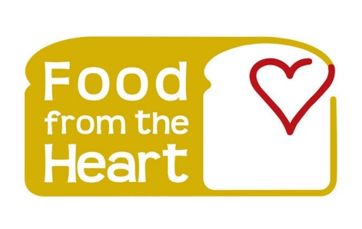

27th April 2020

**FOR IMMEDIATE RELEASE**

**Food from the Heart launches a ’Stop the war on food waste campaign’ to limit food waste**

Our ‘Stop the war on food waste’ campaign will target adults aged 18-24 and will take place in October, November, and December. Our campaign aims to develop a negative attitude towards wasting food and ensure that our audience thinks twice before wasting food. The campaign encourages our audience to create meal plans, and develop conscious eating, spending and ordering habits and not be guided by impulse. We also aim to encourage hotels, restaurants, and hawker centers to adopt food minimization techniques that we suggest.

In 2016, 791,000 tonnes of food waste was generated in Singapore (10% of the total waste). Only 14% of food waste was recycled, and the rest was disposed of at waste-to-energy incineration plants. Results from the Electrolux Food Waste at Home Survey conducted in September 2017 showed that Singaporeans aged 18-24 were more wasteful than Singaporeans aged 45-54. Survey results also showed that women are considered more confident about food waste prevention than men. It also found that 69% of respondents claimed to be ‘passionate foodies,’ but only 41% of this group think about food waste occasionally. 84% of people felt shocked, angry, or guilty over Singapore’s overall food waste, while 10% felt indifferent about it. 20% would never eat food that is past its indicated date, which leads to a lot of food wastage. Each household throws away about $170 worth of food and beverages. On average, in a year, the food wasted by all of Singapore households totals to $200 million. Twenty-three percent of people surveyed throw out leftovers simply because they do not like the idea of eating them. This must change. In 2010, research was conducted by a group of Nanyang Technological University undergraduates. In a survey of 174 Singapore residents, it was found that 6 in 10 purchase more than what they need while shopping for groceries, leading to an over-stocking of food that is likely to expire or spoil before consumption. The survey also revealed that 70 percent would discard edible food that has passed its “use by” date by one to three days.

By collecting a day’s worth of food waste from 150 families staying in HDB flats, condominiums, and landed properties, the survey found that the average household food waste per person per day was 126g. Multiply that by Singapore’s population size, and you get a whopping figure of over 700 tonnes of food waste coming from home kitchens every day. Food waste output has increased by 30% in the last decade in Singapore. Food waste ranks as the 5th most common type of waste in Singapore. An estimated 763,000 tonnes of food waste was generated in 2018, which is equivalent to the weight of 54,000 double-decker buses. An estimated 26,000 tonnes of food is thrown away in households before it is even cooked. An average of $258 worth of food is wasted per household annually, and the value of food wasted per year averages $342 million, which equates to 68,400,000 plates of Nasi Lemak. One-third of respondents from an NEA survey throw out more than 10% of food weekly.

We will encourage hotels to put a limit on how much food each person puts on their plate because people tend to take a lot of food and sometimes waste it. We will also encourage restaurants and cafes to introduce different portion sizes on their menu, so customers do not waste food because often portion sizes for a single person are large.

We will develop an app which will involve a challenge- If people waste less than 5 kg of food in a day over three months (October, November, and December), which is also the entirety of our campaign, they will be rewarded with NTUC vouchers worth $30 each. People must diligently feed the amount they waste into the app, and it will keep a record of this. The app will have a system to measure the amount of food a person wastes. We will collaborate with the National Environmental Agency (NEA) to develop this app since they have the technology and resources to create an app that can weigh food.

We will have our volunteers go door to door in different neighborhoods in October, November, and December and give residents brochures/pamphlets and educate them about the issue of food waste and its impact on society and promote our campaign to tackle food waste. Our volunteers will also collect leftover food from households. We will have NEA set up a collection point at each community center for residents in those neighborhoods to give their leftover food for recycling. We can visit houses in Singapore and ask people for food waste or extra food for the homeless. After this, we can ask them to visit our website, which will have activities they can engage in and gifts if they donate food. Gifts can also be given if creative solutions are given to reduce food waste. We can mainly focus on social media. We can give out vouchers as well. Now, due to the virus situation, people face unemployment and need money to buy food. We can collect extra food from others and give those people a gift if they want to join us in this campaign to help poor people. We can focus on students and give them a gift like a voucher if they give us their food waste.

Booths and stalls will be set up in different parts of Singapore in the second and third week of December, like in malls where children will be able to participate in fun games and contests which will be based on the topic of food waste and it will help educate kids about this issue and promote our campaign. Based on the results of these games, children will have an opportunity to spin a wheel and win exciting prizes. This game does not only attract players but also conveys knowledge to the children. These stalls and booths will be set up throughout December.

We will hold workshops for food waste in schools and offices in slots in October and November to educate people about food waste in Singapore and how they can play a part in solving the problem. Community Centres can be key areas where we spread messages about our campaign. These messages will be spread throughout October, November, and December.

As part of our fundraising event, we will organize a marathon in the second week of November and have a charity event with socialites, celebrities, and influencers. We will also partner with a few social media influencers to help promote our campaign and spread our message across. (they can post for us on their socials and tag us, and maybe they could provide a link for a donation or say ‘check out their page to know more about what they do’ or ‘please help them with their cause, they are doing incredible work’) Some influencers we have enlisted for this purpose are Preetiplease and YOLO.

We will go on a radio talk show and talk about our campaign to ensure that we reach out to audiences on traditional media platforms in the first week of October. We will also do a collaboration video with famous YouTuber Ryan Sylvia in the third week of October.

We will aim to involve around 250,000 adults aged 18-24 in a TikTok challenge involving humor-based videos, where the last spoon of food eaten by a person is depicted in a comedic way, after which that person tags another person (could be a friend or a family member), who must repeat the same action humorously. This challenge will take place over three months to raise awareness about food waste, promote anti-food waste messages and encourage people to donate their excess food to others rather than wasting it and we will provide incentives like NTUC vouchers and bubble tea discounts to ensure that our target audience (adults aged 18 to 24) reduces food wastage over three months.

“Food from the Heart’s Stop the war on food waste campaign aims to help people create meal plans and take steps to purchase fixed quantities of food at a time to prevent wastage,” says chairman Ronald Stride in a statement.

"A food waste reduction hierarchy involves feeding people first, then animals, then recycling, then composting. It serves to show how excess food can be used productively, instead of contributing to leachate and methane formation in landfills," says Treasurer Khushroo Dastur.

“We need to make sure that people stop wasting food because food insecurity is on the rise, and the impact on people’s lives and the environment is disastrous,” says Senior Board Member Linda Soo-Tan.

In Singapore, where the lack of land prevents us from quickly discarding wasted food into landfills, more money has to be invested into constructing incinerators, which are both costly and contribute to air pollution, which may then incur even more cost to treat the pollutants produced from burning food waste before they are released into the air (Begum, Shabana 2019) Hence, wasting food is a very costly phenomenon. It should be avoided in the first place. The global food system is responsible for up to one-third of all human-caused greenhouse gas emissions, making it one of the most significant contributors to climate change, according to the Consultative Group on International Agricultural Research. When food is wasted, more food has to be sourced to meet the food demand, and this affects our food security since Singapore imports over 90% of our food supply. An increasing amount of food waste puts pressure on our resources (Begum, Shabana 2019). We will need to build more waste disposal facilities, such as waste-to-energy plants and landfills, for incineration ash. This is not sustainable for land-scarce Singapore. This increases our carbon footprint, contributing to global warming and climate change (Begum, Shabana 2019).

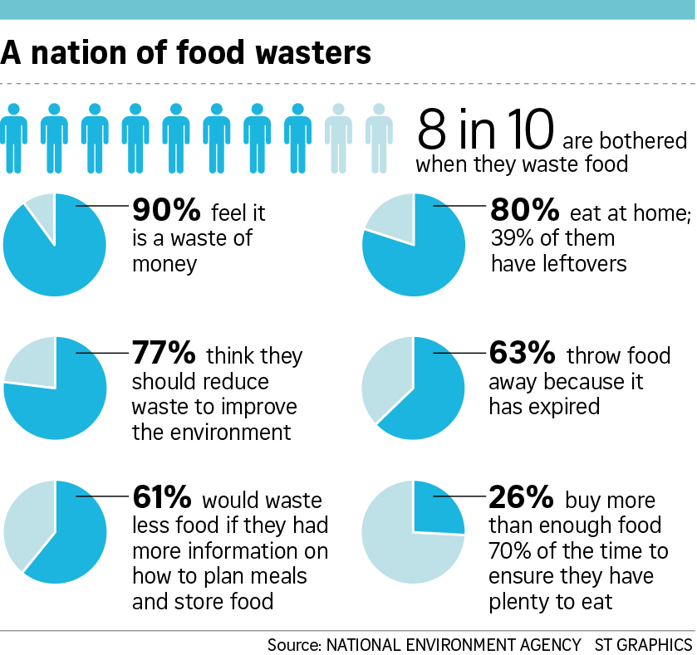

**Above: Results from an NEA survey on Food Waste**

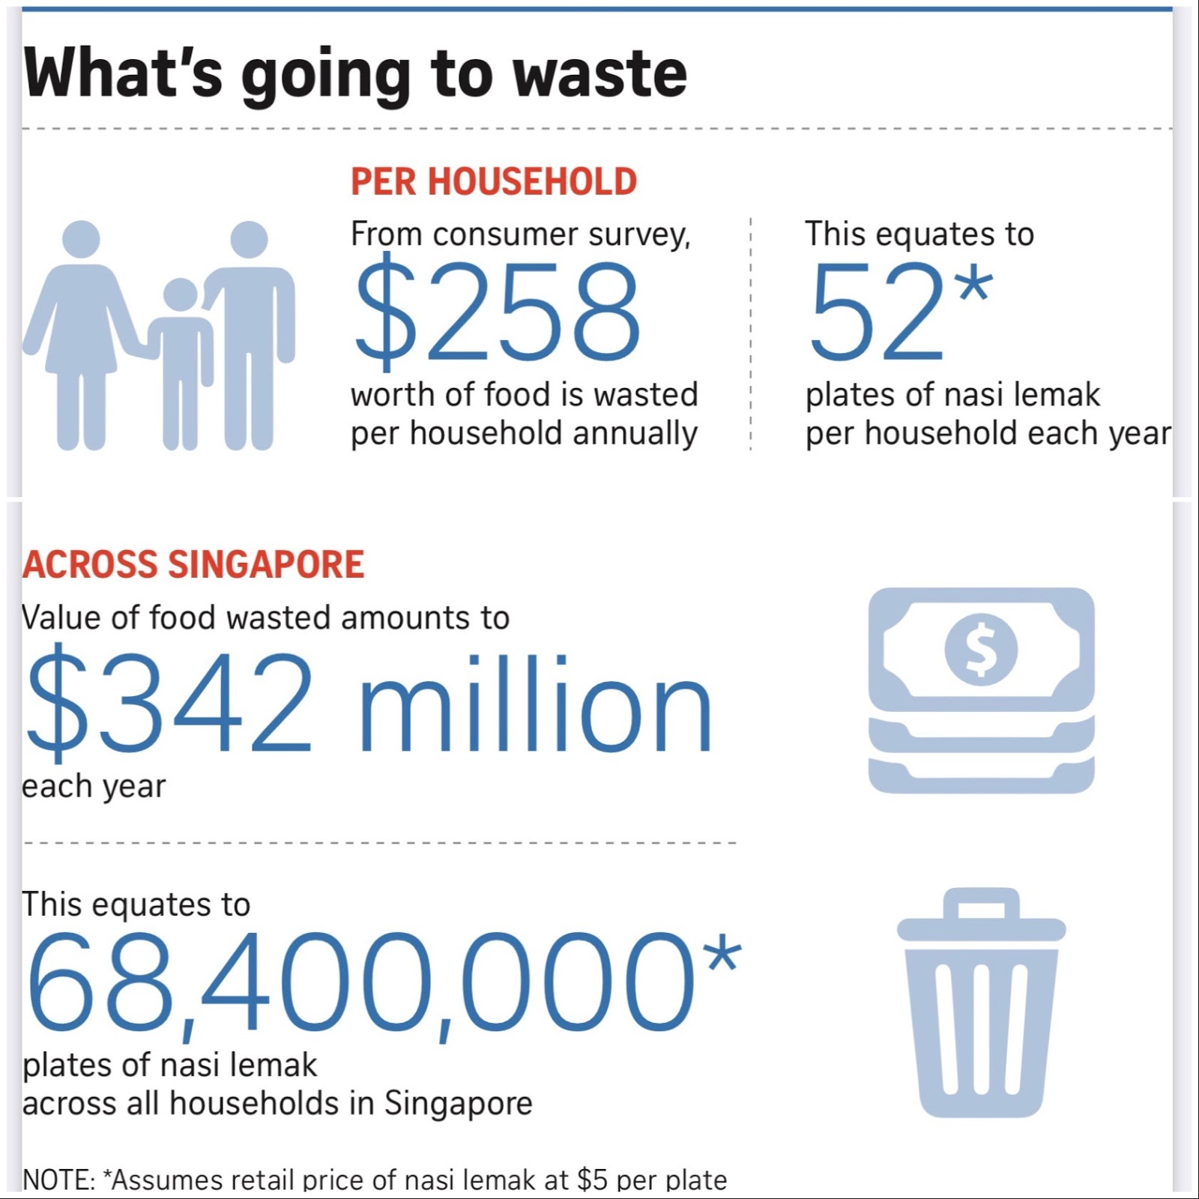

**Above: Food waste in Singapore**

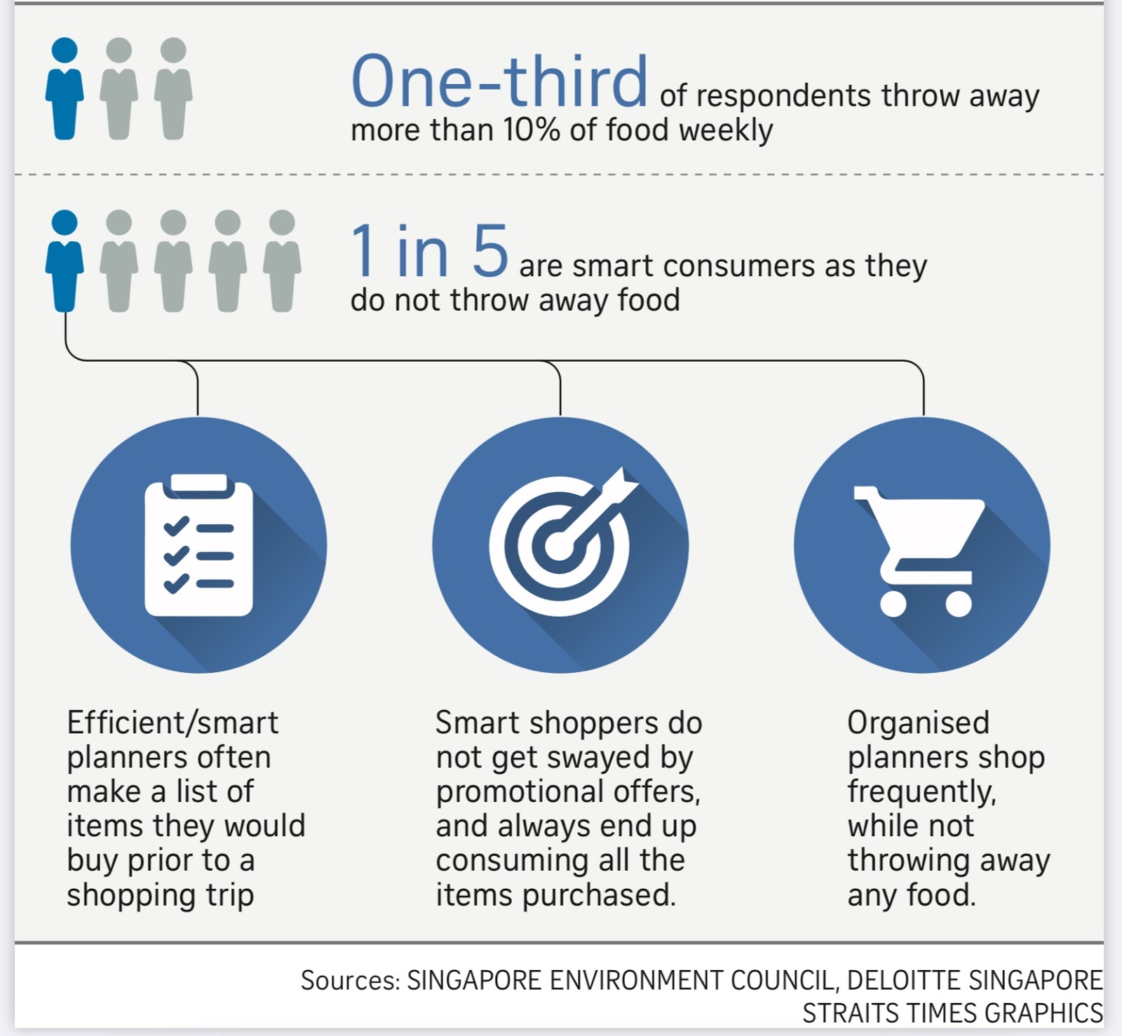

**Above: How to be smart consumers of food and reduce wastage**

**About Us**

Food from the Heart is a non-profit organization that fights food waste. It was established in February 2003 after Singapore-based Austrian couple Henry and Christine Laimer read a report in The Sunday Times about bakeries discarding their unsold bread. Stirred, they then decided to channel surplus food from bakeries to those in need instead of wasting it. Food from the Heart started with 120 volunteers in 2003. As at the end of 2019, our volunteers multiplied to over 10,000, and together we reached 44,600 beneficiaries across Singapore.

Today, Food from the Heart is Singapore's leading independent food waste reduction NGO with an IPC status that makes a tangible and meaningful contribution to fighting hunger through food waste reduction efforts.

To reach struggling individuals and families in Singapore, Food from the Heart encourages people to donate leftover food to the underprivileged and show them that they are cherished too. With sharing hope and healthy lives in mind, the support of donors, food industry partners and more than 1,700 regular volunteers, Food from the Heart made a difference to the lives of more than 44,600 people throughout Singapore by reducing the weight of food wasted to 500 tonnes in 2019 from 700 tonnes in 2018.

**For media enquiries, please contact:**

**Alex Chua:**

**Ph:** 6280 4483

**Email:** [alexchua@foodheart.org](mailto:alexchua@foodheart.org)

**Andy Kuek:**

**Ph:** 6348 4498

**Email:** [andykuek@foodheart.org](mailto:andykuek@foodheart.org)

**For general enquiries, please contact:** [info@foodheart.org](mailto:info@foodheart.org)

Address: 130 Joo Seng Road, #03-01, Singapore 368357 (Formerly Olivine Building)

Opening Hours: 9 am - 6 pm, Mondays to Fridays (Excluding Public Holidays)

Facebook: <https://www.facebook.com/foodheart/>

Instagram: <https://www.instagram.com/foodfromtheheartsg/>

Youtube: <https://www.youtube.com/channel/UCY4yYGZK1DMJHec_D_v7Oqg>

More information can be found on our website: <https://www.foodfromtheheart.sg/>

**BACKGROUNDER**

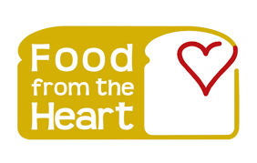

**Overview**

Food from the Heart is a non-profit organization that feeds the needy through its anti-food waste program. It was established in February 2003 after Singapore-based Austrian couple Henry and Christine Laimer read a report in The Sunday Times about bakeries discarding their unsold bread. Stirred, they then decided to channel surplus food from bakeries to those in need instead of wasting it. Food from the Heart started with 120 volunteers in 2003. At the end of 2019, our volunteers multiplied to over 10,000, and together, we reached 44,600 beneficiaries across Singapore.

**Our Vision**

To be the leading non-profit in Singapore devoted to tackling the issue of food waste through our food distribution program and food recycling.

**Food from the Waste Target Markets**

1. **Cafes and restaurants**
2. **Households**
3. **Hotels**

|  |
| --- |
| **HEADQUARTERS**  130 Joo Seng Road #03-01 Singapore 368357  **Main sponsors:**  Official Community Food Pack Partner (2017 - 2021) Images in Motion  Official Logistics & Transport Partner (2017 - 2019) Goldbell Foundation  Marketplace Partner NTUC FairPrice Co-operative Pte Ltd  Provision and Distribution of Eggs for Community Food Pack Programme |

**Ronald Stride,** *Chairman of the board*

**Sim Bee Hia,** *Chief Executive Officer*

**Khushroo Dastur,** *Treasurer*

**Knut Unger,** *Secretary*

**Alex Chua, Chin Bottinelli, Andy Kuek,**

**Eugene Yang, Linda Soo-Tan, Mahesh Buxani,** *Senior Board Members*

**Christopher Martin**, *Advisor*

**Food from the Heart Solutions**

We encourage hotels, restaurants, hawker centers, and cafes to adopt food waste minimization techniques and be conscious of how much food they produce. Restaurants and cafes waste a lot of food, and customers tend not to finish their food because their portion sizes are too big most of the time.

We encourage households to be more mindful of their cooking and eating habits. We encourage people not to over-order food when ordering in.

We encourage hotels to limit the amount of food served in buffets and quantities served in dishes. When hotels provide food to guests, they need to know the number of people and prepare the right amount of food.

**The Food from the Heart Advantage**

We are one of the most transparent food waste reduction NGOs in Singapore, providing sustainable help, and we have obtained an IPC-status. We have developed an extensive network of synergistic partnerships, a sustainable operations model with structured governance, and reliable support, making Food from the Heart’s food programs widely appreciated in Singapore. We are grateful for the warm support of other recognized organizations and individuals who have emerged from their respective fields and professions to join us on our mission to fight food waste. Food from the Heart has also made the most of our unique position to alleviate the hunger of the less fortunate. Moving towards our second decade with the help of over 10,000 volunteers, we were able to provide sustainable food waste minimization techniques to more than 44,600 beneficiaries in 2019.