**PR Campaign Proposal**

**Executive Summary**

‘Stop the war on food waste’ campaign aims to fight the issue of food waste in Singapore and educate people on food minimisation techniques. On average, in a year, the food wasted by all households in the country totals $200 million. According to the Electrolux Food Waste at Home survey, adults aged 18-24 were more wasteful than adults aged 45-54. We have chosen this age group as our target audience because these people can perceive the harmful effects of wasting food and also make up a higher percentage of citizens in Singapore. 23% of people surveyed throw out leftovers simply because they do not like the idea of eating them. This must change. The campaign aims to help our target audience feel strongly about the issue and develop a negative attitude towards it and inculcate smart food purchase, storage and preparation habits and not be guided by impulse. The campaign will run for three months, from October to December.

The increasing amount of food waste puts pressure on our resources, and in Singapore, where the lack of land prevents us from quickly discarding wasted food into landfills, more money has to be invested into constructing incinerators, which are both costly and contribute to air pollution. When food is wasted, more food has to be sourced to meet the food demand, and this affects our food security since Singapore imports over 90% of our food supply. On a local scale, this food waste is a lost opportunity to help feed the food insecure – those who do not know where or when they will have their next meal. When adults do not have consistent access to healthy food, their productivity can drop, their healthcare costs can rise, and in some cases, they could be unable to work due to chronic diseases. This can mean fewer productive people in the workplace, which puts a damper on the economy.

We are going to be organizing several events to help promote our campaign and spread our message. We will have our volunteers go door to door in different neighborhoods in October, November, and December and educate the residents about the issue of food waste and its impact on society. The volunteers will provide them with pamphlets that will contain information on our campaign and how we are dealing with the issue. Our volunteers will also collect leftover food from households for recycling. We will develop an app that will involve a challenge- If people waste less than 5 kg of food in a day over three months (October, November, and December), which is also the entirety of our campaign, they will be rewarded with NTUC vouchers worth $30 each. People must diligently feed the amount they waste into the app, and it will keep a record of this. The app will have a system to measure the amount of food wasted by a person. We will collaborate with the National Environmental Agency (NEA) to develop this app since they have the technology and resources to create an app that can weigh food. Booths and stalls will be set up in different parts of Singapore in the second and third week of December, like in malls where children will be able to participate in fun games and contests which will be based on the topic of food waste and it will help educate kids about this issue and promote our campaign.

**Position:**

**What type of organisation are we?**

**Food from the Heart is an NGO.**

**Our services**

Food from the Heart is a non-profit organisation that fights food waste. It was established in February 2003 after Singapore-based Austrian couple Henry and Christine Laimer read a report in The Sunday Times about bakeries discarding their unsold bread. Stirred, they then decided to channel surplus food from bakeries to those in need instead of wasting it. Food from the Heart started with 120 volunteers in 2003. As at the end of 2019, our volunteers multiplied to over 10,000, and together we reached 44,600 beneficiaries across Singapore.

Today, Food from the Heart is Singapore's leading independent food waste reduction NGO with an IPC status that makes a tangible and meaningful contribution to fighting hunger through food waste reduction efforts.

**What do we do?**

We undertake food waste reduction publicity and outreach programs aimed at educating people on developing food waste minimisation techniques by inculcating conscious eating, spending, and ordering habits.

**Our selected issue:  We have chosen food waste.**

**Current audience and stakeholders**

Our current audience is adults aged 18-24. Results from the Electrolux Food Waste at Home Survey conducted in September 2017 showed that Singaporeans aged 18-24 were more wasteful than Singaporeans aged 45-54. Survey results also showed that women are considered more confident about food waste prevention than men. It also found that 69% of respondents claimed to be ‘passionate foodies,’ but only 41% of this group think about food waste occasionally. 84% of people felt shocked, angry, or guilty over Singapore’s overall food waste, while 10% felt indifferent about it. 20% would never eat food that is past its indicated date, which leads to a lot of food wastage. Each household throws away about $170 worth of food and beverages. On average, in a year, the food wasted by all of Singapore households totals to $200 million. Twenty-three percent of people surveyed throw out leftovers simply because they do not like the idea of eating them. This must change. In 2010, research was conducted by a group of Nanyang Technological University undergraduates. In a survey of 174 Singapore residents, it was found that 6 in 10 purchase more than what they need while shopping for

groceries, leading to an over-stocking of food that is likely to expire or spoil before consumption. The survey also revealed that 70 percent would discard edible food that has passed its “use by” date by one to three days. By collecting a day’s worth of food waste from 150 families staying in HDB flats, condominiums, and landed properties, the survey found that the average household food waste per person per day was 126g. Multiply that by Singapore’s population size, and it comes to a whopping figure of over 700 tonnes of food waste coming from home kitchens every day.

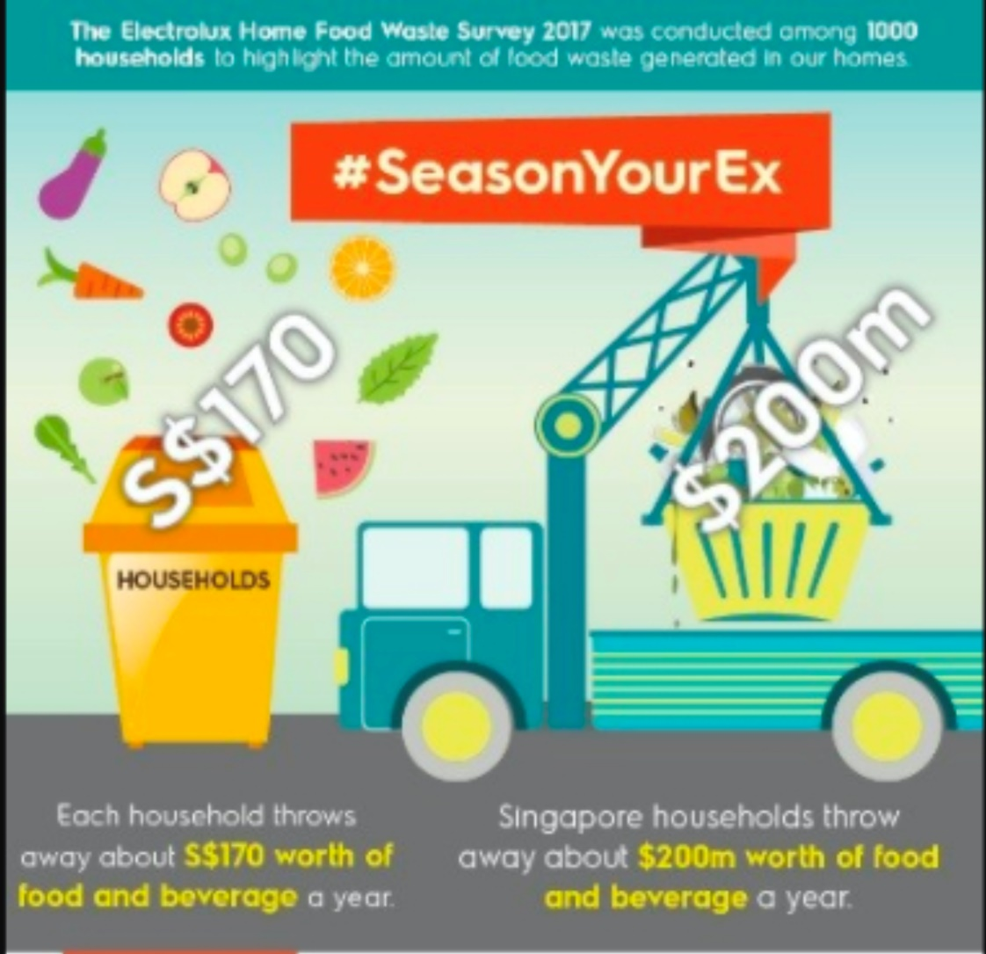

**Above: Results from the Electrolux Survey (1)**

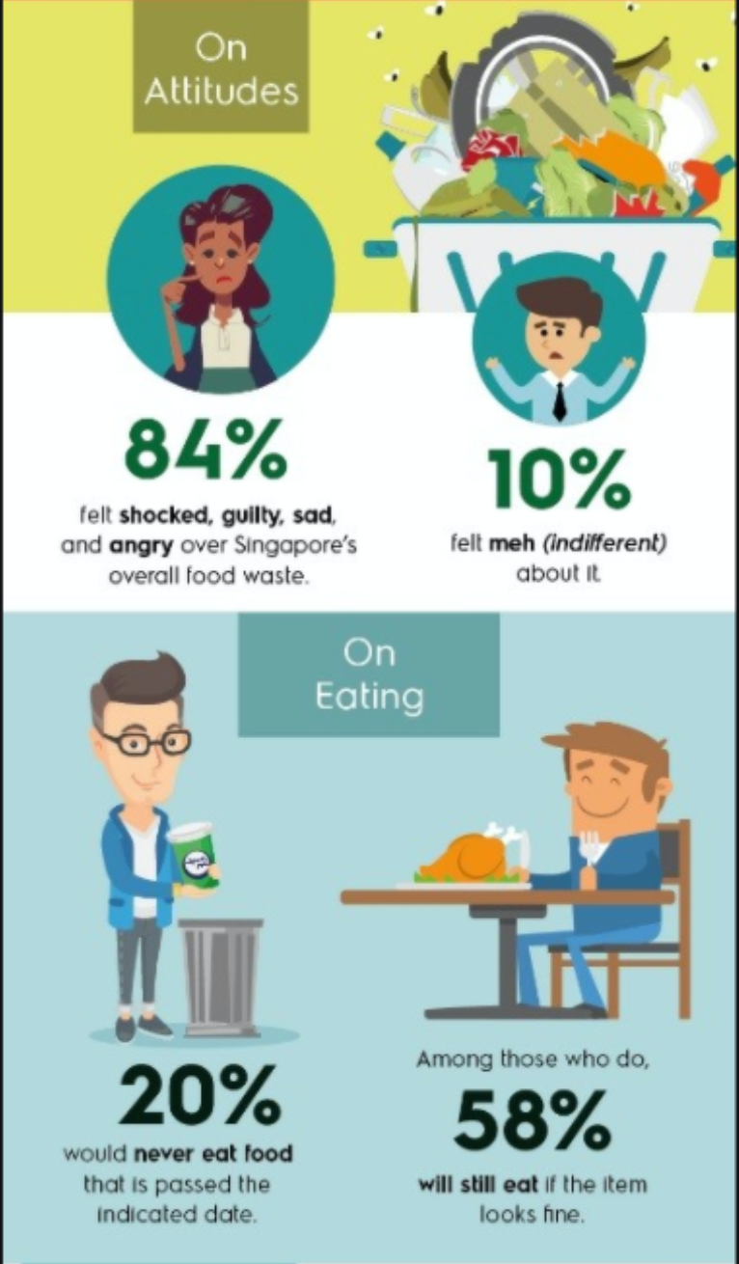

**Above: Results from the Electrolux Survey (2)**

**Trends**

[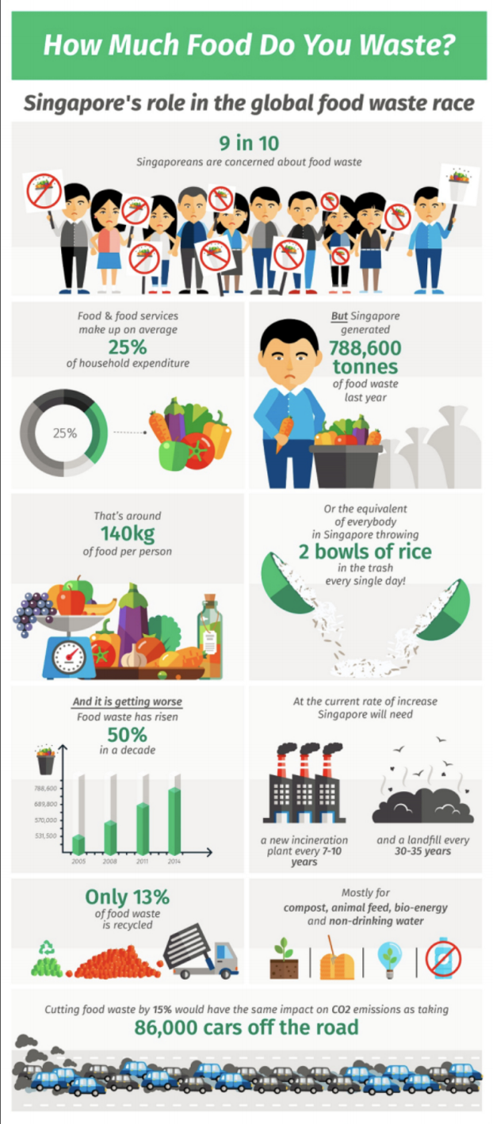](https://www.todayonline.com/lifestyle/food/food-wasting-habits-may-depend-age-and-gender)

**Above: Food Waste Statistics in Singapore**

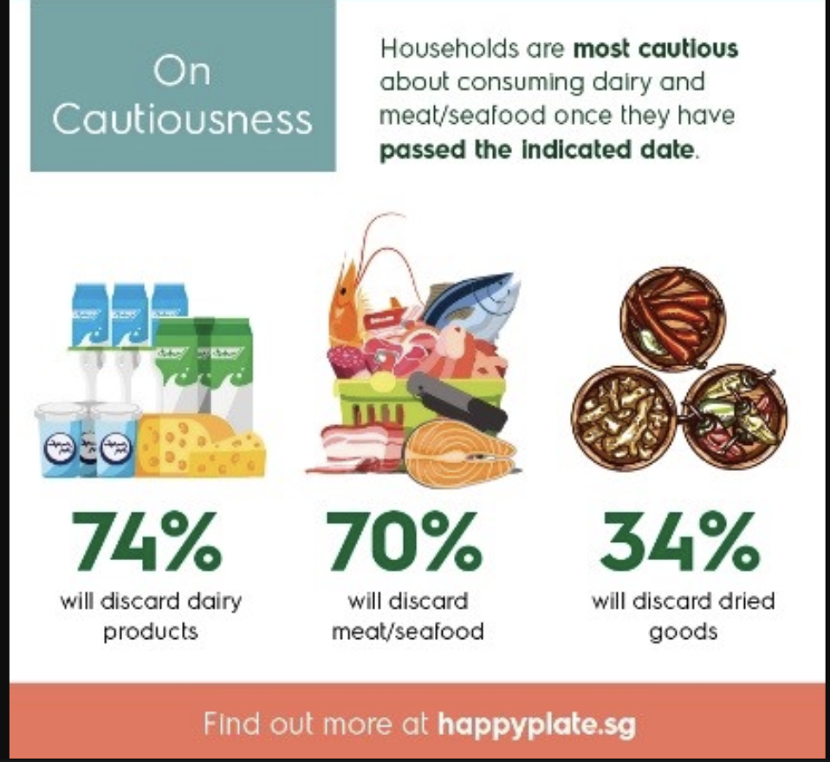

**Above: Percentage of food discarded by households**

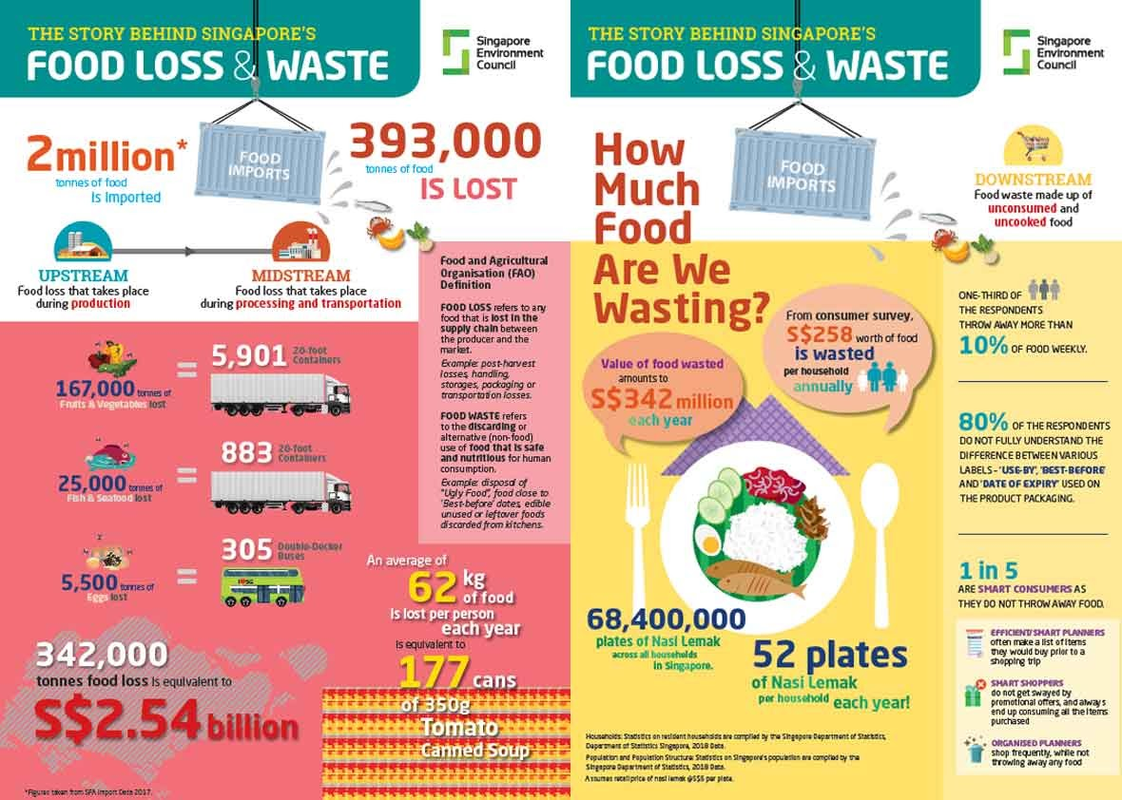

**Above: Food Waste Statistics in Singapore**

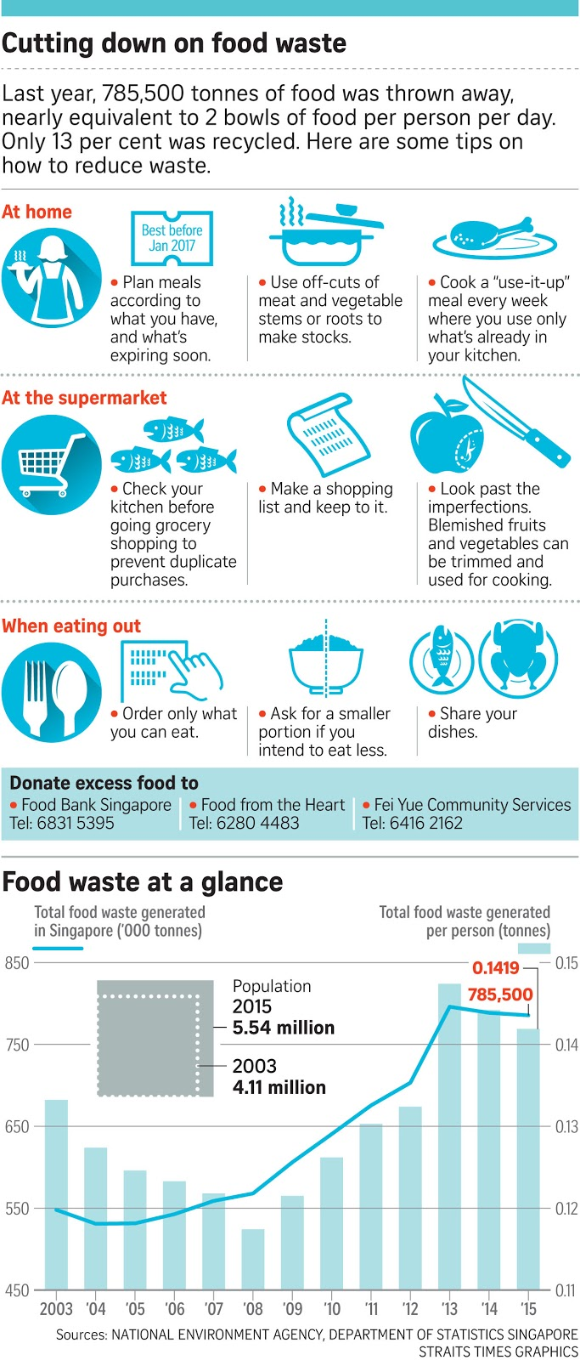

**Above: Methods to reduce food waste.**

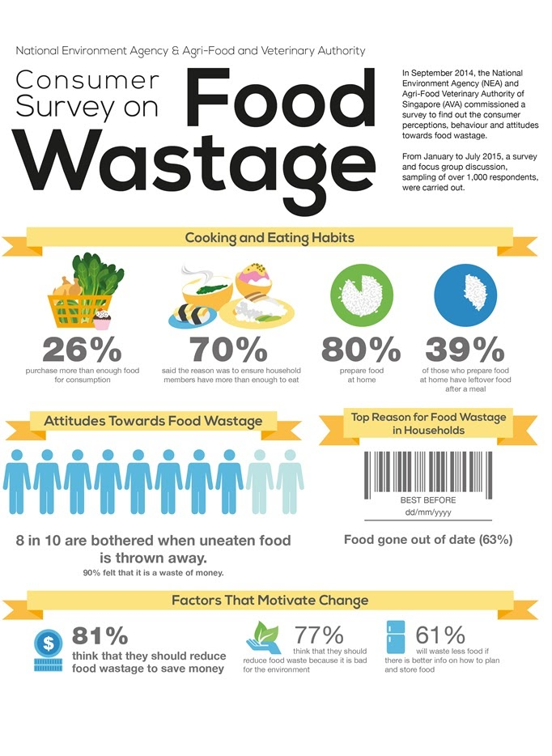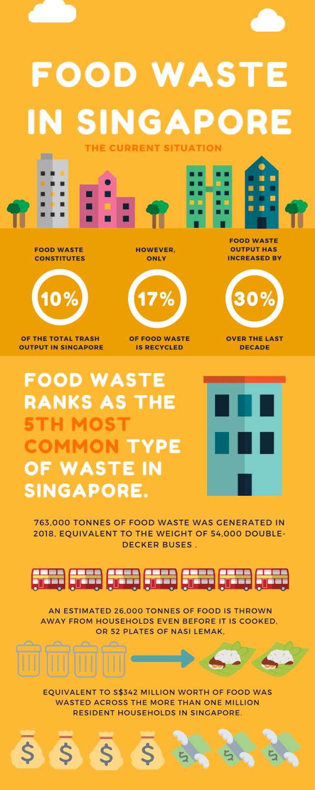

**Competition- Similar campaigns:**

1. **Zero Waste SG:** Zero Waste SG is a new non-profit and non-governmental organization dedicated to helping Singapore eliminate the concept of waste, and accelerate the shift towards zero waste and the circular economy. It started as a website in 2008, providing tips and resources on waste minimization and recycling and is officially registered as a non-governmental organization on 13 Jul 2015. Zero Waste SG aims to promote education and engagement on the 3Rs (Reduce, Reuse, and Recycle) among individuals and households; increase waste minimization and recycling among businesses and organizations, and reduce specific waste. They aim to educate and engage people using campaigns and activities, influence policies with research, surveys, and reports, collaborate to drive change with initiatives and agreements, and solve market problems with technology and social media platforms.
2. **Save Food Cut Waste:** Save Food Cut Waste is a non-profit and non-governmental organization that helps Singapore accelerate the shift towards zero waste and the circular economy. This is a ground-up movement involving educating individuals, businesses, and organizations in Singapore about the environmental and social impacts of food waste and encouraging everyone to take action in reducing food waste. Food waste is created in Singapore every single day from our food cycle production and distribution. The wastage is unfortunately due to several reasons, such as food spoilage due to improper storage or handling, and edible food is thrown away because it does not look nice or has ‘expired,’ discarded food or leftovers during cooking and when we cannot finish our food among others. Therefore, this campaign tries to reduce food waste as much as possible.

**PESTLE Analysis**

**Political**

1. If we keep increasing our waste and dumping it into a landfill at today’s rate, we will run out of space by 2025. Keeping this in mind, by 2025, Singapore will have a co-located, solid waste management system that will help produce water and sludge, which in turn, will produce biogas. This biogas will help prevent the usage of electricity from the grid (CNA, 2019).
2. The government is trying to build areas in malls that handle food waste to produce compost. This solution aims to save transportation costs considerably. The government has done a pilot in Tampines Hub, which produces one ton of food waste a day. With such a large amount of food waste, using this process, they generate 70 kilograms of compost. The advantage of this is that they only need to track one load of garbage a day instead of four. Moreover, food waste is contained in these machines to produce compost (CNA, 2019).
3. The National University of Singapore is one of the participating universities in the government’s scheme, where food waste is segregated for treatment under the project. The process of food segregation is not complicated because when we collect our food from various vendors and when we finish our meal, there is a return point for us to segregate our waste into general waste, liquid waste, and food waste before we return our used cutlery to another station. The food waste is then transported to a facility (CNA, 2019). This facility involves an anaerobic digestion process that produces biogas, which can be used for energy generation.

**Economic**

1. The National Resources Defense Council estimates that each year, the average American family of four throws away about $1,500 worth of food. Globally, one-third of all food is never consumed – from farmers or manufacturers discarding unusable items to grocery stores tossing unsold or rotten produce, to consumers throwing away unused food (Teshome, Mekael 2017).
2. Globally, people waste about $1 trillion of food each year, with a total economic impact of about $3 trillion each year if environmental and social costs are taken into consideration, such as deforestation, soil erosion, increased greenhouse gases, water scarcity, exposure to chemicals and reduced profits for farmers (Teshome, Mekael 2017).
3. Food waste also drives up prices, reducing the number of people who can afford the healthy food they need. On a local scale, this food waste is a lost opportunity to help feed the food insecure – those who do not know where or when they will have their next meal (Teshome, Mekael 2017). When adults do not have consistent access to healthy food, their productivity can drop, their healthcare costs can rise, and in some cases, they could be unable to work due to chronic diseases. This can mean fewer productive people in the workplace, which puts a damper on the economy.
4. The stakes are even higher when children do not have access to the healthy food they need. Food insecurity can influence their physical development and ability to learn (Teshome, Mekael 2017). This can have a lasting impact on their adulthood and that child’s ability to participate in the workforce.

**Social**

1. As most of waste food items are still edible upon the time of discarding, this raises an ethical question about wasting food. Although the numbers have fallen over the past decade, many still live with extreme hunger today. This includes people living in the backyards of the rich, as hunger and malnutrition can also be found in developed countries such as the US and the UK (Elangovan, Navene 2020).
2. Theoretically speaking, this phenomenon can be avoided if food is more evenly distributed between the rich and the poor, especially since the excess food that can feed the poor simply goes to waste and landfills. This further exacerbates the divide between the rich and the poor, resulting in severe social inequity that will have to be addressed by the government (Elangovan, Navene 2020).
3. Although there are no official statistics in Singapore, a Community Food Survey conducted by Food for All, an anti-hunger youth group back in 2009, found that about 12,000 households in Singapore relied on supplementary food rations that year, and the numbers were still increasing. For a country that is so used to prosperity and luxury, this was indeed a shocking finding! This social inequity will pose a challenge for us and future generations to overcome as it is easy to discuss reducing food waste and redirecting excess food to the hungry. However, the implementation phase is often tricky as it is commonly faced with many obstacles, such as policy regulations and health concerns (Elangovan, Navene 2020).

**Technological**

1. Manufacturers have been waxing fruits and vegetables to improve their shelf-life since the 1920s, but California-based company Apeel has taken the concept to new levels. Apeel’s invisible, edible coating is made from wasted agricultural products like leftover grape skins from wine production. Apeel’s coating can extend the shelf life of fruits and vegetables by five times (Mouysset, Christian 2019).
2. Neurolabs reduce food waste by accurately predicting demand with AI. Winnow Solutions’ products aim to solve that problem by allowing kitchens to monitor their waste (Mouysset, Christian 2019). Their latest update to the product is intriguingly named ‘Vision’ and consists of a weighing scale and an AI camera equipped with computer vision algorithms. It records the weight and the type of food as it is thrown (for example, 30g of steak and 500g of fries).
3. A staff member then selects an option from a touch-screen on the wall above to indicate the reason for the waste (for example, kitchen error or a customer complaint). The result is data; if it is used well, it can cut food waste in half. Olio is a free app that connects neighbors to flag up and share surplus food. Users just upload a photo and description, then people in the neighborhood can claim the food before it is wasted. They are now the biggest food-sharing network in the world, with over 450,000 users. Bluapple is a blue, apple-shaped product that sits in your refrigerator and absorbs ethylene gas, allowing consumers to store fresh produce for longer. It lasts for three months before it needs a refill, and is capable of extending produce shelf life by up to three times (Mouysset, Christian 2019).

**Legal**

1. A law to better regulate food waste was legislated in 2019 in Singapore. Singapore planned to make 2019 a " zero food waste" year. "We had hoped that the master-plan would align the 3P (private, people, and public) sectors and the research and development community towards a common vision of a Zero Waste Nation," said Dr. Khor (Teh, Cheryl 2019).
2. More will also be done to reduce and reuse e-waste locally, such as the Extended Producer Responsibility Framework scheme, which will come into effect in 2021. Mr. Louis Ng (Nee Soon GRC) and Ms. Cheng Li Hui (Tampines GRC) had, during the debate on the Ministry of the Environment and Water Resources' budget, seeking more details on the scheme. Dr. Khor also said the framework would make producers of products financially and physically responsible for the end-of-life collection and treatment of these items  (Teh, Cheryl 2019).
3. "We have no plans to bring the start date of the framework forward, as industry feedback has highlighted that both producers and recyclers need sufficient time to adjust," she said. She added that the framework would apply to electrical and electronic equipment, which are categorised as information and communication technology equipment, batteries, lamps, solar panels, and large appliances. It will also include mobility devices, such as e-scooters and power-assisted bicycles. "Almost 90 percent of e-waste in Singapore will be covered," she said. Environment and Water Resources Minister Masagos Zulkifli hoped food waste could be processed in homes without the need to transport it across the island to be composted or disposed. "I look forward to the day when our stores carry home food digesters that are compact, economical, and easy to use, to convert our food waste into compost to grow plants and even food at home," he said. "This also reduces the need to transport food waste across the island, and keeps our waste system free from pests," he added  (Teh, Cheryl 2019).
4. The conversion of food waste to compost, nutrients, and biogas will also take place in Singapore. With the new Act, it will be compulsory to segregate food waste for treatment. In 2018, food waste comprised one-fifth of Singapore’s total waste. However, only 17 percent of food waste was recycled. From 2021 onwards, it will be mandatory for developers of upcoming commercial premises such as shopping malls and hotels to allocate space for on-site food waste treatment systems in their design plans. Large commercial and industrial generators of food waste are required, under to treat food waste 2024 onwards. In doing so, food waste will hopefully be processed into useful compost, nutrients as well as biogas which can be used again for agriculture and fisheries (Teh, Cheryl 2019).
5. Nevertheless, the best way to reduce food waste is not to overproduce or over-order on the consumer end. Besides the Resource Sustainability Act, the government is also investing in research and development to improve our waste management infrastructure (Teh, Cheryl 2019).

**Environmental**

1. In Singapore, where the lack of land prevents us from quickly discarding wasted food into landfills, more money has to be invested into constructing incinerators, which are both costly and contribute to air pollution, which may then incur even more cost to treat the pollutants produced from burning food waste before they are released into the air (Begum, Shabana 2019)
2. Hence, wasting food is a very costly phenomenon, and should be avoided in the first place. The global food system is responsible for up to one-third of all human-caused greenhouse gas emissions, making it one of the most significant contributors to climate change, according to the Consultative Group on International Agricultural Research. When food is wasted, more food has to be sourced to meet the food demand, and this affects our food security since Singapore imports over 90% of our food supply. An increasing amount of food waste puts pressure on our resources (Begum, Shabana 2019).
3. We will need to build more waste disposal facilities, such as waste-to-energy plants and landfills, for incineration ash. This is not sustainable for land-scarce Singapore. This increases our carbon footprint, contributing to global warming and climate change (Begum, Shabana 2019).

**SWOT Analysis**

**Strengths**

1. The presence of the organization in different parts of Singapore is one of the significant strengths of the organisation. It determines the business’ reach to the target market and ensures easy accessibility. The organisation can expand its customer base and offset the losses from specific campaigns with benefits obtained from other campaigns.
2. A robust online presence on different social networking sites and efficient social media management can enhance the organisation and develop strong relationships with customers. A strong financial position brought about through donations and health can allow the firm to make further investments. If the organisation gains access to suppliers that offer raw material at a lower cost, it can help improve overall efficiency.
3. The locational advantage can improve the competitive positioning of the firm in various ways, such as lower cost, improved accessibility, or an enhanced brand image. Well-developed and efficiently integrated IT infrastructure can improve operational efficiency and help the organisation gain knowledge about the latest market trends. Competent and committed human capital can act as an authoritative source of competitive advantage, particularly for food-related organizations.
4. High customer engagement increases brand loyalty and improves Food from the Heart’s strategies to tackle food waste. Workplace diversity can also act as a significant business strength. Horizontal and vertical integration can increase control over the whole value chain, resulting in improved access to raw materials and quick product delivery.

**Weaknesses**

1. The organisation may lose efficiency due to its poor inventory management practices.
2. The shortage of or an excessive amount of inventory can either result in cash shortages or insufficient current assets, negatively affecting the liquidity position and harming the overall business performance.
3. An insufficient budget for marketing and promotion activities weakens the organization’s ability to expand its customer base and encourage repeat purchases. Less expenditure on the research and development activities can weaken the organisation’s performance due to poor local market knowledge.
4. Poor project management practices can internally weaken the ability of the organisation to reach their goals successfully. The misalignment between the organization's leadership style and its core strategic objectives can make the business organisation directionless. Organizational culture also becomes a significant internal weakness when it does not align with the strategic objectives.

**Opportunities:**

1. A key underlying theme in food waste is the speed in the supply chain, particularly in the developing countries, where the lack of sophisticated road networks delays the distribution time. This, combined with the hot tropical climate, cause food to perish faster, creating opportunities for both packaging and food transportation companies to innovate solutions that help food to last longer in the face of infrastructural deficiency and less suitable weather conditions.
2. Tetra Pak introduced a form of packaging with an embedded chip to show signs of spoilage and the duration the package has been outside the refrigerator. This makes the product exciting and useful, helping to boost revenue prospects. Nevertheless, such innovations could be expensive for developing countries, leaving more scopes for affordable packaging innovations.
3. There are opportunities for pesticide and fertilizer companies to prevent crop damage and increase the production yields – however, the environmental implications need to be taken into consideration for these. General Mills is working on technological innovation to use tomato skins and seeds as the primary source of nitrogen to boost the yield for tomato growers. There are opportunities for companies working in the agricultural fields to introduce affordable techniques and devices to farmers in developing countries that can help to reduce waste during the harvesting process. Solar dryers are devices used by African farmers to dry cocoa beans at the right moisture level for the international manufacturers. Cold storage facilities in developing countries have strong prospects given food can be stored over a more extended period while they are being supplied to the market in batches in line with consumer demand.
4. Food waste can be converted to energy, which is more environmentally friendly, although this is further down the line while the immediate objective of food loss and waste is to narrow the gap between food production and global hunger. Niche initiatives are emerging, which can contribute to reducing food waste. VeggiDome is a transparent container for fresh vegetables that resembles a cake stand with a dome-like lid. It can be placed on dining tables, making the vegetables more visible. The container has an inbuilt technology that helps to keep the vegetables fresher for a more extended period, which may have otherwise wilted in the obscurity of the refrigerators.

**Threats**

1. Farmers have increasingly invaded forests in search of more fertile land, which has led to the loss of biodiversity by slash burning, deforestation, and conversion of forests into farmlands, which have destroyed the natural habitats of birds, fish, mammals, and amphibians. The mass rearing of livestock for consumption and the use of pesticides in crop production has also significantly contributed to nitrogen, phosphorus, and chemical pollution in streams, rivers, and coastal waters, thus affecting marine life. According to research, the produced but unconsumed food accounts for approximately 1.4 billion hectares of land, constituting almost 1/3 of the planet’s agricultural land. The world is wasting 30 percent of the world’s fertile land, which could be used for other meaningful purposes such as environmental research. The volume of water used in agricultural food production is immense, and if 30 percent of all the food produced goes to waste, then it means that more than 30 percent of freshwater used in the production and processing of food also goes to waste. This contributes to the blue water footprint, which refers to the amount of consumed surface and groundwater resources (Groundwater depletion is a serious threat to the environment) that goes to waste.
2. The food produced, which later goes to waste, is estimated to be equivalent to 3.3 billion tons of greenhouse gas emission, accelerating the impact of climate change. Research has also shown that food waste is the third biggest emitter of greenhouse gases. The reason for this is the energy wasted and the primary use of fossil fuels in food production, including processing and cooking, together with transportation to various consumer markets worldwide. The methane gas produced in landfills by food thrown away as waste further aggravates climate change and global warming. Economic consequences- In addition to environmental impacts, food wastage also results from indirect economic costs. According to FAO’s report estimates, the economic losses associated with food wastage is about 750 billion dollars per annum.

**Objectives**

**Output**

To put out 30 posts on Instagram targeting 250,000 adults aged 18-24 over three months to educate people about food waste, promote anti-food waste messages, and encourage people to donate their leftover food or excess food to those in need, such as low-income households and migrant workers, rather than wasting it.

To put out 200,000 hashtags on Twitter targeting 250,000 adults aged 18-24 over three months to educate people about food waste, promote anti-food waste messages and encourage people to donate their leftover food or excess food to those in need, such as low-income households and migrant workers, rather than wasting it. We will have two hashtags #NoFoodWaste and #EndHunger.

To put out 20 posts on Facebook reaching out to 250,000 adults aged 18-24 over three months to educate people about food waste, promote anti-food waste messages and encourage people to donate their leftover food or excess food to those in need, such as low-income households and migrant workers, rather than wasting it. We will have two hashtags #NoFoodWaste and #EndHunger.

To involve 250,000 adults aged 18-24 in a Tik Tok challenge involving humor-based videos, where the last spoon of food eaten by a person is depicted in a comedic way, after which that person tags another person (could be a friend or a family member), who must repeat the same action humorously. This challenge will take place over three months to raise awareness about food waste, promote anti-food waste messages, and encourage people to donate their excess food to others rather than wasting it.

**Out-take**

On Instagram, we will have influencers and celebrities that can post about our NGO and our campaign, as well as tag their fellow celebrity friends to join them in supporting us. This way, we can ensure that we meet our target of reaching beyond our target audience of 250,000 and spread our message across.

Informative posts about food waste, and our campaign will be put out on Facebook to target older generations. Incentives like NTUC vouchers can be given as a reward for not wasting food.

We would like to change people’s bad habits. We encourage people to cook only when they are hungry and regulate the quantity they cook. We would like to raise awareness about supermarket quantities.

To increase awareness on Twitter through hashtags about food wastage and provide incentives like NTUC vouchers and bubble tea discounts to ensure that our target audience (adults aged 18 to 24) raises their awareness about food waste by 25% over three months. Hashtags related to the app challenge (least amount of food waste over three months) will be put out.

To increase awareness by 25% through our TikTok challenge about food wastage and provide incentives like NTUC vouchers and bubble tea discounts to ensure that our target audience (adults aged 18 to 24) reduces food wastage over three months.

We would like to ensure that the marathon is a great success and try to get 50,000 people to take part and gain awareness about our campaign and food waste.

Our app challenge will involve the participation of 100,000 people. We predict that 34% of people will complete our app challenge.

Our YouTube collaboration video will result in a 50% increase in awareness about our campaign and food waste. Our radio appearance will result in a 40% increase in awareness about our campaign and food waste.

Door to door volunteers will help raise awareness about proper food waste management by 10%. Workshops in schools and offices will raise awareness by 45% about redistributing leftover food instead of wasting it, and efficient food waste management practices.

Our stalls and booths set up in malls will help raise awareness about our campaign and food waste by 30%. Around 20% of hotels and restaurants will reduce their portion sizes, so food wastage is less. There will be a 50% increase in using leftover food to make new dishes in households, and a 50% increase in restaurants, hotels, and cafes.

There will be a 60% increase in overall awareness about food waste and its impact, and we will have an increase in donations by 25%.

Around 35% of people will develop meal plans, and there will be an increase in donating food to the underprivileged instead of wasting it by 60%.

**Outcome**

To ensure that there is a 30% increase in positive attitudes and behavior on Facebook through our posts and hashtags.

To ensure that there is a 30% increase in positive attitudes and behavior on Twitter through our posts, hashtags, and tweets.

To ensure that there is a 30% increase in positive attitudes and behavior on Instagram through our posts.

To ensure that there is a 30% increase in positive attitudes and behaviour through our challenge on TikTok.

We would like to achieve funding worth $15,000 through our programs like the run, donations, volunteering work, influencer talks, and others.

**Strategies**

**Who is our target audience?**

Our current audience is adults aged 18-24. Results from the Electrolux Food Waste at Home Survey showed that Singaporeans aged 18-24 were more wasteful than Singaporeans aged 45-54. Survey results also showed that women are considered more confident about food waste prevention than men. It also found that 69% of respondents claimed to be ‘passionate foodies,’ but only 41% of this group only thinks of food waste occasionally. 84% of people felt shocked, angry, or guilty over Singapore’s overall food waste, while 10% felt indifferent about it. 20% would never eat food that is past its indicated date, which leads to a lot of food wastage. Each household throws away about $170 worth of food and beverages. On average, in a year, the food wasted by all of Singapore households totals to $200 million.

Students, particularly international students who depend on their family’s finance and office workers who do not have mindful eating habits, are a significant part of our target audience. We have chosen this age group as these people can perceive the harmful effects of wasting food and also make up a higher percentage of citizens in Singapore. Twenty-three percent of people surveyed throw out leftovers simply because they do not like the idea of eating them. This must change. In 2010, research was conducted by a group of Nanyang Technological University undergraduates. In a survey of 174 Singapore residents, it was found that 6 in 10 purchase more than what they need while shopping for groceries, leading to an over-stocking of food that is likely to expire or spoil before consumption. The survey also revealed that 70 percent would discard edible food that has passed its “use by” date by one to three days. By collecting a day’s worth of food waste from 150 families staying in HDB flats, condominiums, and landed properties, the survey found that the average household food waste per person per day was 126g. Multiply that by Singapore’s population size, and you get a whopping figure of over 700 tonnes of food waste coming from home kitchens every day.

**What do we want them to think, feel, or do?**

We would like the audience to develop a negative attitude towards wasting food and would like to ensure that they think twice before wasting food. Our campaign aims to ensure that if people see a person wasting food, they would immediately take steps to stop the action from occurring. These steps could include informing the person about starving people and how wasting food means taking what we have for granted, and asking them to donate their leftover food to food banks instead of wasting it. This campaign would like to help people feel that they are privileged and not food insecure. We would like to ensure that the audience takes only as much food as they require. Extra food can always be taken later, but careful consideration of how much food is taken in the first place can help reduce food waste (especially in instances like buffets). We want our target audience to feel very determined to stop food waste by spreading awareness about the issue among their friends and family, in exchange for a coupon, which could be used to purchase a fixed quantity of food, to better learn about fixed quantities. Our campaign aims to encourage our audience to create meal plans, as well as turn leftovers into new meals. Meal plans will help organize what and how much food people purchase, which not only reduces food waste but makes people develop a positive attitude towards managing their purchase of food. We aim to encourage our audience to take a photograph of their pantry shelves before they leave home so that when they go to the grocery store, they can refer to it, and not buy extra items - something they already have! Our campaign aims to promote the donation of excess food to needy people instead of wasting it. We aim to instill a community spirit in our audience, so they feel like they are contributing to society by doing this.

When eating out, we encourage our audience to only order what they can finish. We encourage them to ask for less rice/noodles if they cannot finish them, and we strongly urge our audience not to be afraid to refuse side dishes they will not eat. Twenty-four percent of households often throw away spoiled or rotten food because they either bought too much food or did not realize that they had food hidden at the back of their fridge. Before going grocery shopping, we encourage our audience to make a list of things they need so they do not overbuy. We encourage them not to forget to check their fridge and cabinet, so they do not end up buying things you already have. Not only will this minimize food waste, but they also will not overspend too! Find out who is coming home for dinner and plan how much food to cook accordingly. If people plan on cooking a variety of dishes for their families, the portions should be downsized to avoid wasting food. Instead of throwing away their leftovers, we encourage our audience to turn them into new dishes.

Working 18-24-year olds are part of the new generation, and so can offer new and innovative solutions to reduce food waste in the companies they work in. One such suggestion would be recommending that office cafeterias provide different portion size options and indicate serving sizes properly to minimise food wastage. Actively changing food preparation and disposal methods to maximize edible food products and ensuring that little food goes to waste is a very effective tactic which companies, food chains, and hotels can employ. These young employees can encourage companies to set up treatment plants on their premises to convert excess fish bones and other food waste into animal feed. We encourage the section of our audience who work at supermarkets to encourage setting up systems to give consumers an option to purchase just the right amount of food for themselves, instead of having to purchase one standard size. Food manufacturers can also help by packing food into smaller portions to cater to smaller families. This not only helps reduce food wastage due to overbuying but also allows for the preservation of freshness. The NEA provides food waste minimization guidebooks as well, which are a useful reference for companies to reduce their waste.

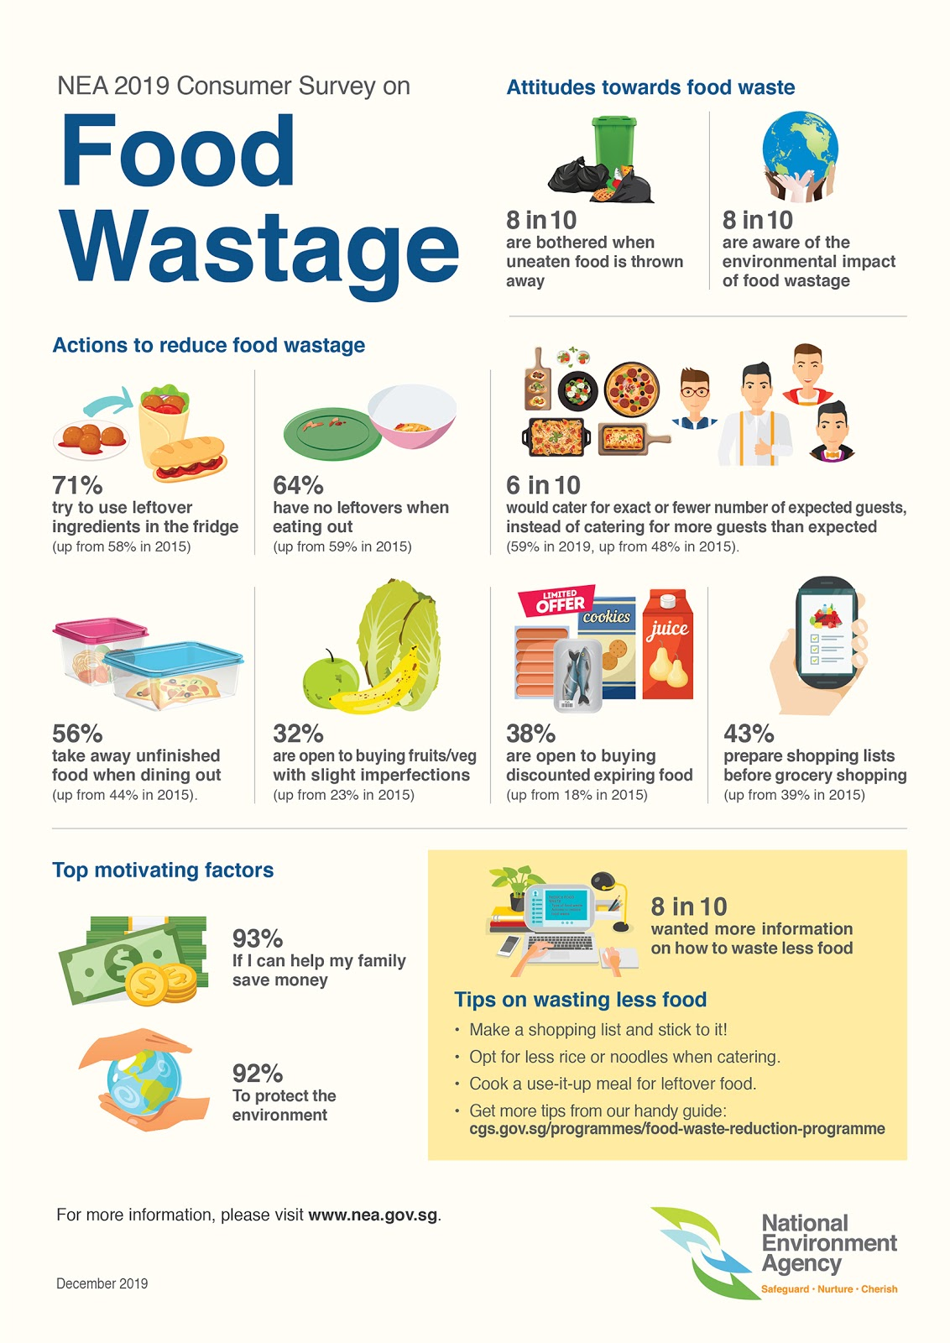

**Where are we targeting our audience?**

**Social media-** Instagram, Twitter, Facebook, and TikTok.

**Instagram**

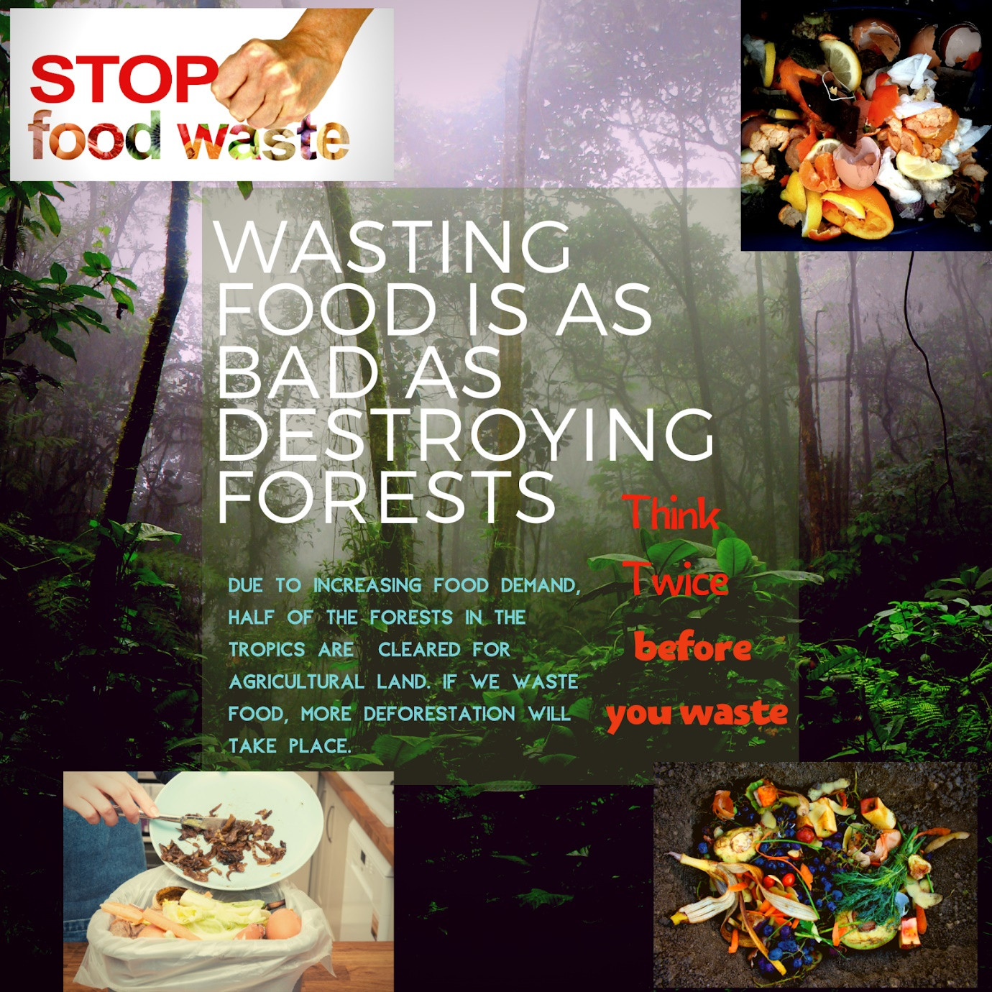

**Twitter**

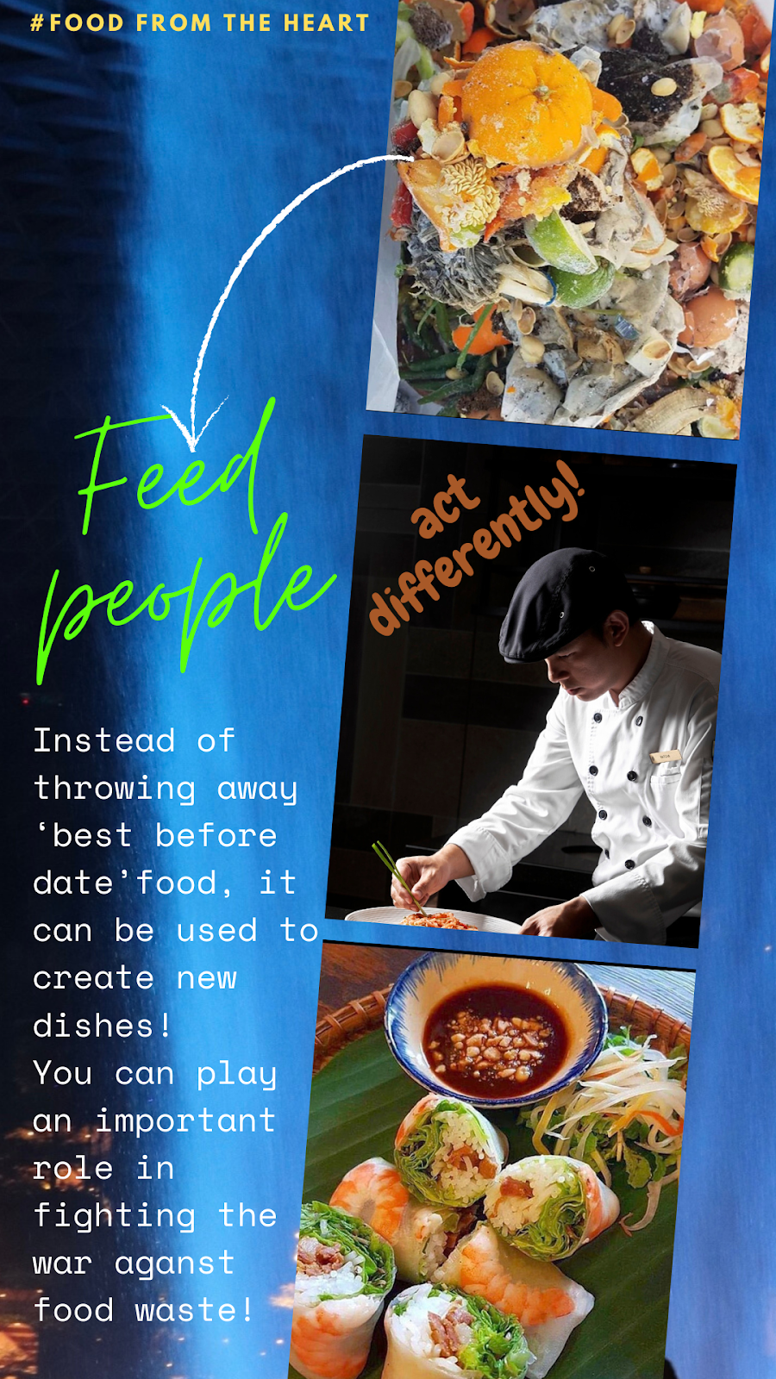

**Facebook**

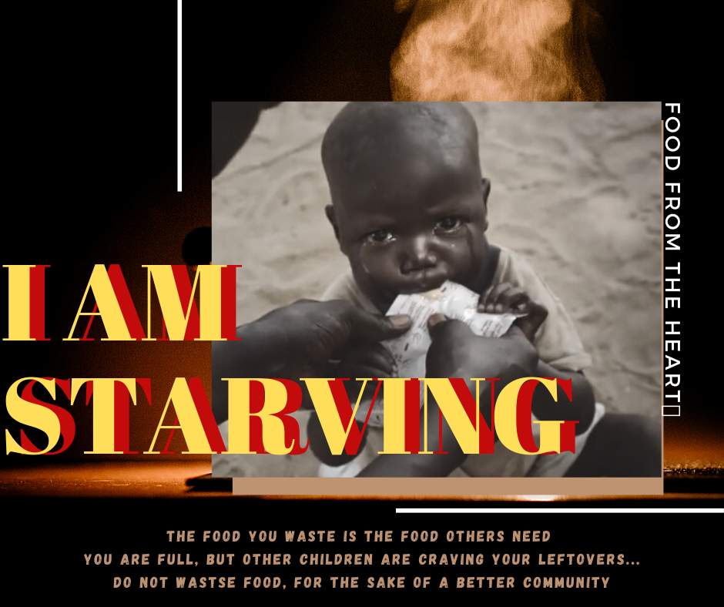

**TikTok**

Creation of a TikTok challenge involving humor-based videos, where the last spoonful eaten by a person is depicted in a comedic way, after which the person chooses another person, who must repeat the same action in a different, but still humorous way. This challenge will take place over three months to raise awareness about food waste, promote anti-food waste messages, and encourage people to donate their excess food to others rather than wasting it.

**Traditional media**

**Newspapers**- Articles concerning the consequences of food waste, the environmental impact of food waste, our campaigns in various locations, spreading the message of donating excess food instead of wasting it.

We will write an article about what happened in April 2020. Singaporeans were faced with the overload of food waste in landfills. Citizens paid a high cost for it by asking for help from the Malaysian government. Moreover, the amount of food in Singapore was less this year because other countries could not export as much food into Singapore because of Covid-19 restrictions. Singaporeans tried to hoard as much as possible, and supermarkets ran out of goods in a short time. FairPrice made a rule that customers can only purchase a fixed amount of a product, for example, 30 eggs per person. NTUC also donated their excess food to our organisation and became a partner with us to deal with food waste.

We can talk about how the Singapore government celebrated our campaigns and launched a new law. On one day in the month, a government officer will go to each household and check how they manage their food and check their fridge to make sure that they do not hoard up too much. The government also mentioned locations where homeless people can come and receive food daily from us. They also encouraged households to be more aware of the impact of food waste on the country.

People tend to believe news from government organisations, so by providing news concerning those organisations, we can convince people to stop wasting food.

Ryan Sylvia: This channel has 900K followers on YouTube. Their videos are extensive. One of the most popular series of videos produced by Ryan Sylvia (or Night Owl Cinematics) is their Food King Videos.

In October, Dee Kosh, Aiken, and Ryan (famous YouTubers in Singapore from Ryan Sylvia’s channel) made a video with content about Q&A related to food waste surveying poly students. In the video, these students mentioned the habits Singaporeans adopt towards stopping food waste and talk about our organization, where each individual can play a role in stopping the wastage of food. At the end of the video, the channel challenged its fans to cook creatively with whatever ingredients were left in the fridge. They were required to post a picture on Instagram within two weeks. The picture which got the highest number of likes had the opportunity to appear on Ryan Sylvia’s channel in the Food King Singapore series.

Fans follow influencers' actions, and the people who follow these particular fans will also adopt similar food waste reduction habits.

**Television-** Ads on the impact of food waste on the environment, information on what the public can do to reduce food waste, images of homeless, starving children, inspirational stories of Singaporeans who cannot take food for granted, thus inspiring people not to waste food, and several documentaries and movies about food waste.

Our Television advertisements will also focus on highlighting the food waste taking place right now in big offices and schools where people take excessive amounts of food and end up wasting it.

**TV ad:**

00:10- In a big company, several employees are sitting in the cafeteria. They have much work, so, during mealtime, they work and eat at the same time. As a result, they often waste food and take the unlimited quantities they receive for granted. The break finishes and they go back to work, leaving most of the food behind on the table. All that food is thrown away.

00:20- A student goes to a dessert shop and orders what she wants. She over-orders and cannot finish what she buys. Habitually, she throws away what does not taste good.

00:30- At mealtime in a household, a mother is feeding a child, but the child swats her hand away. The food from the bowl falls into the dustbin. Meanwhile, with a spoon, a homeless mother feeds her children. These children are happy, and they laugh loudly. The mother cries.

00:40- The message at the end of these three scenarios: the food you waste is valuable to others. You can feed yourself, but others are starving and craving the FOOD YOU THROW…

00:45- Manage your food well and donate your leftover food to Food from the Heart instead of wasting it. We can help save many homeless people from hunger together.

**Radio**

We must use everything and waste nothing. 80% of us never think about what will happen to our food if we throw it away. A large number of NGOs and NPOs have been created to deal with the issue of food waste. They are collecting tons of food waste each day from supermarkets and convenient stores to re-cook and give out to citizens. We are sending the food waste to a landfill and ignoring hungry people. The situation is terrible and we need to change our attitude towards this food waste. Our lives are based on the community around us. A story from a Singaporean- Shanger Pannerchelvam is genuinely inspiring. The only ingredients his family could afford were rice, hot water, and salt. This is unbelievable because Singapore is such a rich country, but has limited success in its food wastage campaigns. Not long ago, talented chefs came up with an idea which involves taking produce, which is almost inedible and converting it to proper dishes. Households, especially mothers, you need to look at your kitchen differently. It does not matter where you are or how much money you have; you can reduce a small amount of food waste. This is important, and you can do it right now! Together we can fight the war against food waste!

**What type of events does our audience attend?**

Eighteen to Twenty-Four-year olds attend career workshops to gain better insight into specific jobs. Since workshops already appeal to our audience, we aim to conduct similar workshops on the topic of food waste to raise awareness and reduce food wastage.

Internships are also very popular with our audience. These internships involve a big company taking over a project and helping raise funds, or overseeing a part of the project. Interns can also help in social media marketing, and we aim to do something similar to this. People help prepare and deliver meals by volunteering, which can also help obtain raw materials.

**Who does our audience look up to?**

Audiences aged 18 to 24 are influenced by multinational idol singers or famous actors, who are invited to volunteer for food waste reduction campaigns and appear in campaign advertisements. Many people from the younger generation can sympathize with and understand food waste.

Audiences aged 18 to 24 have access to social media, e-newspapers, and news broadcasts, and by watching politicians in a particular country adopting food waste reduction techniques, they will be compelled to do the same and take the initiative.

Audiences aged 18-24 look up to their families, so if they reduce their food wastage, our audience will have a greater inclination to do the same. Some portion of our audience look up to their teachers, and if these teachers adopt food waste reduction habits, our audience will follow suit. Entertainers, including musicians and comedians, make up a portion of whom our audience looks up to. Fans of an influencer follow their actions, and the people who follow these fans (their friends and families) will also adopt similar food waste reduction techniques.

**Tactics**

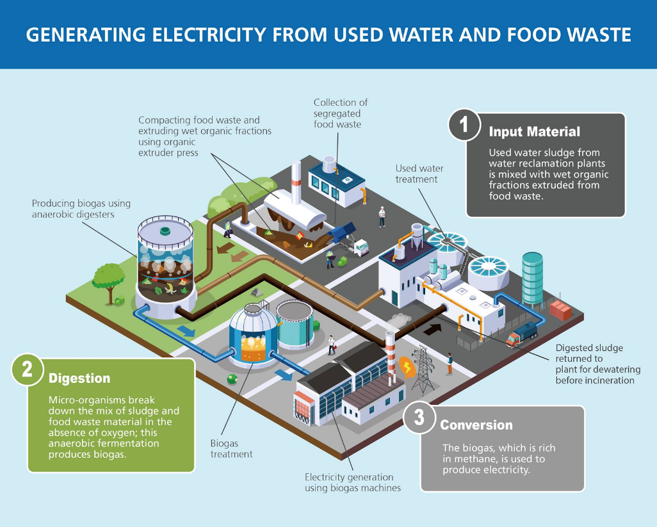

We will encourage hotels to put a limit on how much food each person puts on their plate because people tend to take a lot of food and sometimes waste it. We will also encourage restaurants and cafes to introduce different portion sizes on their menu, so customers do not waste food because often portion sizes for a single person are large.

We will develop an app that will involve a challenge- If people waste less than 5 kg of food in a day over three months (October, November, and December), which is also the entirety of our campaign, they will be rewarded with NTUC vouchers worth $30 each. People must diligently feed the amount they waste into the app, and it will keep a record of this. The app will have a system to measure the amount of food a person wastes. We will collaborate with the National Environmental Agency (NEA) to develop this app since they have the technology and resources to create an app that can weigh food.

We will have our volunteers go door to door in different neighborhoods in October, November, and December and give residents brochures/pamphlets and educate them about the issue of food waste and its impact on the society and promote our campaign to tackle food waste. Our volunteers will also collect leftover food from households. We will have NEA set up a collection point at each community center for residents in those neighborhoods to give their leftover food for recycling. We can visit houses in Singapore and ask people for food waste or extra food for the homeless. After this, we can ask them to visit our website, which will have activities they can engage in and gifts if they donate food. Gifts can also be given if creative solutions are given to reduce food waste. We can mainly focus on social media. We can give out vouchers as well. Now, due to the virus situation, people face unemployment and need money to buy food. We can collect extra food from others and give those people a gift if they want to join us in this campaign to help poor people. We can focus on students and give them a gift like a voucher if they give us their food waste.

Booths and stalls will be set up in different parts of Singapore in the second and third week of December, like in malls where children will be able to participate in fun games and contests which will be based on the topic of food waste and it will help educate kids about this issue and promote our campaign. Based on the results of these games, children will have an opportunity to spin a wheel and win exciting prizes. This game does not only attract players but also conveys knowledge to the children. These stalls and booths will be set up throughout December.

We will hold workshops for food waste in schools and offices in slots in October and November to educate people about food waste in Singapore and how they can play a part in solving the problem. Community Centres can be key areas where we spread messages about our campaign. These messages will be spread throughout October, November, and December.

As part of our fundraising event, we will organize a marathon in the second week of November and have a charity event with socialites, celebrities, and influencers. Some of the influencers we have enlisted are Preetiplease and YOLO. We will also partner with a few social media influencers to help promote our campaign and spread our message across. (they can post for us on their socials and tag us, and maybe they could provide a link for a donation or say ‘check out their page to know more about what they do’ or ‘please help them with their cause, they are doing incredible work’)

We will go on a radio talk show and talk about our campaign to ensure that we reach out to audiences on traditional media platforms in the first week of October. We will also do a collaboration video with famous YouTuber Ryan Sylvia in the third week of October.

**Administration**

**Length of Campaign- 3 months.**

**Budget**

Newspapers- $630 ($63*10cm); 10 ads*630=$6300

Posters- 20 posters *A2 size=$360

Radio- $500/ad; 5 ads=$2500

TV- $713; 713*10 ads=$7130

Cost of the app- $500

Cost of workshops-$2000

Cost of organising the run- $1500

Cost of setting up booths and stalls- $1600

Total- $21,890

**Results**

We have successfully reached 350,000 people on Instagram over three months. There was a 60% increase in positive attitudes towards reducing food waste. Our followers increased by 10,000. Influencers also helped spread our message.

We have successfully reached 300,000 people on Facebook over three months. There was a 50% increase in positive attitudes towards reducing food waste. Our bubble tea vouchers and NTUC vouchers proved to be an excellent incentive for Singaporeans.

We have successfully reached 200,000 people on Twitter over three months. There was a 50% increase in positive attitudes towards reducing food waste. Our hashtags were trending for three weeks and saw a significant increase in the number of participants in the app challenge, and 23% of people who gained awareness about the challenge through Twitter completed it.

Our TikTok challenge was a big success, as well. TikTok was the most effective at spreading our message, and a new trend emerged involving posting videos of people doing the challenge. Around 200,000 people took part in the challenge.

The marathon was a great success, and 100,000 people took part and gained awareness about our campaign and food waste.

Our television and radio ads resulted in a 35% shift in behavior regarding efficient food preparation and reusing leftover food.

Our radio appearance led to a 45% increase in awareness about our campaign.

Our collaboration video with famous YouTuber Ryan Silvia led to a 35% increase in awareness about our campaign.

The app challenge was a big success, and ordinary people showed great enthusiasm for it. They posted videos of them completing the challenge and inspired others to take up the challenge. One hundred fifty thousand people took part in the app challenge. 40% completed the challenge. Door to door volunteers helped raise awareness about proper food waste management by 15%. Workshops in schools and offices help raise awareness by around 25% about redistributing leftover food to underprivileged people instead of wasting it and efficient ways to reduce food waste by effective management.

Our stalls and booths set up in malls generated $5,000 in funding. Awareness about our campaign and food waste increased by 25%, and 54% of people who visited these stalls had a change in behaviour towards food waste.

10% of hotels and restaurants reduced their portion sizes, so their food wastage is less.

There was a 50% increase in using leftover food to make new dishes in households.

There was a 60% increase in using leftover food to make new dishes in restaurants, cafes, and hotels.

There was a 55% overall increase in awareness about food waste and its impact. We also had an increase of 40% in donations.

There was a shift in behaviour regarding the way people deal with food waste. People became more conscious about the amount they cooked and ate, thus avoiding wastage. Around 35% of people developed meal plans and donated 40% more food instead of wasting it.