HOW CAN SOCIAL MEDIA

IMPACT TRAVEL?

RAHUL GULATI

G1948660K

Sharmila Goyal

Table of Contents

|  |  |
| --- | --- |
| Letter of Transmittal | 3 |
| Justification | 4 |
| Abstract | 5 |
| **1.Introduction** | 6 |
| **2. Impact Of Social Media On Travel**  **2.1 Broad Scope of Social Media in travel today.**  **2.2 How Social Media impacts Millennials’ Travel**  **2.3 Impact of Social Media on Individual Travellers**  **2.4 How Social Media is used by travel companies to influence travellers**  **2.5 Social Media in the past**  **2.6 How Social Media can be used by travellers to find unknown places**  **2.7 How Travellers make decisions on travel by seeing what is Trending** | 6  6  6  8  9  10  10  10 |
| **3. Negative Impact Of Social Media On Travel** | 11 |
| **4. Conclusion and Recommendations** | 12 |
| References |  |

Letter of Transmittal

August 26,2019

Sharmila Goyal

PSB Academy

Marina Square

**Subject: Letter Of Transmittal**

Dear Ma’am,

I would like to respectfully inform you that I have reported on ‘The Impact of Social Media on Travel’.

This report has enabled me to gain an insight into how social media impacts individual travellers as well as how companies use social media to influence travellers.

I would be thankful if you gave your advice on the same.

Thank you,

Yours sincerely,

Rahul Gulati

Justification

I chose this topic because it is interesting to see in what way social media affects how people travel and how they take decisions based on others travel as well as how decisions are made based on companies’ influence on them to travel to a particular destination.

Abstract

The question 'How can social media impact travel?' aims to answer how social media is utilised by travel companies to attract a large number of people for tours. It also seeks to answer how travel photographs posted by people influence others to travel to specific destinations. It aims to analyse how hotels promote themselves on social media. The use of social media while travelling would alert other travellers of the dangers of a country and can result in them being more careful when they travel there, resulting in fewer incidents. It aims to show how both travellers and companies use social media. In the case of travellers, it impacts how they travel and in the case of companies- how they use social media to get people to travel using their services. The conclusion obtained is that social media definitely impacts travel.

**1.Introduction**

Social media has changed the way people travel. In these times, nobody uses so-called 'tour guide' books (Brown, Rachel n.d.), and lengthy hard copy maps to explore a new city or country. Instead, they use real-time data like, for example, Google Maps to help find and discover new places. They also look for inspiration for where to travel from others with social media playing a role in achieving this. 84% of travellers use social media ([Williams](https://www.mobilemarketer.com/editors/rwilliams/) ,Robert 2018) according to an Expedia survey. 1 out of 5 travellers use social media (Williams, Robert 2018) to get inspiration about where to travel next. As Neal Schaffer rightly said, "Social media replaces nothing but compliments everything".  Unquestionably, social media impacts travel in many ways.

**2. Impact Of Social Media On Travel**

**2.1 Broad Scope of Social Media in travel today.**

Unlike past times, social media is widely used these days by people to research destinations to travel. Social media is also used by hotels to influence people to stay there. Travellers use social media when going to a new destination by asking travellers who have been there before for their opinion. Social media sees the sharing of travel photographs, which helps promote the tourism of the country. In an Olapic case study (Olapic, n.d) involving Texas Tourism. Texas Tourism used a #TexasToDo hashtag on social media like Facebook and Twitter to promote tourism among residents and to encourage tourists to visit Texas. As a result, there was a 33% increase (Olapic, n.d.) in visitors returning to Texas after their first time. This case study is an excellent example of using a hashtag.

**2.2 How Social Media impacts Millennials’ Travel**

A surprising finding (Smart Insight,2017) was that after deciding on a place to visit, only 48% of people finally went there while the other 51% chose a different destination. For millennials, (Semlani, Mili 2019) travelling to a new place, having a new experience, trying new food and talking to an extensive range of people from diverse cultural backgrounds have become popular. Youth are passionate travellers. They are more likely to make their travel decisions on new places based on social media (Semlani, Mili 2019) because it is a more authentic source of information for them. At the same time, they take pictures and videos of their travels and influence others to travel where they have been. Friends and colleagues get inspired to travel there. The presence of Wi-fi at various places ([Semlani](https://www.traveldailymedia.com/profile/mili/" \o "Browse Author Articles) ,Mili 2019) is a gift for these young travellers as it enables them to post live travel updates.

[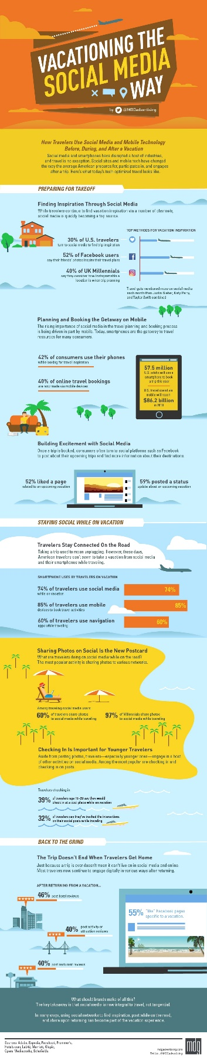](https://www.mdgadvertising.com/marketing-insights/infographics/vacationing-the-social-media-way-infographic/)

Figure 1- Statistics on How Travellers Utilize Social Media Before, During and After a Vacation.

Source: <<https://martech.zone/social-media-statistics-travel-vacation/>>

**2.3 Impact of Social Media on Individual Travellers**

When travellers make decisions, they try to understand their needs and social media in a large part (Sigala, Christou, Gretzel 2012, p8) helps to fulfill these needs. These travellers go onto social media to look for information related to their travels, such as what kind of place they are going to is. Travellers then summarise their decision and then purchase items (Sigala, Christou, Gretzel 2012, p8) such as tour packages due to deals and recommendations made by others on social media. People receive support (Sigala, Christou, Gretzel 2012, p8) even after their purchase, which encourages them to spread positivity about the tour company, for example. Social media can be used by travellers to raise questions as well as voice their grievances, which helps other travellers understand a city or country better. Travel companies, as well as other chains like hotels, can help answer questions and sort out the grievances of people.

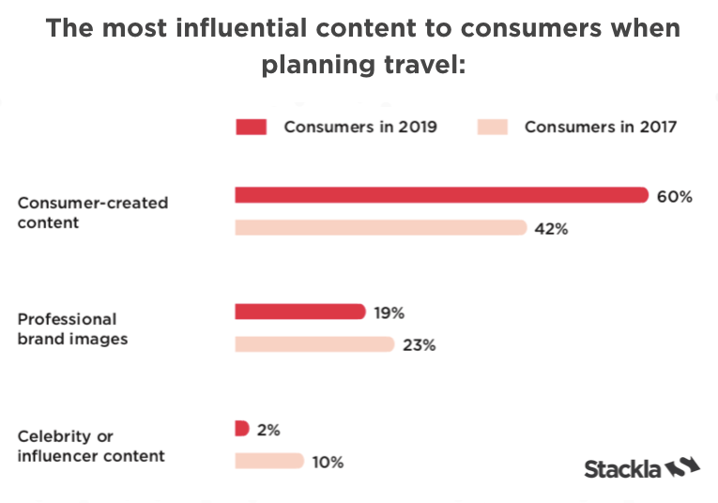

Figure 2: Social Media content influencing consumers’ travel.

Source : <<https://stackla.com/resources/blog/5-statistics-that-prove-social-media-will-influence-your-next-travel-destination/>>

**2.4 How Social Media is used by travel companies to influence travellers**

Travel companies should include a large number of spots (Fitzpatrick, Kawasaki 2014, p107) in their tour packages for travellers to take photographs. The higher the number of spots, the better the lure they create on social media, which helps draw people into going to the destination as well as take the tour from that company. Tour companies can show people enjoying themselves in pictures (Fitzpatrick, Kawasaki 2014, p108) and portray this on social media platforms to travellers attracting them to go for their packages. Hotels and other companies benefit from social media when travellers post pictures of products or services they offer with their company logo. In the case of a social media post, a tag showing the location and the name of the hotel is hugely beneficial. Encouraging people to share good deals and experiences on social media helps the company expand enormously.

For example, when a tour finishes the final message given to travellers/ tourists who took the tour is 'We hope you enjoyed your experience! Please share it with others on social media!'

If an Australian tour company made a small, hilarious film on Melbourne showing quirky aspects of the city, it would get shared rapidly on social media platforms. As a result, the number of travellers bound to Melbourne would increase. People rapidly keep shifting to new social media platforms (Fitzpatrick, Kawasaki 2014, p100) as they release, so travel companies need to influence people there. However, at the same time, they must have a base on older platforms for loyal users. The clever use of these platforms can significantly impact travel, both to unknown and well-known destinations.

Hotels and airlines announce hugely discounted rates for their hotels and flights to selected destinations. Discounted rates not only improve tourism in that city or country but also helps increase the number of passengers travelling by that aircraft or the number of people staying in that hotel.

**2.5 Social Media in the past**

In the past, before the dominance of social media platforms, the spread of online news about an incident acted as social media and impacted travel. A definitive example of the working of this was when 9/11 took place in 2001. Internet sites acted like social media (Anslow, Louis 2016) spreading the news about the incident. The news spread rapidly and raised terrorism concerns in the rest of the world, which resulted in enormous damage to the tourism of America. The travel to the United States decreased until it was safe once more.

**2.6 How Social Media can be used by travellers to find unknown places**

Social media can help people gain knowledge about small villages they would never know existed. By posting photographs of those villages, more people would travel to them and help support the villagers' trade and their families. It would also benefit travellers since they would see traditional living styles and make them grateful for how lucky they are. They would gain a sense of admiration for these villagers. All these excellent benefits are stemming from just a single post on social media.

**2.7 How Travellers make decisions on travel by seeing what is Trending**

a) By looking at what is trending on Google, people choose a travel destination (Fitzpatrick, Kawasaki 2014, p28). Based on this, we can say the internet itself is a potent social media tool impacting travel.

b) Destinations trending on Facebook, Twitter and Pinterest (Fitzpatrick, Kawasaki 2014, pp.29-30) also heavily influence travel. Lists like 'Most Loved Travel Destinations This Year' help people determine where others are going the most and encourage them to visit those places as well.

c) Social media posts that are dramatic (Fitzpatrick, Kawasaki 2014, pp.81-82) result in greater sharing among travellers and impacts travel to a particular destination as well.

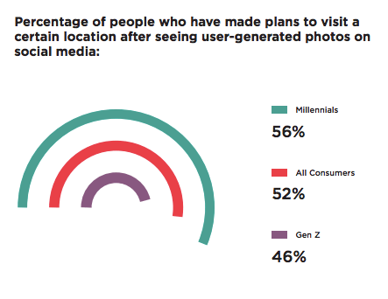

Figure 3: Percentage of people who have made plans to visit a certain location after seeing photos on social media.

Source: <<https://stackla.com/resources/blog/5-statistics-that-prove-social-media-will-influence-your-next-travel-destination/>>

**3. Negative Impact Of Social Media On Travel**

However, social media negatively affects travel as it removes the possibility of exploring new places because people have seen them already on social media platforms. Social media can give a personalised, false impression of a country.

Because of social media (Karsten, Matthew 2019), there has been a more significant number of tourists visiting a country or a site which affects the infrastructure because the country cannot keep up with the huge surge of tourists and the environment is also affected because increased tourism would result in an increase of all forms of pollution.

**4. Conclusion and recommendations**

In conclusion, social media impacts travel in society. A random social media platform like Instagram, will impact travel. Social media platforms are successful in impacting people in Singapore, so they would impact everyone else in the world. Companies should encourage the use of a hashtag (Fitzpatrick, Kawasaki 2014, p102) with their brand in these posts. The use of a hashtag promotes the brand and widens the audience the brand can reach.

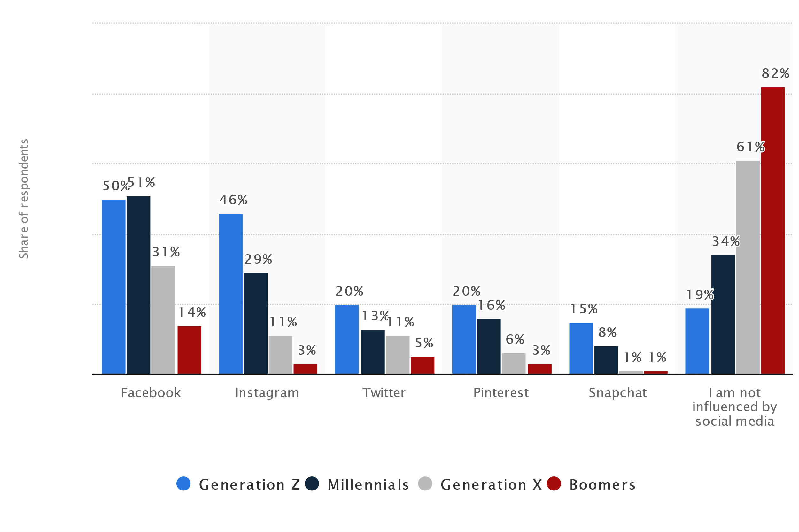

Figure 4- Which of the following social media sites influence or inspire your decision-making process in booking a trip?

Source- <https://www.statista.com/statistics/806118/social-media-influence-in-booking-a-trip-great-britain-by-generation/>

References

* [Semlani](https://www.traveldailymedia.com/profile/mili/) , Mili (2019). *Social media continues to influence the way we travel: Cox & Kings.* [online] Available at <<https://www.google.com/url?sa=t&rct=j&q=&esrc=s&source=web&cd=1&cad=rja&uact=8&ved=2ahUKEwjIgrGIncrjAhUI6nMBHaOdApYQFjAAegQIAhAB&url=https%3A%2F%2Fwww.traveldailymedia.com%2Fsocial-media-continues-to-influence-the-way-we-travel-cox-kings%2F&usg=AOvVaw2_7SQHi5AZvU8ZZOVP0Ra8>>

[Accessed August 14, 2019]

* Karsten, Matthew 2019. *Liked to Death: Is Instagram & Social Media Ruining Travel?* [online] Available at<<https://expertvagabond.com/instagram-tourism-impact/>> [Accessed August 12, 2019.]
* Fitzpatrick, Kawasaki (2014). *The Art of Social Media-Power Tips for Power Users.* United States: Penguin Group

* Sigala, Christou, Gretzel (2012). Ch. 1: Introduction to Part 1- The Integration and Impact of Web 2.0 on Business Operations and Strategies. In: *Social Media in Travel, Tourism and Hospitality: Theory, Practice and Cases,* Surrey: Ashgate Publishing Limited, p8
* Williams, Robert, 2017. *84% of Gen Z travellers are influenced by social media, Expedia study finds.* [online] Available at <<https://www.mobilemarketer.com/news/84-of-gen-z-travelers-are-influenced-by-social-media-expedia-study-finds/542551/>>

[Accessed August 20, 2019.]

* Smart Insights, 2017. *How Social Media and Mobile Technology Impact Travel.* [online] Available at <<https://www.smartinsights.com/social-media-marketing/social-media-mobile-technology-impact-travel/> >

[Accessed August 12, 2019.]

* Brown, Rachel n.d. *The Impact of Social Media on Travel Inspiration.* [online] Available at <http://www.olapic.com/resources/the-impact-of-social-media-on-travel-inspiration_blog-p1aw-f1tr-v1th-t1sm/>> [Accessed August 14, 2019.]

- Olpaic, n.d. *Case Study: Texas Tourism.* [online]Available at <http://www.olapic.com/resources/case-study-texas-tourism/> [Accessed August 10, 2019.]

* Anslow, Louis (2016). *Here’s what the internet looked like in the hours after 9/11; Earth shattering news in the pre-social media world.* [online] Available at < https://timeline.com/internet-looked-like-9-11-dd4afad61330>

[ Accessed August 18, 2019.]

PICTURE AND GRAPH REFERENCES

1) Karr, Douglas (2018). *Statistics on How Travelers Utilize Social Media Before, During, and After a Vacation.* [online] Available at <<https://martech.zone/social-media-statistics-travel-vacation/>> [Accessed August 12 ,2019]

2) Macdonald, Lindsay (2019). *5 Statistics That Prove Social Media Will Influence Your Next Travel Destination.* [online] Available at <<https://stackla.com/resources/blog/5-statistics-that-prove-social-media-will-influence-your-next-travel-destination/>> [Accessed August 13, 2019]

3) Luty, Jennifer (2019). *Which of the following social media sites influence or inspire your decision- making process in booking a trip?* [online] Available at

< <https://www.statista.com/statistics/806118/social-media-influence-in-booking-a-trip-great-britain-by-generation/>> [Accessed August 18, 2019]

APPENDICES

1. Statistics on How Travellers Utilize Social Media Before, During and After a Vacation.

[](https://www.mdgadvertising.com/marketing-insights/infographics/vacationing-the-social-media-way-infographic/)

1. Social Media content influencing consumers’ travel.



1. Percentage of people who have made plans to visit a certain location after seeing photos on social media.



1. Which of the following social media sites influence or inspire your decision-making process in booking a trip?

