**COMPARITIVE ANALYSIS**

**OF WORLD VISION INTERNATIONAL’S**

**‘END TRAFFICKING IN PERSONS’ PROGRAM**

**AND WORLD WILDLIFE FUND’S**

**IVORY LANE CAMPAIGN**

**By: Rahul Gulati**

**Student number: 10640249**

**INTRODUCTION**

**World Wildlife Fund-** The World Wildlife Fund works with communities around the world to help protect themselves and wildlife in their respective regions *(WWF, n.a.).* For this assignment, WWF’s Ivory Lane Campaign in Singapore has been chosen.

**World Vision International-** World Vision International provides calamity relief, water, education, and healthcare to poverty-stricken global communities (*WVI, n.a.*). For this assignment, WVI’s End Trafficking Campaign involving six Asian countries has been chosen.

**COMPARITIVE ANALYSIS OF WVI’S ‘END TRAFFICKING IN PERSONS’ CAMPAIGN AND WWF’S ‘IVORY LANE’ CAMPAIGN**

1. **Comparison of the aims of the respective campaigns:**

**‘End Trafficking in Persons’ Campaign:** The End Trafficking in Persons Campaign was a campaign carried out by World Vision International between 2011-2016. This campaign aimed to increase awareness about trafficking, prevent future trafficking, protect trafficking survivors, and ensure that governments implement better trafficking laws in six Asian countries. The budget for this program was $14 million (*WVI, 2016)*. Half the funds came from the Australian government, and the other half came from other countries, including Canada, Japan, and Taiwan.

**Ivory Lane Campaign:** The launch of The Ivory Lane Campaign took place in 2018. This campaign aimed at retaining people’s negative attitude towards the sale of ivory products. The budget for this program was approximately $S15,000. The essentiality of launching this campaign was to generate awareness about 40 ivory product shops in Singapore, which are allowed to sell ‘old ivory’ legally *(WWF,2018)*. The illegal trade of ivory in Singapore hides in plain sight. The ivory trade in Singapore has persisted, despite an international ivory ban almost 30 years ago, in 1990. This trade exists by exploiting loopholes present in the legislation of Singaporean laws. Singapore plays a substantial role in the global trade of ivory, especially as a significant transit point for illegal ivory. However, more than 50% of people are not aware of these ivory shops, and the ivory trade is not a big issue for Singaporeans (*WWF,2018)*. The killing of African Elephants takes place every 25 minutes, and 90% of African elephants are extinct due to poaching. Since the frequency of these killings is incredibly high, it ‘normalizes’ poaching for ornaments and jewelry, which is unacceptable. Possessing ivory shows that a person is wealthy, and criminal organizations illegally sell it to make a profit. The official motto of this campaign was ‘Stop the trade by sparking the conversation.’

1. **Activities involved in the respective campaigns:**

**‘End Trafficking in Persons’ Campaign:** Kim and Sriramesh (2009) define activism as the ‘coordinated effort of a group that organizes voluntarily in an effort to solve problems that threaten the common interest of members of the group’ (*Benedict, Ben 2017*). World Vision International successfully applied activism to bring about an increase in awareness about trafficking. The establishment of clubs to help train youth to become anti-trafficking activists in Laos and Vietnam were very successful. Setting up systems to prevent and report trafficking took place in Thailand, Myanmar, Vietnam, and Laos. According to Sandra Ball-Rokeach and Melvin DeFleur, the proposers of the media dependency theory in 1976, ‘the dependency theory conceives of dependency as a relationship in which the fulfillment of one party’s needs and goals are reliant on the resources of another party’ (*Lin, Yang n.a.*). In the case of these NGOs, the ‘other party’ is opinion leaders. No opinion leaders or influencers were used in this campaign.

Cambodia: Cambodia has several provinces, and these are the epicenter of trafficking in the country. Foreign workers in Cambodia find themselves in greater danger of being trafficked since they are not fluent in the local language *(WVI, 2016)*. The majority of Cambodians sent back to their country by Malaysia worked as sex workers. Cambodia had introduced the ‘Suppression of Human Trafficking and Exploitation’ law in 2008. However, the United States reprimanded Cambodia and said that they are not meeting the minimum requirements of the law. The ‘National Day to Combat Human Trafficking at District Level,’ raising awareness in rural areas and programs for child rights in schools are some of the activities undertaken by World Vision International to make people aware of their rights and the anti-trafficking laws in place.

China: Most trafficking cases in China occur among the vast number of foreign workers, whose employment is in factories. Trafficking among children chiefly takes place through illegal adoption and marriage. Traffickers take advantage of people in under-developed regions and people with physical disabilities. The creation of an anti-trafficking group in Luchan, China, was a significant achievement in the campaign *(WVI, 2016)*. Forums and Chat Rooms for children helped raise awareness about trafficking. The establishment of the China Academy of Social Science helped conduct trafficking research in the region.

Laos: A large number of foreign workers come from neighboring Asian countries, like Vietnam and Thailand. Laotians seek refuge in Thailand due to the vast number of similarities between both countries *(WVI, 2016*). Trafficking of females takes place through being hired as prostitutes, while work with dangerous conditions prevails for men. Without warning, some Laotians are sent back to their country by boat. Movies helped people gain awareness about trafficking, and preparations in place ensured that people knew what they required to travel overseas safely.

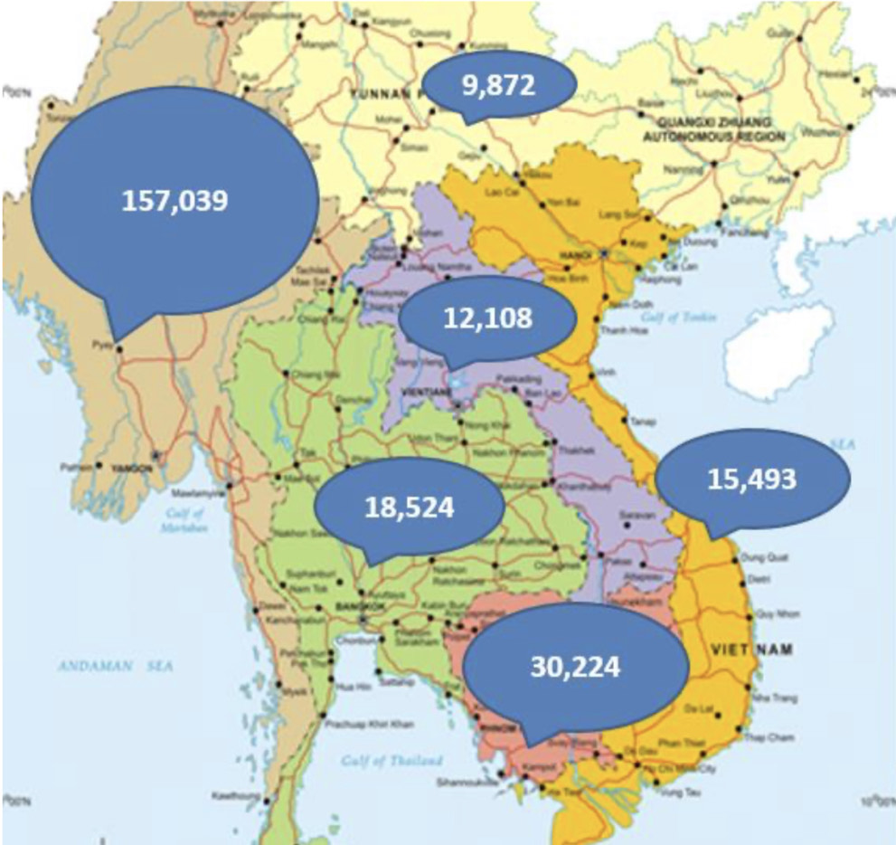

**Figure 1: The number of people who experienced an attitudinal and behavioral change regarding trafficking in the campaign countries. Source: WVI.**

Myanmar: Due to unfavorable conditions, large numbers of people seek work in surrounding Asian countries. However, trafficking takes place within Myanmar as well. Survey results showed that trafficking occurred among 14% of workers. The Kyaut Taw Gyi Pagoda Festival and Child Labour Day helped raise awareness about human trafficking. Over 12,000 youth participated in youth club activities *(WVI, 2016).* The youth who attended these clubs had some previous understanding of trafficking and hoped to gain further awareness and ways to protect themselves from it. Talent shows and children’s books helped children gain awareness about trafficking. People were made aware of an emergency number they could call in case they witnessed trafficking or were subject to it themselves. People were made aware of some reasons for trafficking and how children could safeguard themselves.

Thailand: Workers from surrounding Asian countries love the country’s favored location. Some of these workers come to the country illegally, which exposes them to trafficking. A majority of workers in Thailand come from Myanmar. Construction, agriculture, and prostitution are the main areas in which trafficking takes place *(WVI, 2016)*. The provision of essential supplies to workers and some events like children’s day helped generate awareness about the issue.

Vietnam: Vietnamese women and children are victims of trafficking by being used by criminal organizations at the country’s borders. Forced begging for money is also common for children. The application of the discourse theory proved to be successful here *(WVI, 2016)*. Theatrical performances, games, drawing classes, and sharing experiences with others helped generate awareness about trafficking, and people were informed of their rights and always told to reconsider decisions regarding choosing jobs. The provision of essential supplies to locals like cycles and farm animals took place.

According to Ohio State, the **two-way symmetrical model by Hunt and Grunig** argues that ‘the public relations practitioner should serve as a liaison between the organization and key publics, rather than as a persuader. Here, practitioners are negotiators and use communication to ensure that all involved parties benefit, not just the organization that employs them.’ World Vision did an excellent job benefiting the locals in these Asian countries, as well as successfully educating them about trafficking. Activities engaging younger generations like youth clubs were hugely beneficial and received a positive response from the community.

**Ivory Lane Campaign (Singapore):**

World Wildlife Fund successfully applied activism to bring about an increase in awareness about the ivory trade in Singapore.This campaign was very bold and different from previous elephant protection campaigns launched by the WWF since it involved the creation of a fake website with products claiming to be from the ivory of deceased elephants. The website was named Ivory Lane. Some of the products sold on the website included necklaces, rings, and earrings. The creation, display, and photography of these products attempted to convince people that they were ivory-based, but in reality, were made from other materials (*WWF, 2018)*. This campaign focused on social media like Instagram and Facebook posts and a YouTube channel. Ivory Lane applied the media dependency theory to help raise awareness about the ivory trade in Singapore and used environmental activity-based influencers and fashion celebrities like Liv Lo, Charmaine Yee, and even the famous actor, Paul Foster. These influencers are catalysts of change and are knowledgeable and articulate. The Ivory Lane Campaign also made use of the symmetrical model by Hunt and Grunig by using influencers to have a dialogue with the target publics.

The World Wildlife Fund also worked closely with a fashion and lifestyle magazine named Buro to ensure that the website Ivory Lane looked authentic, and the products looked genuine (*WWF,2018)*.



**Figure 2: The Ivory Lane Website. Source: WWF.**

Ivory Lane had some key characteristics which made it successful. The first factor leading to its success was a highly ambitious social media presence. Instagram and Facebook posts, coupled with tweets, caught the attention of thousands of people. Photographs used on Ivory Lane for this campaign were incredibly attractive and drew people in (*WWF,2018)*. Lastly, Ivory Lane had a convincing brand story about a fictional, passionate woman named Ivy Ng, who started Ivory Lane to sell ‘beautiful, handcrafted vintage ivory products.’ It was a ‘Made in Singapore’ fictional company, hoping to inspire feelings of ‘local pride’ and aimed at being a luxury accessory space, imbibing aspects of pop culture.

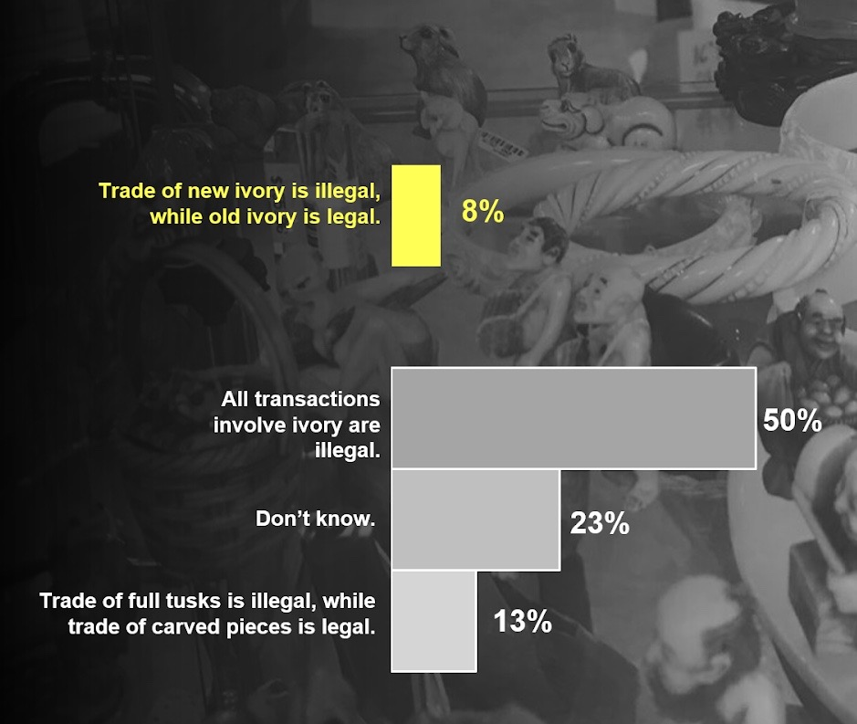

**Figure 3: Results of a survey on old versus new ivory in Singapore. Source: WWF.**

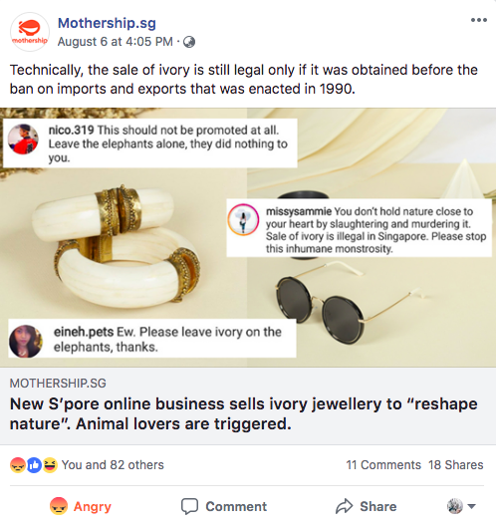 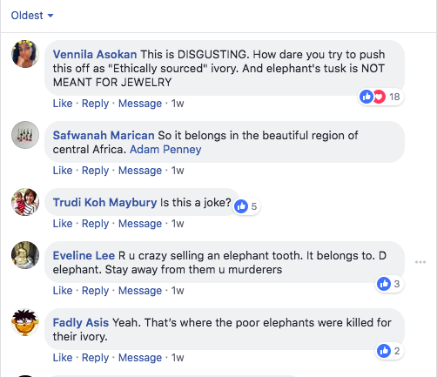

**Figure 4: Debate on social media**

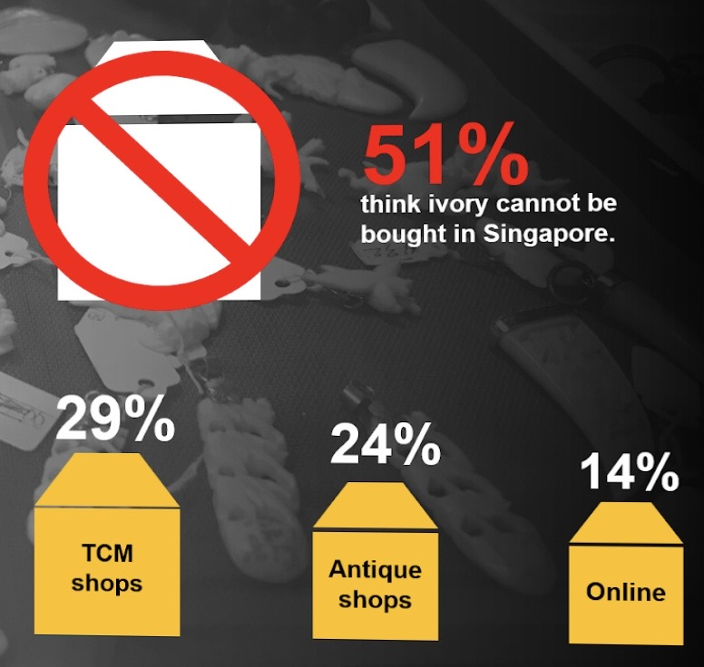

**Figure 5: Fifty-one percent of people think ivory cannot be purchased in Singapore. Below: Where ivory is sold and purchased in Singapore. Source: WWF.**

Using data gathered by surveys while the campaign was running, the results indicated that 51% of people think the purchase of ivory cannot take place in Singapore, while 50% thought that all ivory-based transactions were illegal. Extensive campaign research also revealed that the source of 29% of ivory purchased is TCM and backroom shops, antiquated traditionalist shops make up 24% of purchased ivory, and online websites make up the rest of the 14% of ivory purchased in Singapore. Physical and online marketplaces selling ivory in Singapore only possess a limited stock of ivory. These are signs of a backward and shady practice (*WWF, 2018*). While conducting this campaign, WWF found that only 8% of Singaporeans know that the trade of ‘new’ ivory is legal, while the trade of ‘old’ or ‘vintage’ ivory is legal. Another important observation made during this campaign was that 13% of survey respondents believed that the trade of full elephant tusks is illegal, but selling tusks with carvings and markings is legal.

1. **Comparison of the Results and Impact of both campaigns:**

**‘End Trafficking in Persons’ Campaign:** A total of 68% of groups in all six countries combined succeeded in raising awareness of human trafficking. The campaign was the most successful in Thailand, where anti-trafficking groups concisely developed plans to stop trafficking in children. More than 240,000 people spread across all six campaign countries gained awareness about human trafficking. More than 12,000 children attended youth clubs to gain awareness about trafficking. The campaign observed several activities like showing people videos and movies of trafficking so that they become aware and protect themselves from it. The effectiveness of these activities was higher than radio-based programs *(WVI, 2016)*. There was a 12.6% increase in awareness among children about child trafficking. In the six Asian countries where this campaign took place, 17.2% of children were at a much lower risk of trafficking. Approximately 35% of trafficking survivors re-synthesized into society. Since there was a lack of motivation between governments in this particular region to collaborate, World Vision helped bridge this gap. Chinese and Cambodian governments were able to craft joint policies for the prevention of trafficking.

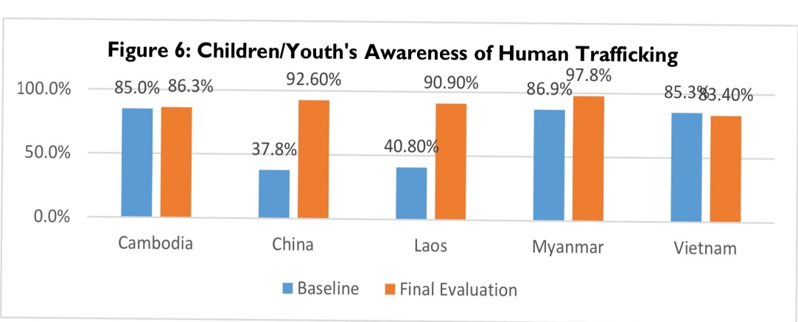

**Figure 6: A comparison of children’s awareness of human trafficking before and after the campaign. Source: WVI.**

Laos’ trafficking law got further amendments to ensure that restrictions in place were stricter and ensure the law was well-defined. Due to WVI’s extensive work, the creation of secure, guaranteed employment opportunities in Laos greatly benefitted the community and reduced the risk of trafficking.

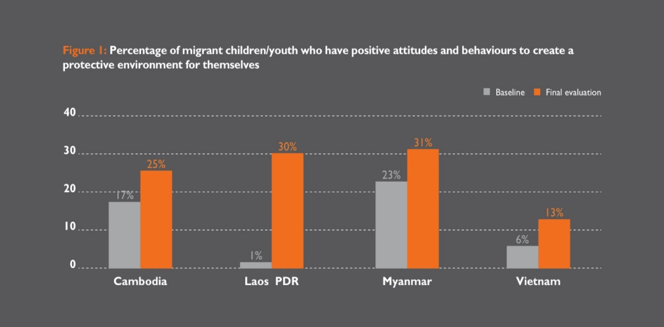

**Figure 7**: **Comparison of the percentage of migrant children who have a positive attitude and exhibit certain behaviors to ensure a protective environment for themselves before and after the campaign. Source: WVI.**

WorldVision also worked closely with Thai and Cambodian governments to help the Chinese government focus on trafficking issues. Crafting a comfortable environment enabled trafficking survivors to share their experiences. WVI ensured that these survivors received their full support, and WVI also helped these people recover from their trauma of being trafficked *(WVI, 2016)*. People were motivated to bring governments’ attention to this issue. Since traveling to other countries for work was a significant reason for trafficking, WVI analyzed the reasons workers did not want to work in their own countries. The results revealed that poor working conditions were a significant reason for shifting abroad. Even though no influencers or opinion leaders explicitly took part, the campaign was a massive success.

**Ivory Lane Campaign:** In less than a week, The Ivory Lane campaign reached over five million people and elicited more than 65,000 outcry comments. Over 150,000 people were engaged. Singapore’s wildlife laws became a global conversation overnight. According to the Reverse Agenda-setting theory, ‘the correlation between media and public and advocates that mass media has a significant impact on shaping the agenda for political campaigns by making people aware of important political issues’ (*Nair P., Sharma S. 2017*). This campaign was successful in stirring public opinion and convincing the media in various countries to write about it.

The campaign sparked a public debate on wildlife laws and shone the light on overlooked issues. Jason Baker from People for the Ethical Treatment of Animals (PETA) spoke out against the issue, and asked which cruel person would want to gather the ‘fragments of a tortured, dead elephant.’ News about Ivory Lane had circulated among over 70 media outlets worldwide, from New York to Bangkok (*WWF, 2018).* The campaign was successful in raising issues on the illegal trade of ivory and laws which must be in place to prevent this. Ivory Lane raised a massive uproar both in Singapore and internationally. People demanded legislative action against Ivory Lane and the sale of ivory. The outcry was so enormous that WWF had to reveal that Ivory Lane was a fake site set up to highlight the fact that ivory could be sold legally in countries like Singapore.

The campaign was named a ‘PR stunt,’ and ‘fake news,’ but the anger and negativity fueled by the campaign helped raise awareness about this issue. The creation of several podcasts on the issue, as well as news segments on various local news channels like Channel News Asia, was an important milestone for the campaign.

In June 2016, the Agri-Food and Veterinary Authority of Singapore (AVA) destroyed smuggled ivory, sending a clear message that the toleration of illegal ivory will not take place. In March 2017, the Parliament announced that they might ban the ivory trade in Singapore *(Lee, Pearl 2017)*. Later the same year, in December, after a Convention on International Trade in Endangered Species of Flora and Fauna (CITES) conference in Geneva, it was decided that Singapore will not have to create a National Ivory Action Plan, which was disliked by people *(Chin, Neo 2017)*. However, the government said that it was aware of the ivory trade and was taking steps to counter it. In March 2018, the confiscation of a shipment containing US$2.5 million worth of ivory took place as it passed through Singapore. The final destination for this illegal ivory was Vietnam *(Huiwen, Ng 2018)*. In 2019, Singapore Immigrations confiscated S$17.6 million worth of ivory *(Liu, Vanessa 2019)*. The final victory for WWF came when Singapore announced a ban on ivory in 2019, which would take effect from 2021 *(National Parks Board Singapore, 2019)*. With the banning of ivory, the implementation of specific measures needs to take place so that the demand for illegal products from other species of wildlife does not rise. Ivory Lane helped raise a local issue that had a global impact.

1. **Comparison of Limitations and Challenges faced by both campaigns**:

**‘End Trafficking in Persons’ Campaign:** Country-Specific groups came into existence at the end of the campaign, rather than the beginning, which was a considerable limitation faced by World Vision. This End Trafficking in Peoples Campaign was costly ($14 million), and an enormous amount of resources was required for it to have a greater reach, which was difficult to obtain (*WVI,2016)*. Problems with communicating in English also took place due to the diversity of languages in these six Asian countries.

**Ivory Lane Campaign:** Some people did not have a negative attitude towards old ivory, and one of the biggest challenges faced by this campaign was to convince people that elephants are slain for ivory whether it was old or new, and purchasing products made of old ivory was like justifying their deaths. The World Wildlife Fund was also very concerned about their reputation as an organization conducting activities based on scientific research, since this campaign did not rely on science, but was a PR stunt *(WWF, 2018).* WWF had to go through several internal loopholes to get permission for this campaign and had to ensure that the Singapore government agreed to buy into the campaign.

**Conclusion**

Although both campaigns targeted entirely different issues, they showed how NGOs have the power to make a difference in people’s lives and even change a country’s laws. An enormous amount of dedication and passion is required for this to take place, and targeting younger generations proved to be extremely fruitful. The Trafficking campaign made a difference in the lives of thousands of people in Asia, while the Ivory Lane campaign brought about a change in legislation.

REFERENCES

1. World Vision International (2016). *End Trafficking in Persons Programme Regional Report.* [online] Australia: World Vision International, p. 9-11,17-19, 28, 38,43,44,54,68, 74-85, 93. Available at: <https://www.worldvision.jp/about/ETIP%20Final%20Evaluation%20Report%20%281%29_final.pdf> [Accessed 3 May 2020].
2. WWF, 2018, *Ivory Lane (MUMBRELLA),* Singapore.
3. Lee, P. (2017). Parliament: Singapore may ban the domestic sale of ivory. *The Straits Times* [online]. Available at: <https://www.straitstimes.com/singapore/parliament-singapore-may-ban-domestic-sale-of-ivory> [Accessed 17 May 2020].
4. Chin, N. (2017). Ivory trafficking: S’pore a transit hub but ‘actively working’ to tackle the problem, says Cites. *Today online* [online]. Available at: <https://www.todayonline.com/singapore/ivory-trafficking-spore-transit-hub-actively-working-tackle-problem-says-cites> [Accessed 20 April 2020].
5. Huiwen, N. (2018). Singapore authorities seize elephant ivory worth US$2.5 million from Vietnam-bound shipment. *The Straits Times* [online]. Available at: <https://www.straitstimes.com/singapore/singapore-authorities-seize-elephant-ivory-worth-us25-million-from-vietnam-bound-shipment#:~:text=Singapore%20authorities%20seize%20elephant%20ivory%20worth,million%20from%20Vietnam%2Dbound%20shipment&text=SINGAPORE%20%2D%20More%20than%2060%20bags,from%20a%20Vietnam%2Dbound%20shipment.> [Accessed 22 May 2020].
6. Liu, V. (2019). Record haul of elephant ivory seized in Singapore, with pangolin scales, worth over $66m in total. *The Straits Times* [online]. Available at: <https://www.straitstimes.com/singapore/record-haul-of-elephant-ivory-seized-in-singapore-together-with-pangolin-scales-worth-over#:~:text=Record%20haul%20of%20elephant%20ivory%20seized%20in%20Singapore%2C%20with%20pangolin,over%20%2466m%20in%20total&text=SINGAPORE%20%2D%20A%20record%208.8%20tonnes,has%20seen%20in%20recent%20years.> [Accessed 25 April 2020].
7. National Parks Board Singapore, (2019). *Singapore announces a ban on domestic trade in elephant ivory.* Singapore: National Parks Board, p1. Available at: <https://www.nparks.gov.sg/biodiversity/cites/domestic-trade-ban-in-ivory#:~:text=On%2012%20August%202019%2C%20Singapore,will%20be%20prohibited%20in%20Singapore.> [Accessed 18 May 2020].
8. World Wildlife Fund. Available at: <https://www.worldwildlife.org/> [Accessed May 16 2020].
9. World Vision International. Available at: <https://www.wvi.org/> [Accessed May 14 2020].
10. Lin, Y. (n.a.). Media dependency theory. *Encyclopedia Brittanica* [online]*.* Available at: <https://www.britannica.com/topic/media-dependency-theory> [Accessed 6 June 2020].
11. Ohio State (n.a.). *Four Models of public relations* [online]. Available at: <https://ohiostate.pressbooks.pub/stratcommwriting/chapter/four-models-of-public-relations/> [Accessed 4 June 2020].
12. Nair.P, Sharma S. (2017). Reverse Agenda Setting: Politics in the time of Facebook. *Research Gate* [online]. Available at: <https://www.researchgate.net/publication/318967041_Reverse_Agenda-setting_Politics_in_the_Time_of_Facebook> [ Accessed 3 June 2020].
13. Benedict, B.(2017). Activism in Public Relations: Then and Now.*Graduate Thesis: Mount Saint Vincent University* [online]. P.17. Available at: <http://dc.msvu.ca:8080/xmlui/bitstream/handle/10587/1841/BenBenedictMACThesis2017.pdf?sequence=1&isAllowed=y> [Accessed 8 June 2020].