**THREATS**

**TO**

**THE**

**DIGITAL SPACE**

**FOR**

**EVERYDAY**

**USERS**

**Rahul Gulati**

**Student ID: 10640249**

**Introduction**

The current digital space has brought about many changes in the way people communicate with others. There is a shift from traditional media to digital platforms. In the post-digital space, rapidly progressing technology will transform our world, and interconnected smart cities will prevail. However, every rose has its thorn, and technology is no exception. The development of technology brings risks like cybercrime and cyberbullying, as well as increasing privacy concerns and increased surveillance. This project aims to analyze the threats faced by everyday users arising from the current and post-digital space.

**Threats to the digital space for everyday users**

1. **Cybercrime**:

In the current digital space, cybercriminals are people who want to prove their skills to others, big criminal organizations that sell private information online, and even companies looking to gain an advantage by sabotaging their competitors *(FBI, n.a.)*. However, the most significant risk comes from terrorists who make attempts to steal a country’s secrets and use that to launch deadly attacks. Due to the coronavirus, cybercrime is on the rise, especially in developing countries like Nepal (*Aryal & Dhungana 2020*). People need to be careful about what content they view, as well as take precautions to ensure they are not the victims of cybercrimes. Innocent looking emails laden with trojans are significant risks. Identity theft and social media harassment cases are on the rise at the moment in Nepal (*Aryal & Dhungana 2020*). People must attempt to put in the effort to protect themselves. Mass hacking of over 500,000 Zoom passwords took place on the dark web, which is incredibly concerning and generates fear about what the future of cybercrime will be.

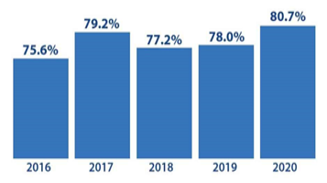

**Figure 1: The percentage of people affected by at least a single cybercrime attack has been on the rise since 2016.**

**Source: Comparitech.**

<https://www.comparitech.com/vpn/cybersecurity-cyber-crime-statistics-facts-trends/>

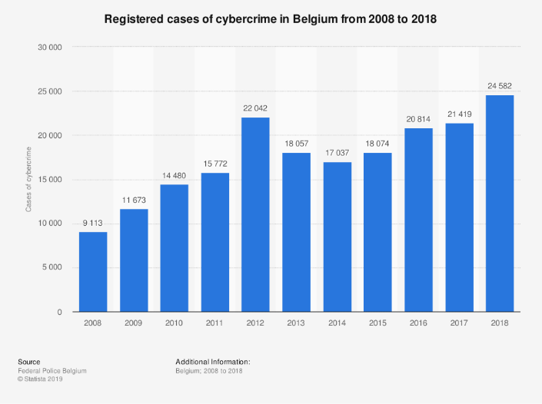

**Figure 2: Statistics showing cybercrime in Belgium between 2008-2018 reveals how it is one of the biggest threats to people in the current digital space.**

**Source: Statista.**

<https://www.statista.com/statistics/534977/cybercrime-in-belgium/>

The cybercrime researcher Chris Roberts said that he was able to gain control of a plane’s computer system while it was flying (*Loria, Kevin 2015*). The possibility that a criminal syndicate could do something like this is incredibly frightening. The post-digital space will see a more significant shift of data to online platforms. A crime syndicate known as Carbanak hacked into international banks and siphoned out money from them (*Loria, Kevin 2015*). The current digital space has over 200 billion interconnected devices, and the number will increase in the post-digital space *(Loria, Kevin 2015).* Hacking of Target’s data (the famous US general items store) took place, and over 70 million people were affected. More copious amounts of data online will mean that the next time something like this happens, a more significant number of people will be affected. The opportunities for cybercriminals in the post-digital space will be limitless and pose a higher risk to everyday users, and will require further development of security techniques.

Drone-based hacking is also on the rise. Using specialized technology, drones are effectively able to bypass a phone’s security and steal data while in flight. ‘Marketplaces’ with ‘hacking kits’ are available on the dark web for purchase, enabling anyone to steal a person’s data (*Kharpal, Arjun 2015*). Hacking of wearable technology like smartwatches also takes place and is a simple way for hackers to access a person’s information.

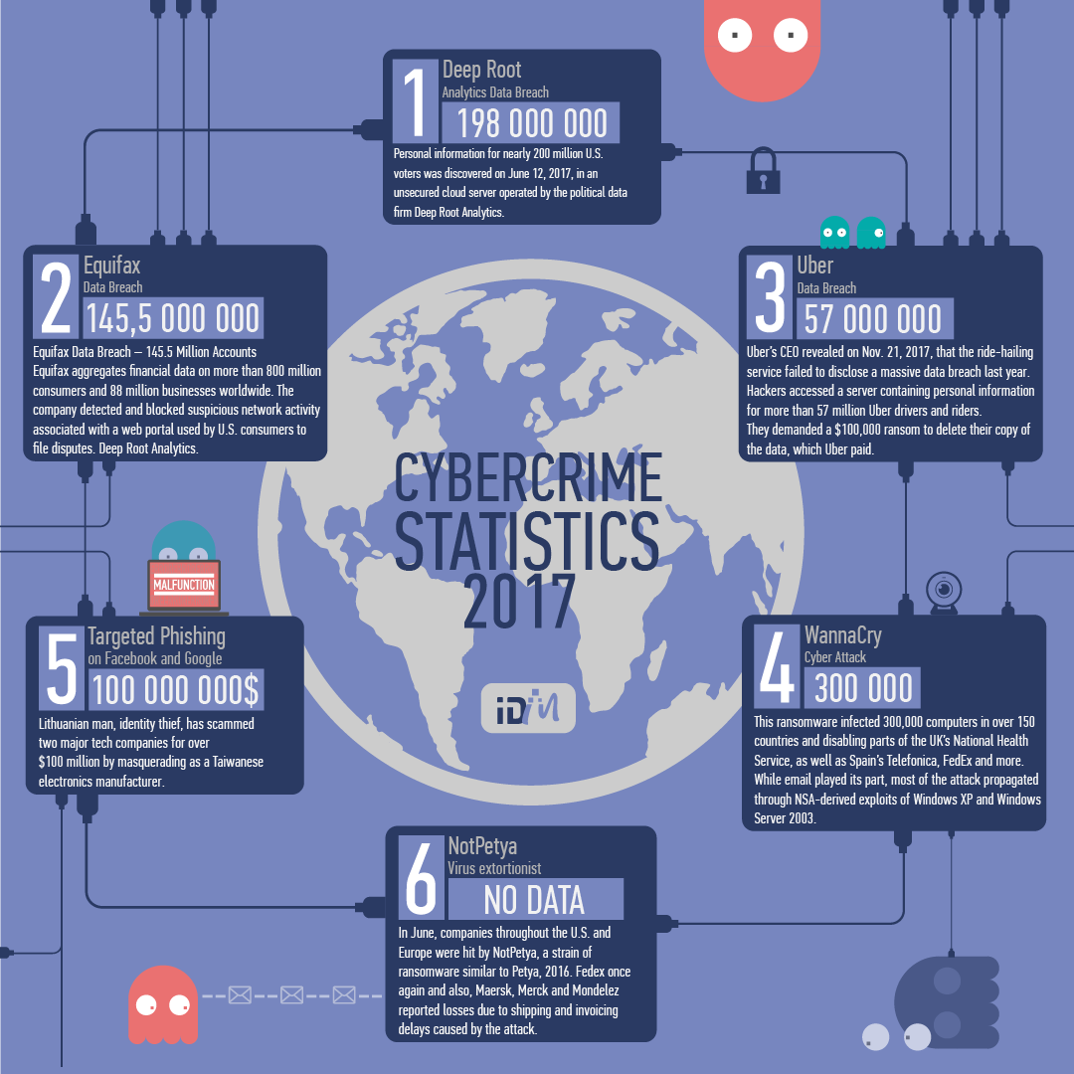

**Figure 3: Cybercrime Statistics in 2017 were alarming and raises concerns about the future.**

**Source: Medium.**

<https://medium.com/@IDMdatasecurity/cybercrime-statistics-in-2017-b7d9985fb32f>

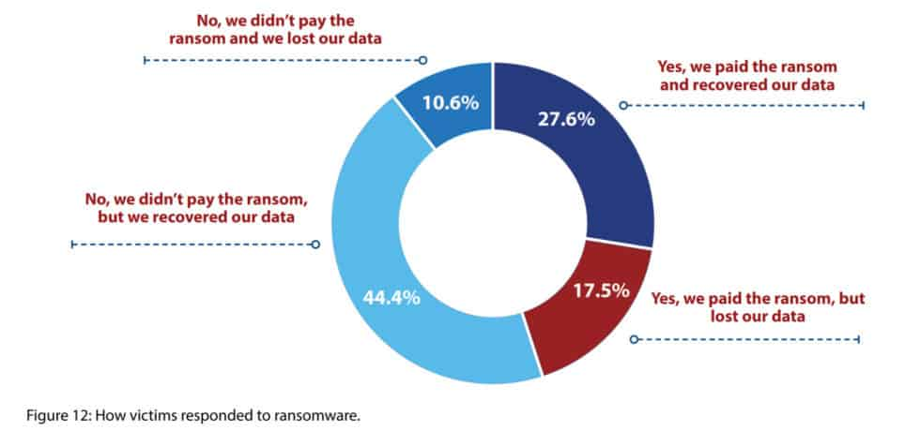

**Figure 4: Victims’ response to Cybercrime attacks.**

**Source**: **Comparitech**.

<https://www.comparitech.com/vpn/cybersecurity-cyber-crime-statistics-facts-trends/>

1. **Privacy and Surveillance:**

In the current digital space, when a person visits a website, a small file called a ‘cookie’ stores some information about the person. Personal details stored as cookies on websites are an enormous privacy concern. The post-digital space will see the disappearance of cookies (*Broughton, Mathew 2019*). A large amount of personal data previously collected by companies will provide advertisements based on people’s needs in the post-digital space. It seems like an exciting prospect for advertisers but raises privacy concerns for consumers.

Manufacturers received unencrypted data from devices like mobile phones. These files involve significant amounts of personal information, which raises suspicions among people about whether any of their data is truly private. An incredibly concerning discovery involved the linking of Smart TVs with Netflix, whereby Netflix received data from Smart TVs (*Steele, Beth 2019*). The discovery was incredibly alarming because the type of data sent to Netflix was unknown. Hackers can access the microphone of Smart TVs and listen to conversations (*Steele, Beth 2019)*.



**Figure 5: Mobile Surveillance Vehicles threaten privacy to a greater extent.**

**Source: Digiview Security.**

<https://digiviewsecurity.com/index.php/mobile-surveillance-unit/>

In 2018, a survey revealed that 22% of companies around the world are monitoring employees, including their computer and calendar-usage data (*Sheng, Ellen 2019*). The monitoring of social media accounts of employees aims to prevent the tarnishing of the company’s reputation. Companies claim that this information is collected to increase productivity, but the truth may be very different (*Sheng, Ellen 2019*). In both the current and post-digital space, surveillance in the workplace must follow the laws of the country to ensure violation of an employee’s privacy does not occur, and it is the company’s responsibility to ensure that employees have a harassment-free workplace.

Due to the current coronavirus situation, many cities in China placed surveillance cameras outside quarantined people’s homes to ensure they do not leave their houses (*Gan, Nectar 2020*). There was no formal announcement that this would take place, yet it has. People are enraged since this is a massive violation of their privacy. People have no choice but to accept this, and protests are futile- they are silenced by the state-owned media and a communist government (*Gan, Nectar 2020*). More concerningly, in rare cases, China has installed security cameras inside people’s homes enabling the government to monitor people very closely. If the post-digital space involves continuous government surveillance inside our own homes, the concept of privacy may become non-existent.

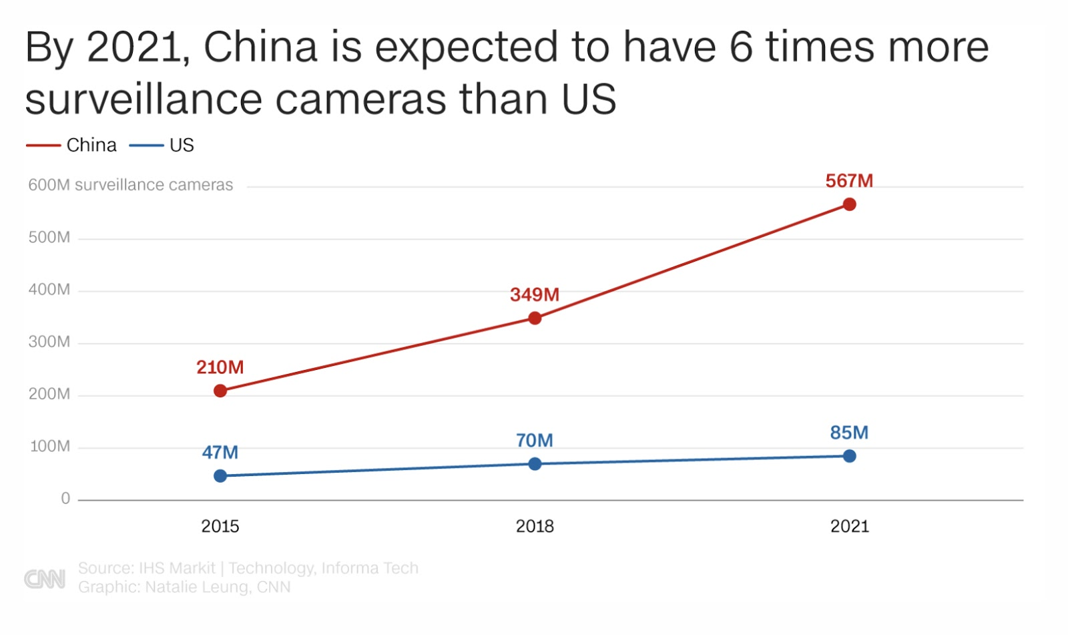

**Figure 6: China has eight of the world’s top ten most surveilled cities.**

**Source: CNN.**

<https://edition.cnn.com/2020/04/27/asia/cctv-cameras-china-hnk-intl/index.html>

Due to rapidly progressing technology, law enforcement agencies in the United States have had the opportunity to increase their surveillance activities. These activities involve monitoring peoples’ movements, which poses a greater danger to privacy (*Holmes, Aaron 2020*). Social media platforms like Instagram and Facebook claim that their users’ data is private. However, the only reason for free account creation on these platforms is the selling of data to advertisers without people’s consent *(Electronic Privacy Information Center, n.a.*). Social media can also be used by the police to find details about a person and his/her contacts. In a 2016 survey, ¾ th of law agencies used social media tactics to find information about a suspect (*Holmes, Aaron 2020*). Around 60% of these agencies directly reached out to social media companies to obtain information. Law enforcement agencies in London and Surat, India, are adopting similar face recognition and speeding offense tackling technology. The crime rate in Surat fell by 27% because of this *(Vasudevan, Smita 2015)*. Facial recognition technology is incredibly advanced in the current digital space, and there is no doubt that the post-digital space will see further advancements (*Holmes, Aaron 2020*). This technology’s current use involves the identification of criminals in crowded areas. Computer-driven programs can predict where a crime will take place and take preventive measures to stop it from even happening. Surveillance technology like drones have a variety of uses in the current digital space, and this will increase in the post-digital space.

By converting their Instagram accounts to a ‘business’ account, individual sellers may get a tremendous boost in their followers and interest for the product they sell, but this considerable boost is a trade with privacy (*Frier, Sarah 2019*). In a ‘business’ account, the person’s email address and phone number are made public to Instagram’s entire user base, which includes over a billion people. Instagram then provides comprehensive data and statistics based on how well the person’s product is doing, and even who has viewed it.

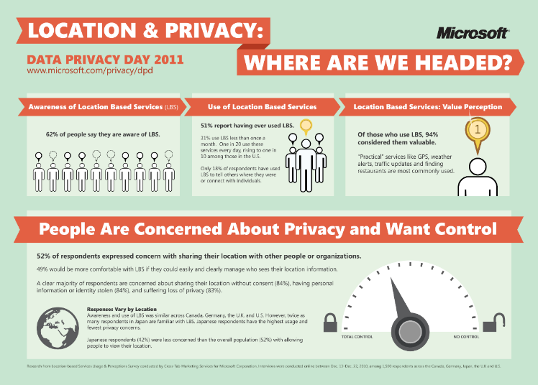  
**Figure 7: The future of location and privacy**

**Source: Visually.**

<https://visual.ly/community/Infographics/technology/location-and-privacy-where-are-we-headed?utm_source=visually_embed>

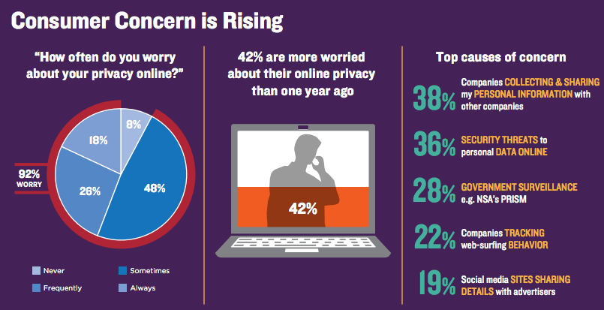

**Figure 8: Consumer Concern about Privacy is rising**

**Source: Trustarc.**

<http://trustarc.com/blog/tag/data-privacy-day/>

1. **Online and Social Media Threats (Including Cyberbullying and Trolling):**

Before the introduction of technology, opinion leaders were considered experts on a particular subject. In the current digital space, an opinion leader is merely a person who is famous online. An example of an opinion leader is an influencer. It is crucial to analyze whether an opinion leader is an expert on a particular subject in the current digital space (*Scherer & Trepte 2010*). The answer is straightforward - popularity does not mean expertise. Endorsements are manipulative since they portray a person promoting and speaking highly of a product even though, in reality, that person has never actually used the product (*Scherer & Trepte 2010*). Endorsements have such extraordinary power that people do not realize that they are victims of endorsement. When a trusted, respected celebrity promotes a product, people tend to believe that the product is incredible, without contemplating the possibility that an endorsement is involved.

Citizen Journalism is ‘a rapidly evolving form of journalism, which has enabled ordinary people to report newsworthy situations around them’ (*Noor, Rabia 2017*). Some adverse effects of citizen journalism include biased reporting and providing fake stories on an issue, resulting in the development of negative attitudes and biases, which is a considerable threat both in the current and post-digital space. A good example is during the 2016 US elections, in which anytime information about Hillary Clinton was leaked, citizen journalists scrambled to manipulate the information by posting on Twitter and other social media platforms that were distinctly anti- Clinton, resulting in more biases and negative attitudes towards her (*Singal, Jesse 2016)*.

One of the biggest challenges to the current digital space is cyberbullying, which involves the sharing of demeaning content and leaking personal information about others. In 2005, in the UK and Ireland, research on cyberbullying was conducted among 770 children, between the ages of 11-19 (*Gaffney & Farrington, 2018*). Results showed that cyberbullying occurred among 20% of these children. Cyberbullying typically takes place on social media platforms and online, and is constant because digital media enables cyber bullies to harass the victim continuously (*stopbullying.gov*). Since cyberbullying takes place online, it becomes challenging for others to identify it. Governments forbid people’s access to certain websites, depending on their location, proof that there is no democracy in the current digital space. People in the post-digital space will be restricted further.

Fandoms consist of fans of a particular person, team, fictional series, or anything else regarded collectively as a community or subculture (*Lexico Dictionary, n.a*). Fandoms create an ‘Us Versus Them’ dispute whereby people of a particular fandom consider themselves as part of the ‘us group’ and consider other people who are not part of the fandom as ‘them.’ People in the ‘us’ group share a strong group of values and can develop negative attitudes and biases towards those in the ‘them’ group because they do not share the same views and opinions as them (*Jensen, Joli 1992*). Furthermore, within an online fandom, new members will be judged, ridiculed, and criticized for not having as much knowledge about the particular fandom as people who have been part of the fandom group for a more extended period.

Some civil movements involve thousands of people protesting against a particular cause on a global scale, brought about by social media. A good example is mass protests organized in 128 countries in March 2019 to prompt world leaders to take action against climate change in the UN conference in December (*Carrington, Damian 2019*). Although mass movements like these sometimes bring about positive change, some adverse movements do take place, and these have disastrous consequences, which include the creation of particular stereotypes about a group or class of people, and can even lead to arrests (*Ghobadi, Shahla 2018*).

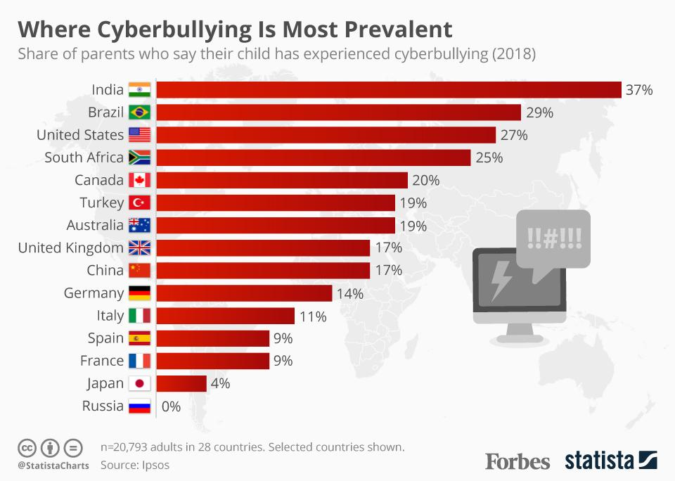

**Figure 9- Statistics showing cyberbullying prevalence by country.**

**Source**: **Forbes**. <https://www.forbes.com/sites/niallmccarthy/2018/10/29/new-report-cyberbullying-is-most-prevalent-in-india-infographic/#33938eaf7537>

Social media also introduces the concept of echo chambers. If we ignore content that does not agree with our beliefs, we are also effectively ignoring different points of view (*Grimes, David 2017*). If people do this, it is challenging for them to accept the views and opinions of a person in power, and in crises, governments require full cooperation. Peoples’ opinions change with the situation. When an unfavorable event takes place, people try to convince themselves that it is not so bad, despite knowing that this event will have fatal consequences (*Hammond, Claudia 2018*). People expect the worst from terrible events, and conflicting opinions arise on social media, and this causes chaos. People have an insatiable desire for likes and re-shares on social media platforms. Obtaining ‘likes’ on social media is turning into a competition for who can get the most. If people feel that they are not getting enough ‘likes’ on social media for a post, they feel anxious, and this anxiety can lead to insomnia as well as physical and mental disorders (*Squier, Chemmie 2016*). The danger to mental disorders is so enormous that the Thai Department of Mental Health warned that social media could affect Thailand’s development, as well as people’s creativity and innovation (*Squier, Chemmie 2016*). Psychologists reveal that the desire for ‘likes’ stems from our primary desire for approval and validation from other people. A research study titled ‘The Dove Self Esteem Project’ revealed that 2/3rd of females believed that they looked more beautiful on social media, and 60% of university students revealed that social media affected their confidence. Some people even remove posts if they feel that they do not get enough ‘likes.’

1. **Artificial Intelligence, Virtual Reality, and Hyperreality**

In both the current and post-digital space, Artificial Intelligence (AI) poses a vast amount of danger. One of the biggest threats is military-based: AI-controlled weaponry, which would be unstoppable and cause countless deaths (*Marr, Bernard 2018*). Artificial Intelligence is incredibly sophisticated in the current digital space, with robots being able to clean houses and even perform surgeries. Controversial issues arise about whether the fate of a human’s life should be in a robot’s hands. In the post-digital space, AI will be able to understand what consumers want, and convincingly target them (*Marr, Bernard 2018*). The provision of specific goals and instructions to machines will be essential, as they focus solely on the achievement of a task, rather than the consequences of rushing to finish a task. Finally, AI can be used by employers to discriminate whether a person meets specific criteria for a job. (*Marr, Bernard 2018*).



**Figure 10- Robots like ASIMO are designed to complete household chores, but how safe are intelligent robots?**

**Source: Telegraph.** <https://www.telegraph.co.uk/technology/8878257/Artificial-intelligence-robot-which-can-help-round-the-home-is-unveiled.html>

The presence of devices such as the Oculus Rift shows that Virtual Reality technology is rapidly progressing. Ultra-immersive technology tends to blur the line between what is real and artificial in the current digital space, and will further do so in the post-digital space (*Cipresso P., Giglioli I., Raya M. and Riva G., 2018*). This technology makes people believe that virtually crafted experiences are taking place, which is incredibly dangerous because people get detached from reality, and fatal accidents can occur (*Kim, Monica 2015)*. According to Baudrillard, ‘Hyperreality is the meticulous reduplication of the real, preferably through another, reproductive medium, such as photography’ (*Wolny, Ryszard 2017*). Hyperreality is dangerous because it changes the way people interact with each other and examines society’s inclusion in the media space (*Crozat, Dominique 2010*).

An example of the dangers of hyperreality is when people perceive images of their role models manipulated by hyperreality as actual role models when in reality, the depicted role model is a different person altogether (*Gwazi, Dinfa* *2017*). People will strive for unrealistic perfection, and there will be no actual role models whom people will look up to. Similarly, in online advertisements, images of products are depicted very differently from the way they look, and a good example is McDonald's, who show their BigMac burger in a particular way, but this is very different from the burger served in reality (*Gwazi, Dinfa 2017*).



**Figure 11: The appearance of a BigMac burger (left) and the actual burger(right).**

**Source: Medium.** <https://medium.com/@.WOKE/hyperreality-media-personalization-expectations-and-preferences-587b45a80899>

In the post-digital space, people will have greater difficulty distinguishing virtuality from reality, and certain negative biases and stereotypes about the world can develop. Nobody will know where to draw the line between these two worlds.

Conclusion

The definition of immediacy is ‘the fact that something seems real and important so that you feel involved with it’ (*Cambridge Dictionary, n.a.*). The problem with immediacy is that people feel achieving a particular desire will ultimately satisfy them, which is not the case (*Daily Athlete, n.a.)*. People’s desire for new technology and immersive experiences are growing, and they are never satisfied. As our world rapidly progresses, new technology will develop, which will bring its own set of challenges and threats. People need to be aware of how they utilize current technology as a form of preparation for future technology. Automated robots will soon be able to take over workplaces and do a variety of tasks, but people must keep in mind the dangers that arise from this, and ensure that artificial intelligence does not surpass human intelligence. Stephen McBride, the editor of the RiskHedge Report, predicts that the biggest cybercrime heist in history will take place within the next six months (*McBride, Stephen 2020)*. The dangers of drone hacking are steadily on the rise, further increasing the risks of the leakage of sensitive data. Consumers find opinion leaders relatable, and these people have the power to influence consumers’ behavior drastically, and their role is only expected to increase. Social media has tremendous power to create revolutions, and a single comment can spark a global debate. As the world goes digital, steps also need to be taken to combat cyberbullying to ensure the creation of a safe space where everyone is accepted. Virtual Reality will create more profound, immersive experiences, and people must learn to differentiate between virtual experiences and reality.

References

1. Broughton, M. (2019). *What does the end of cookies mean for digital advertising?* [Blog] ExchangeWire. Available at : <https://www.exchangewire.com/blog/2019/10/23/what-does-the-end-of-cookies-mean-for-digital-advertising/> [Accessed 8 May 2020].
2. Cipresso P., Giglioli I., Raya M. and Riva G (2018). The Past, Present, and Future of Virtual and Augmented Reality Research: A Network and Cluster Analysis of the Literature. *Frontiers in Psychology,* [online]. Available at: <https://www.frontiersin.org/articles/10.3389/fpsyg.2018.02086/full> [Accessed 15 May 2020].
3. Kim, M. (2015). The Good and Bad of Escaping to Virtual Reality. *The Atlantic,* [online]. Available at: <https://www.theatlantic.com/health/archive/2015/02/the-good-and-the-bad-of-escaping-to-virtual-reality/385134/> [Accessed 19 May 2020].
4. Grimes, D. (2017). Echo chambers are dangerous- we must try to break free of our online bubbles. *The Guardian* [online]. Available at: <https://www.theguardian.com/science/blog/2017/dec/04/echo-chambers-are-dangerous-we-must-try-to-break-free-of-our-online-bubbles> [Accessed 14 May 2020].
5. Gan, N. (2020). China is installing surveillance cameras outside people’s front doors… and sometimes inside their homes. *CNN,* [online]. Available at: <https://edition.cnn.com/2020/04/27/asia/cctv-cameras-china-hnk-intl/index.html> [Accessed 24 April 2020].
6. Stopbullying.gov (2020). *What is Cyberbullying?* Available at:

<https://www.stopbullying.gov/cyberbullying/what-is-it> [Accessed 26 April 2020]

1. Steele, Beth, Federal Bureau of Investigation (2019). *Oregon FBI Tech Tuesday: Securing Smart TVs.* [online]. Available at: <https://www.fbi.gov/contact-us/field-offices/portland/news/press-releases/tech-tuesdaysmart-tvs/?=portland-field-office> [Accessed 18 May 2020].
2. Trepte.S, Scherer H. (2010). *Opinion Leaders: Do they know more than others about their area of interest?* [online]. ResearchGate. Available at: <https://www.researchgate.net/publication/215640148_Opinion_leaders_Do_they_know_more_than_others_about_their_area_of_interest> [Accessed 12 May 2020].
3. Ghobadi, Shahla (2018). *Going viral: What social media activists need to know.* [online]. The Conversation. Available at: <https://theconversation.com/going-viral-what-social-media-activists-need-to-know-96043> [Accessed 18 April 2020].
4. Hammond, C. (2018). The surprising reason people change their minds. *BBC* [online]. Available at: <https://www.bbc.com/future/article/20180622-the-surprising-reason-people-change-their-minds> [Accessed 24 May 2020].
5. Wolny, R. (2017). Hyperreality and Simulacrum: Jean Baudrillard and European Postmodernism. *European Journal of Interdisciplinary Studies* [online] Volume 3 (3), pp.1-5. Available at:<http://journals.euser.org/files/articles/ejis_may_aug_17/Ryszard.pdf> [Accessed 10 June 2020].
6. Crozat, D. (2010). Towards harsh horizons: fear and violence in hyperreality. *HAL archives-ouvertes.fr* [online] pp. 2-3. Available at: <https://halshs.archives-ouvertes.fr/halshs-00916270/document> [Accessed 11 June 2020].
7. Jenson, Joli (1992). ‘Fandom as Pathology: The Consequences of Characterization,’ in Lewis, Lisa (ed.) *The Adoring Audience: Fan Culture and Popular Media.* London and New York: Routledge,

pp. 1-12. Available at: <https://ollicelebrityinamerica.weebly.com/uploads/3/7/1/9/37199089/jenson.pdf> [Accessed 28 May 2020].

1. Daily Athlete Yesterday (n.a.). *The problem of immediacy* [online]. Available at: <https://www.dailyathlete.ca/the-problem-of-immediacy/> [Accessed 14 May 2020].
2. Noor, R. (2017). Citizen Journalism vs. Mainstream Journalism: A Study on Challenges Posed by Amateurs. *Athens Journal of Mass Media and Communications* [online] Volume 3 (1), p. 55, 64-69. Available at: <https://www.athensjournals.gr/media/2017-3-1-4-Noor.pdf> [Accessed 12 May 2020].
3. Singal, J. (2016). ‘Citizen Journalism’ Is a Catastrophe Right Now, and It’ll Only Get Worse. *New York Intelligencer Magazine* [online]. Available at: <https://nymag.com/intelligencer/2016/10/citizen-journalism-is-a-catastrophe-itll-only-get-worse.html> [Accessed 16 May 2020].
4. Frier, S. (2019). *Young Instagram users trade privacy for followers.* [online] *NNY360-Powered by Watertown Daily Times and Northern New York Newspapers.* Available at: <https://www.nny360.com/artsandlife/artsandentertainment/young-instagram-users-trade-privacy-for-followers/article_112a468b-4255-5489-b3fe-1bd8c6a84f99.html> [Accessed 27 April 2020].
5. Squier, C. (2016). Why Do We Get So Obsessed With ‘Likes’ on Social Media? *Grazia Magazine* [online]. Available at: <https://graziadaily.co.uk/life/opinion/care-likes-social-media/> [Accessed 17 May 2020].
6. Vasudevan, S. (2015). *Here is what Surat City* *Police did to cut crime rate by 27%.* [online] DataQuest. Available at: <https://www.dqindia.com/here-is-what-surat-city-police-did-to-cut-crime-rate-by-27/> [Accessed 13 June 2020].
7. Electronic Privacy Information Centre (n.a). *Social Networking Privacy.* Available at: <https://epic.org/privacy/socialnet/> [Accessed 12 June 2020].
8. Holmes, A.(2020). *How people are using technology like drones, and facial recognition to monitor protests and track people across the US.* [online] Business Insider. Available at: <https://www.businessinsider.com/how-police-use-tech-facial-recognition-ai-drones-2019-10> [Accessed 14 May 2020].
9. Loria, K.(2015). *Cybercrime poses a potentially existential threat to our society, and we’re completely unprepared.* [online]. Business Insider. Available at: <https://www.businessinsider.com/future-of-cybercrime-and-cybersecurity-2015-5> [Accessed 18 May 2020].
10. Dhungana S. and Aryal A.(2020). With everyone forced indoors and online by the lockdown, cases of cybercrime are increasing. *The Kathmandu Post* [online]. Available at: <https://kathmandupost.com/national/2020/04/28/with-everyone-forced-indoors-and-online-by-the-lockdown-cases-of-cybercrime-are-increasing> [Accessed 12 June 2020].
11. Federal Bureau of Investigation (n.a.). *Cyber Crime.* Available at: <https://www.fbi.gov/investigate/cyber> [Accessed 5 June 2020].
12. Kharpal, A.(2015). Amateurs are buying DIY hacking kits off the dark web. *CNBC* [online]. Available at: <https://www.cnbc.com/2015/06/03/dark-web-amateurs-are-buying-diy-hacking-kits-using-cryptocurrencies.html> [Accessed 7 June 2020].
13. Sheng, E. (2019). Employee privacy in the US is at stake as corporate surveillance technology monitors workers’ every move. *CNBC* [online]. Available at: <https://www.cnbc.com/2019/04/15/employee-privacy-is-at-stake-as-surveillance-tech-monitors-workers.html> [Accessed 3 June 2020].
14. Gaffney H. and Farrington D. Cyberbullying in the UK and Ireland. *ResearchGate* [online] pp. 1-13. Available at:<https://www.researchgate.net/publication/325025233_Cyberbullying_in_the_United_Kingdom_and_Ireland> [Accessed 27 May 2020].
15. Lexico Dictionary (n.a.). *Fandoms* [online]. Available at: <https://www.lexico.com/definition/fandom> [Accessed 5 June 2020].
16. Carrington, D. (2019). School climate strikes: 1.4 million people took part, say, campaigners. *The Guardian* [online]. Available at: <https://www.theguardian.com/environment/2019/mar/19/school-climate-strikes-more-than-1-million-took-part-say-campaigners-greta-thunberg> [Accessed 8 June 2020].
17. Marr, B. (2018). Is Artificial Intelligence Dangerous? 6 AI Risks Everyone Should Know About. *Forbes* [online]. Available at: <https://www.forbes.com/sites/bernardmarr/2018/11/19/is-artificial-intelligence-dangerous-6-ai-risks-everyone-should-know-about/#6a1c38e42404> [Accessed 4 May 2020].
18. Cambridge Dictionary *(n.a.). Immediacy* [online]*.* Available at : <https://dictionary.cambridge.org/dictionary/english/immediacy> [Accessed 6 May 2020].
19. Gwazi, D. (2017). *Hyperreality, Media Personalization, Expectations, and Preferences.* [online] Medium. Available at: <https://medium.com/@.WOKE/hyperreality-media-personalization-expectations-and-preferences-587b45a80899> [Accessed 18 May 2020].
20. McBride, S. (2020). Why The Largest Cyberattack in History Could Happen Within Six Months. *Forbes* [online]. Available at: <https://www.forbes.com/sites/stephenmcbride1/2020/05/14/why-the-largest-cyberattack-in-history-will-happen-within-six-months/#41570582577c> [Accessed 20 May 2020].